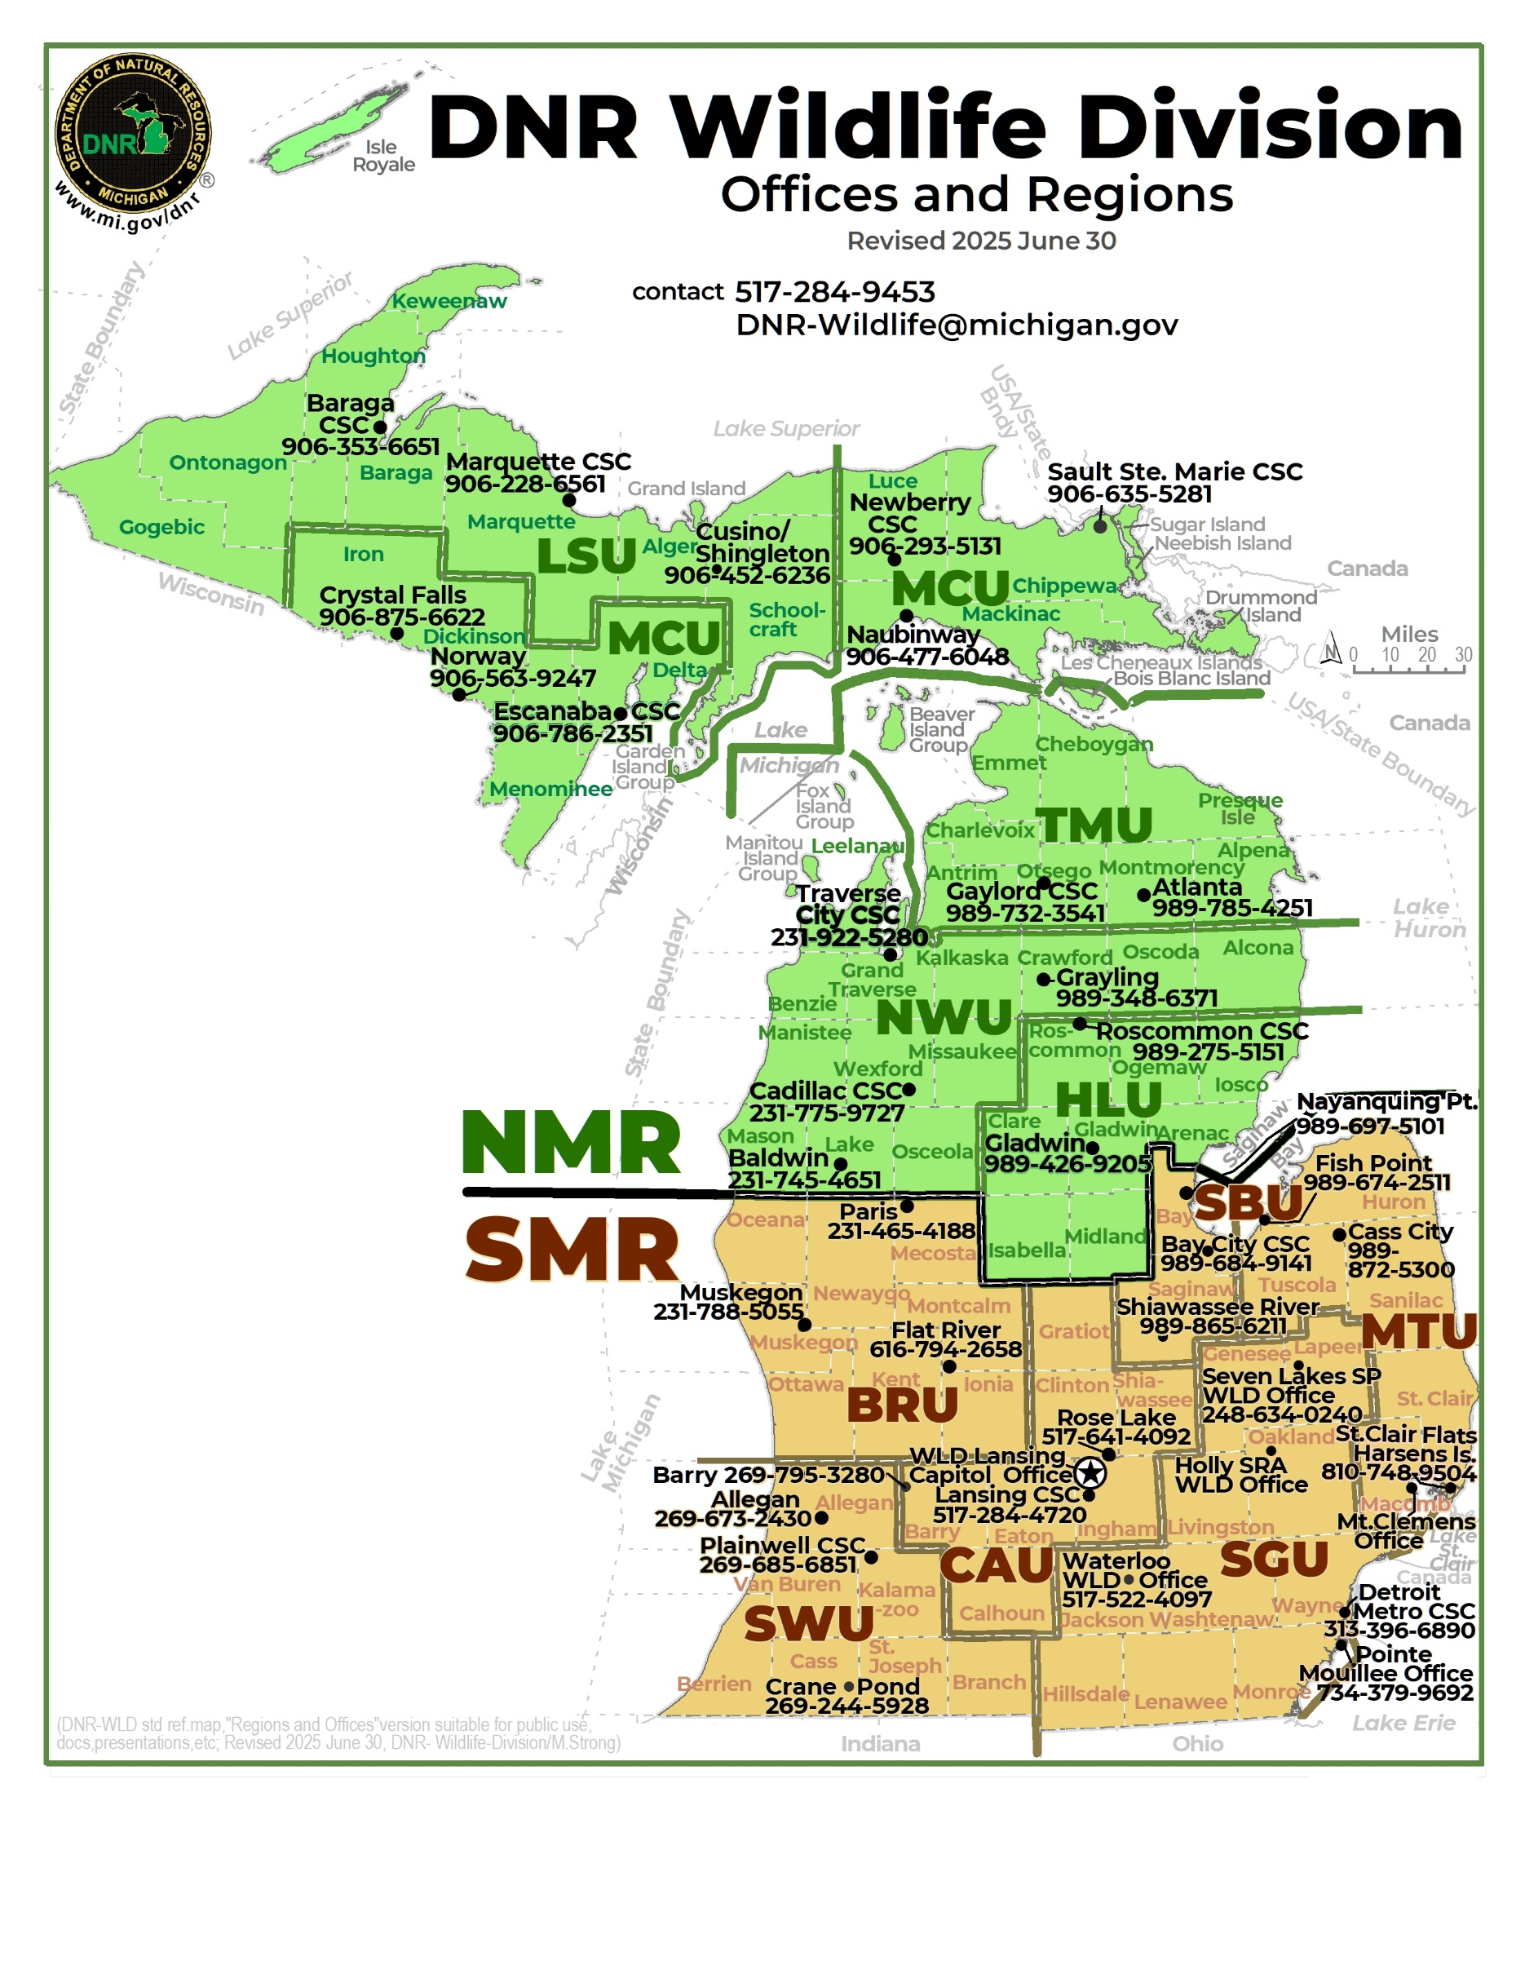

[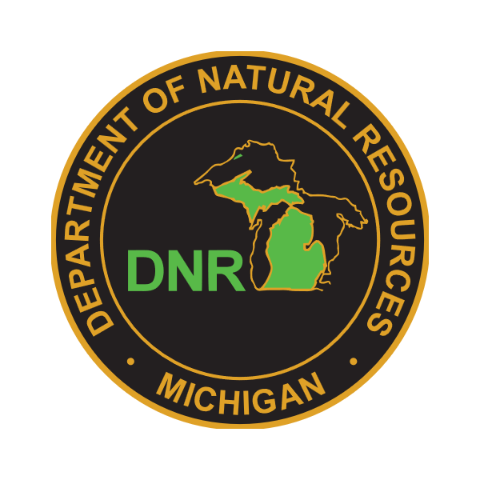](https://www.michigan.gov/DNR)Michigan DNR Wildlife Division (WLD)web: [www.michigan.gov/DNR](http://www.michigan.gov/DNR)

main phone: **517-284-9453** e-mail: [**DNR-Wildlife@michigan.gov**](mailto:DNR-Wildlife@michigan.gov) ;

mail-to: **Michigan Department of Natural Resources Wildlife Division**,

**P. O. Box 30444, Lansing, MI 48933 USA**. (revised 2025June27)

|  |
| --- |
|  |
| Abbreviation: region / section / unit-name supervisor name phone#/ |
|  |
| WLD Statewide Program Sections & Units ------------------------------------------------------------------------------ |
|  |
| Lansing Capitol Complex, Stabenow Building 517-284-9453 |
| WLD Chief Sarah Thompson 810-705-1296 |
| WLD **Assistant Chief** Keith Kintigh 517-219-2074 |
| ► DCU: Design and Communications Unit Dustin Isenhoff 517-599-8507 |
| **►** ESU: Employee Services Unit Brandi Holden 517-614-1478 |
| **►** PAS: Planning and Adaptation Section Amy Derosier 517-614-7050 |
| **►** PRU: Policy and Regulations Unit Sarah Cummins 517-388-1161 |
| **►** PSS: Program Support Section Janet Liesman 517-643-6431 |
| **►** RNU: Rare & Nongame Species Unit Vacant |
| Lansing Customer Service Center 517-248-4720 |
| ► **ARS:**  **Applied Research Section**  Dwayne Etter 517-388-6577 |
| ► **CIU:**  **Cervid & Wildlife Interactions Unit** Chad Stewart 517-282-4810 |
| ► **LMU:**  **Land Matters Unit** Earl Flegler 517-930-3528 |
| ► **SMS:**  **Species Management Section** Barb Avers 517-930-1163 |
| Wildlife Disease Lab at MSU Veterinary Diagnostic Laboratory 517-336-5030 |
| **►** WHS: Wildlife Health Section Mitch Marcus 517-242-0745  > Lab Operations Melinda Cosgrove 517-512-9486 |
|  |
| WLD Field Regions & Units ------------------------------------------------------------------------------------------------- |
|  |
| ► **NMR: Northern Michigan Region**  Dave Lemmien 906-203-8187 |
| > **LSU: Lake Superior Unit** Bill Scullon 906-250-6781  Counties: Alger, Baraga, Gogebic, Houghton,  Keweenaw, Marquette, Ontonagon, Schoolcraft |
| > **MCU: Mackinac Central Unit** Karen Sexton 906-399-6853  Counties: Chippewa, Delta, Dickinson, Iron,  Luce, Mackinac, Menominee |
| > **TMU: Tip of the Mitt Unit** Scott Eggeman 517-989-8119  Counties: Alpena, Antrim, Charlevoix, Cheboygan,  Emmet, Montmorency, Otsego, Presque Isle |
| > **NWU: North West Unit** Mike Parker 517-898-3293  Counties: Alcona, Benzie, Crawford, Grand Traverse,  Kalkaska, Lake, Leelanau, Manistee, Mason, Missaukee, Osceola, Oscoda, Wexford |
| > **HLU: Houghton Lake Unit** Brian Piccolo 989-390-1397  Counties: Arenac, Clare, Gladwin, Iosco, Isabella,  Midland, Ogemaw, Roscommon |
| ► **SMR: Southern Michigan Region** Mark Mills 269-967-5397  Joe Robison 734-777-1066 |
| > **BRU: Big River Unit** John Niewoonder 231-349-7690  Counties: Ionia, Kent, Mecosta, Montcalm, Muskegon,  Newaygo, Oceana, Ottawa |
| > **CAU: Capital Area Unit** Kristin Wildman 517-740-5085  Counties: Barry, Calhoun, Clinton, Eaton, Gratiot,  Ingham, Shiawassee |
| > **SWU: South West Unit** Chris Kramb 269-550-6359  Counties: Allegan, Berrien, Branch, Cass,  Kalamazoo, St. Joseph, Van Buren |
| > **SBU: Saginaw Bay Unit** Nate Levitte 989-412-3867  Counties: Bay, Saginaw |
| > **MTU: Michigan Thumb Unit** Terry McFadden 906-235-9087  Counties: Macomb, Huron, St. Clair, Sanilac, Tuscola |
| > **SGU: Southern Gateway Unit** Tammy Giroux 517-930-4452  Counties: Genesee, Hillsdale, Jackson, Lapeer,  Lenawee, Livingston, Monroe, Oakland, Washtenaw, and Wayne |