Michigan Department of Natural Resources
Forest Management Division
Forest Treatment Proposal
 |  |  |  |  |  |  |  |  |  |  | Check if applicable: |  | Burning |  |  | X Planting |  | Seeding
Location (State Forest, Game Area, etc.)  Atlanta Forest Management Unit |  |  |  |  |  |  |  |  |  |  |  |  |  | Proposal No.  C54-1109
County  Alpena |  |  | Township  31N |  |  | Range  07E |  | Section  25, 26, 27, 35, 36 |  | Subdivision  Many |  | 1/4 Twp |  |  | Comp. No.  104 & 105 |  | Stand No.  See Below
Additional Stand Numbers (if applicable)
Comp 105 Stands 44 and 98; Comp 104 Stands 4, 19, 20, 28, 34, 65, 84

See Attached for Maps

Stand | Acres
4 | 8.9
20 | 7.5
19 | 26.7
28 | 5.3
34 | 4.1
44 | 6.7
65 | 5.7
84 | 14.9
98 | 52.2

(Scale 1 inch = chains) Indicate forest cover type, roads, trails, water features and boundary of area to be treated: x-x-x, After completion, cross hatch area treated.
Materials Needed (chemicals, planting stock, etc.)
Item |  | Units |  |  | # Per Acre | Total Units |  |  | Cost
Other Special Needs
 |  |  | $/acre |  |  |  | Total
ESTIMATED COSTS:

Comments (attach additional pages if necessary):
Timber Sale No. 54-050-16-01 Closed On: 6/18/2018
Stands 98 and 44 of Compartment 105 had to have the high ground mapped for planting due to a high water table in those stands.

Treatment Proposed: Trench and Plant to Red Pine
Cover Type Objective:  R3 |  |  |  |  | Wildlife SPP Objective:  N/A |  |  |  |  |  |  |  |  |  | Acres to Treat:  132 Acres
Recommended Methods: Per TMS
Job Specifications: Trench and plant to red pine using methods approved at Compartment Review.
Present Conditions
Cover Type:  R0 |  |  | Soil Type:  Variable |  |  |  |  | Site Index - SPP:  Variable |  |  |  |  |  |  |  | Yr of Stand Origin:  2016/2011
Ground Cover SPP:  Variable |  |  |  |  |  | Topography:  X Level Rolling Steep
 |  | Light |  | Med. |  |  |  |  | Heavy |  |  | Basal Area Summary
Stumps |  |  |  | X |  |  |  |  |  |  |  |  |  |  |  |  | B.A. |  |  | SPP.
Slash |  |  |  | X |  |  |  |  |  |  |  | Saps |  |  |  |  | 0
Rocks |  | X |  |  |  |  |  |  |  |  |  | Poles |  |  |  |  | 0
Brush |  | X |  |  |  |  |  |  |  |  |  | Saw |  |  |  |  | 0
 |  |  |  |  |  |  |  |  |  |  |  | TOTAL |  |  |  |  | 0
Burn Prescription (for burning only)
Air Temp | Wind Speed -Direction |  |  |  |  |  | 10-Hr Stick Moisture % |  |  |  |  |  | Fuel Load (tons/A) |  |  |  |  |  | Relative Humidity:
Season to Burn (months) |  |  |  |  | Likely to Achieve Objectives?  Yes No |  |  |  |  |  |  |  |  | Date of Prescription
By: |  |  |  |  |  |  |  |  |  |  | Title Date
Plantation Pest Risk Rating (for planting only)
Indicate Ground Cover Types on Map:
Gb = Blueberry |  |  |  |  | Gs = Sweetfern |  |  |  |  |  |  |  |  | Gw - Other Weeds
Grb = Bracken |  |  |  |  | Gr - Grasses |  |  |  |  |  |  |  |  | ⊗ = Sand Blows
Nearest Pine Plantation (Northern LP Only):
X < 1/8 mi 1/8 - ¼ ¼ - ½ ½ - 1 > 1 mi
Pine Species in Nearest Plantation |  |  |  |  |  |  |  |  |  |  | Red Pine
Pine Root Collar Weevil Present? Yes X No
Prepared by:  D. Parris |  |  |  |  |  |  |  |  |  | Title:  Forester  Date |  |  |  |  |  |  |  | Date:  6/18/2018
Approvals
Area Forester Date |  |  |  |  |  |  |  |  |  | Forest Mgt. Supervisor Date
Habitat Biologist Date |  |  |  |  |  |  |  |  |  | District Biologist Date
Fisheries Biologist Date |  |  |  |  |  |  |  |  |  | Fisheries Supervisor Date

C54-1109 Maps

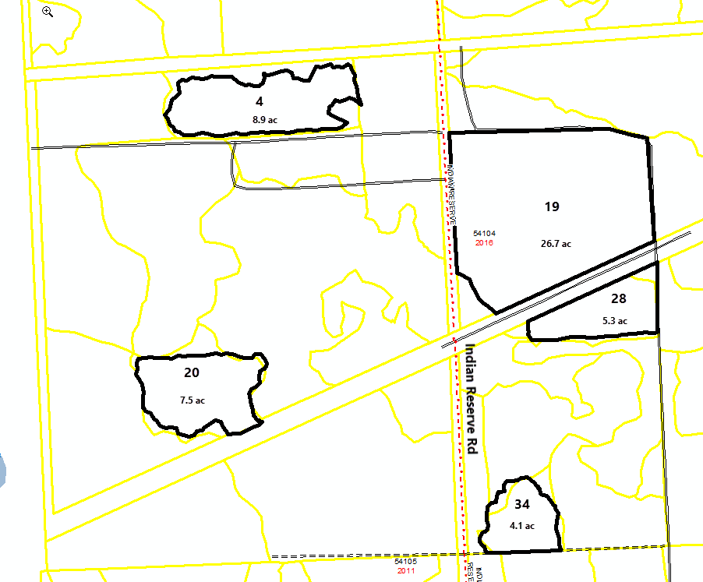

C54-1109 Maps Cont.

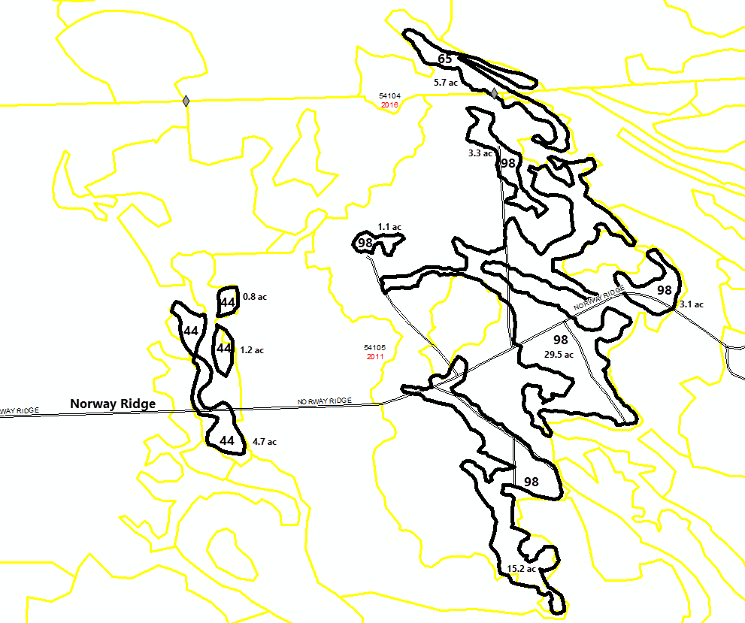

C54-1109 Maps Cont.

