FRD-Gwinn Unit-FY22-Project#2 T44N-R25W Sections 25 & 36
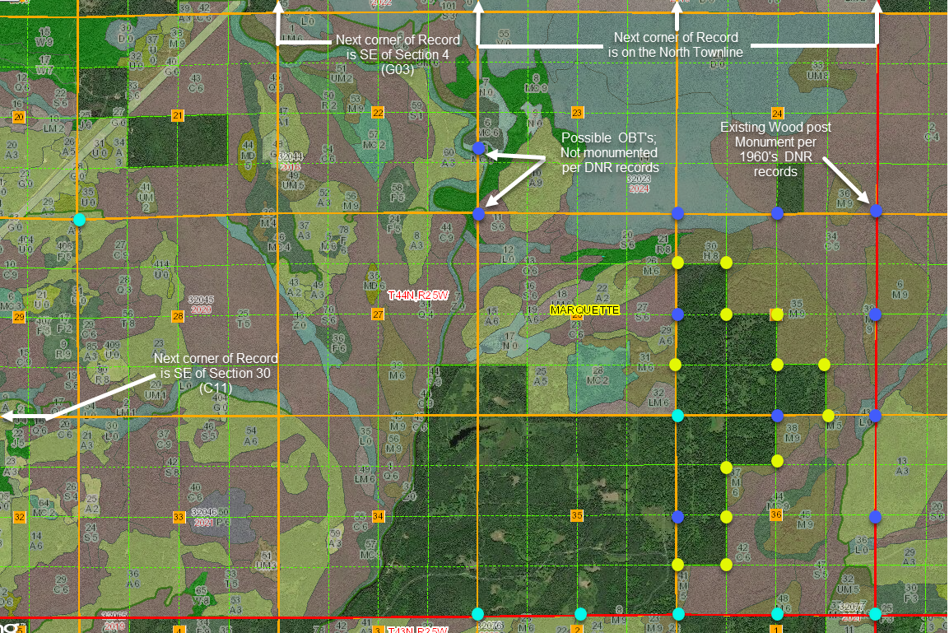

Corner Search 11 corners
- Control Measurement 7 corners
- Monumentation of Section Subdivisional Corners, if not existing 13 corners
Certificate of Survey/ Plat of Survey - Drawing 1 each Page 1 of 1

