FRD-Gwinn Unit-FY22-Project#3 T43N-R24W Sections 2-4 & 9-18
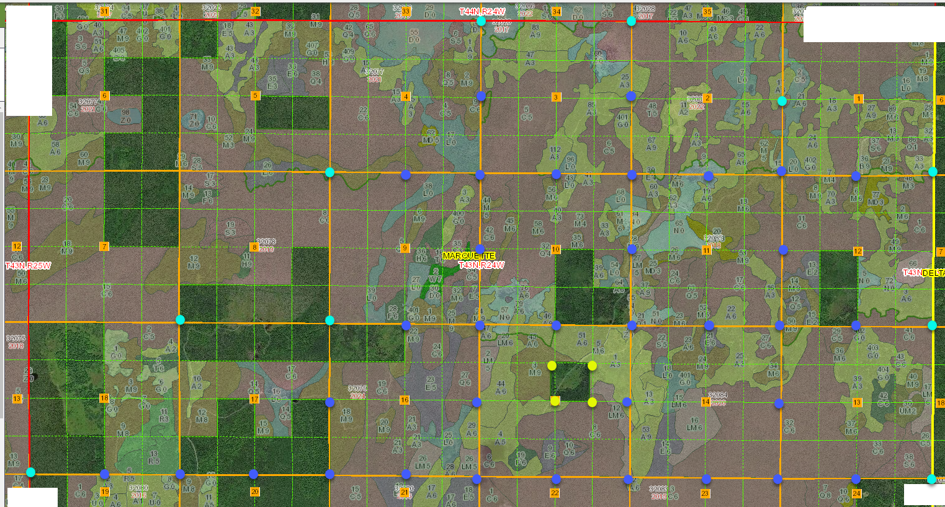

Corner Search 34 corners
- Control Measurement 10 corners
- Monumentation of Section Subdivisional Corners, if not existing 4 corners
Certificate of Survey/ Plat of Survey - Drawing 1 each Page 1 of 1

