FRD-Gwinn Unit-FY23-Project#1
T42N-R24W Sections 5, 8, 17, 20, 21, 22, 23, 33, & 34
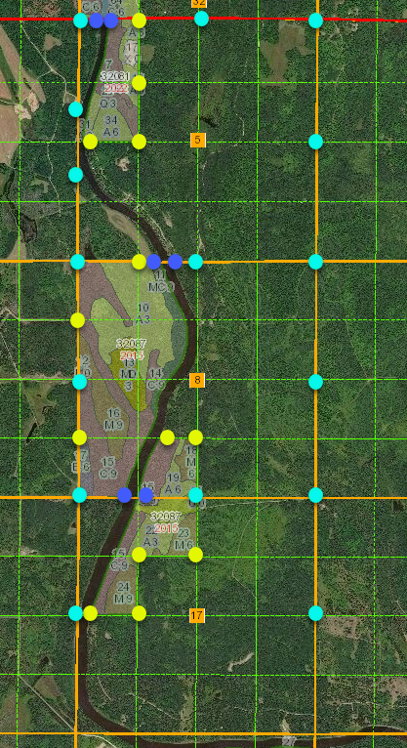
Project Name FRD-Gwinn Unit-FY23-Project#1

Page 1 of 3

FRD-Gwinn Unit-FY23-Project#1
T42N-R24W Sections 5, 8, 17, 20, 21, 22, 23, 33, & 34

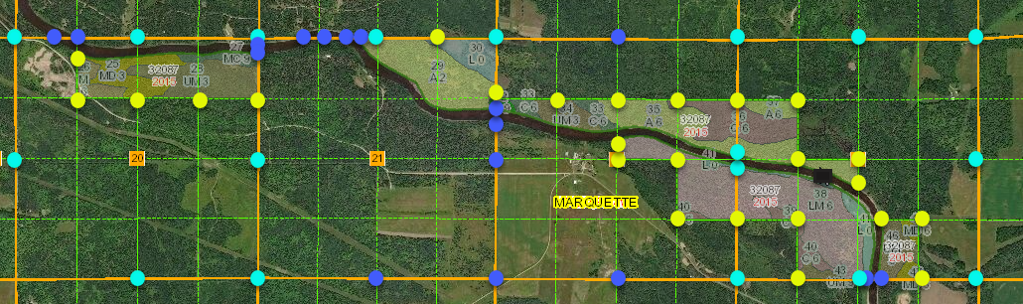

Project Name FRD-Gwinn Unit-FY23-Project#1

Page 2 of 3
FRD-Gwinn Unit-FY23-Project#1
T42N-R24W Sections 5, 8, 17, 20, 21, 22, 23, 33, & 34
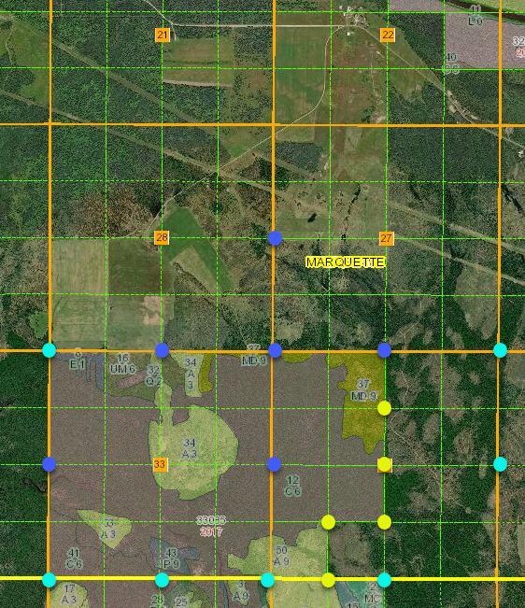
Project Name FRD-Gwinn Unit-FY23-Project#1

Corner Search 29 corners
- Control Measurement 42 corners
- Monumentation of Section Subdivisional Corners, if not existing 36 corners
- Monumentation of Minor Subdivisional Corners, if not existing 7 corners
Certificate of Survey/ Plat of Survey - Drawing 1 each

Page 3 of 3

