The Baraga Management Unit administers 138,700 acres of State owned land in the Western Upper Peninsula. Land management functions are handled out of the Baraga Operations Service Center. There are two field offices in Twin Lakes and Wakefield that are staffed mainly for fire control and snowmobile trails.

This is an area of heavy lake effect snowfall from Lake Superior. The amount of snow varies depending on the distance from the lake and the elevation. Snow depths of five feet on the ground are common in the snow belt. Snow frequently starts with scattered storms in October. The heavy snows start in December and last into early February. Snow remains on the ground into late March and sometimes into April and May.

Much of the state owned lands are in Baraga, Houghton and Ontonagon counties. There are smaller amounts in Keweenaw, and Gogebic counties. Some of the lands are larger blocks of several thousand acres, but there are also scattered partial sections of State ownership. Much of the land came into State ownership through tax reversion (non-payment of taxes). Some of the parcels tax reverted parcels were sold to the public, but the State retained mineral ownership. This was an area of copper and iron mining and many former mining sites reverted to State ownership. There are numerous mine shafts, adits, and test pits both on State surface ownership and on State mineral ownership.

Baraga Management Unit supervises a 945 mile snowmobile trail network. Much of this system is groomed and maintained under grants to local snowmobile clubs or chambers of commerce. Snowmobile use has been heavy in the past two years. A trail counter in Twin Lakes (a heavy snowfall area) recorded over 46,000 snowmobiles in the winter off 2001-2 and again in 2002-3. Use fell to 36,000 in 2003-4 (when others had snow).

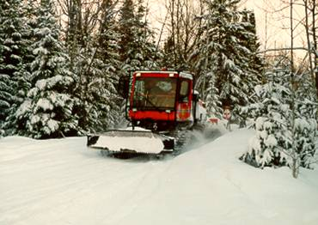
Bill Nicholls trail

The unit has five small campgrounds, Big Eric’s, Big Lake Beaufort Lake, King Lake and Emily Lake state forest campgrounds.
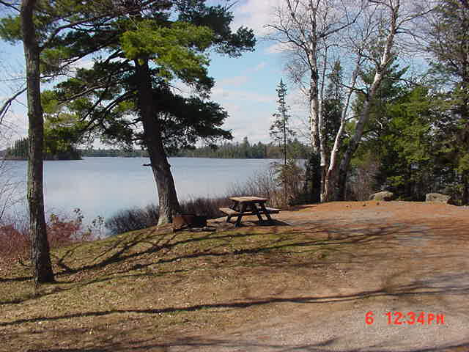
King Lake State Forest Campground

There is one ORV trail and several ORV routes. Several of the snowmobile trails and ORV routes use former railroad grades: The Bill Nicholls Rail-trail (Copper Range Railroad); The Hancock to Calumet Rail-trail (Mineral Range Railroad); Bergland to Sidnaw Rail-trail (Duluth, South Shore and Atlantic Railroad); and the Stateline Rail-trail (Chicago and Northwestern Railroad). Two grades were recently acquired: The Chassell to Houghton grade (DSS&A) and the Hancock to Ripley grade (DSS&A).

The 8,387 acre block of State owned land at the tip of the Keweenaw Peninsula is being studied by a citizen advisory committee. The citizen advisory committee was formed in January 2004 to take public input and make recommendations about future management of this area to the DNR. The committee’s recommendations are due in early October, 2004. We will then review the recommendations and make decisions on use and management of this area.
Compartment 81 is part of this block of land. The review for this compartment will be delayed until final decisions are made on management for this block.

The Keweenaw Point block has over 11 miles of Lake Superior shoreline including several unique beaches and bays: Fish Cove, Keystone Bay, and High Rock Bay. The block has some inland lakes: Schlatter Lake, Hoar Lake, Copper Lake, and Bay Lake. Rivers and streams include part of the Montreal River (including the mouth, and waterfalls), and several other small streams. The land will be managed as State Forest.
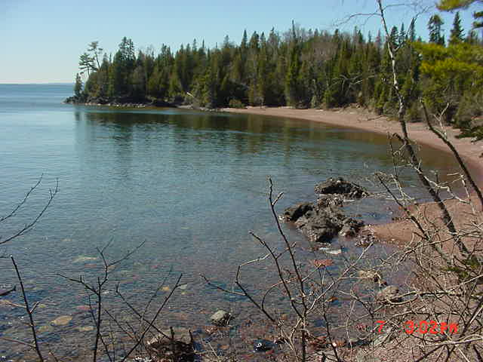
Fish Cove
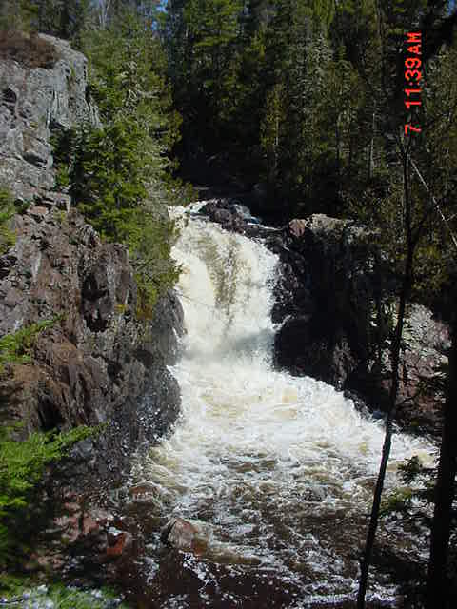
Falls on the Montreal River
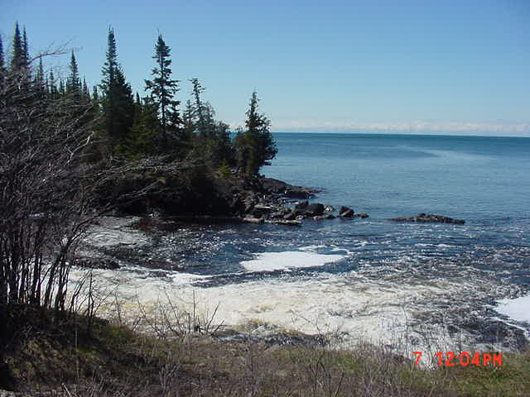
Mouth of Montreal River

Scheduled Compartments: Designated entry years for several compartments were changed this winter to provide more balance in timber management. The revised list gives about the same acreage of the northern hardwood cover type in each entry year. The amount of timber scheduled for harvest should then be more even. The compartments in Keweenaw Point will not be included in the annual review process until management decisions have been made for that block.

The predominant timber cover type in the Baraga Management Unit is northern hardwood. This type (sugar maple, red maple, yellow birch, basswood, white ash, red oak) is managed with an individual tree selection cut. The cutting cycle is 20 years between cuts. For any one compartment about half of the northern hardwood type will be cut every ten years. Areas of steep slopes and riparian zones are removed from the area designated for cut.

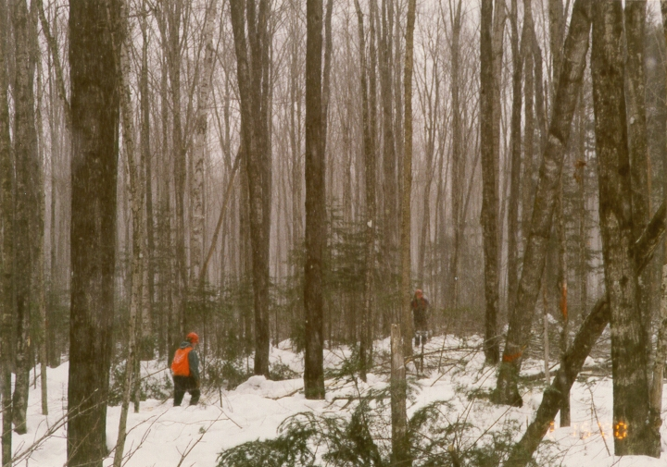
Selection harvest being cut in the winter

Minor cover types are aspen, upland spruce fir, and swamp conifers. There is a small (5,000 acre) area of jack pine in the Baraga Plains. Kirtland warblers have on occasion nested here.

Water quality is a prime concern throughout the management unit. There are numerous streams and drainages as well as larger streams and rivers. Branches of the Otter River, Sturgeon River, Huron River, Misery River and the Ontonagon River cross state land. Proper stream crossings, buffer strips along rivers and streams, and best management practices for water protection are very important in this management unit.

The areas of deep snow limit the deer herd. There are moose within the unit, particularly in eastern Baraga County. Wolves are found throughout the unit. There is a healthy beaver population in most streams.

