The Baraga Forest Management Unit administers 142,900 acres of State owned land in the Western Upper Peninsula. Land management functions are handled out of the Baraga Operations Service Center. There are two field offices in Twin Lakes and Wakefield that are staffed mainly for fire control and snowmobile trails.

This is an area of heavy lake effect snowfall from Lake Superior. The amount of snow varies depending on the distance from the lake and the elevation. Snow depths of five feet on the ground are common in the higher elevations in the snow belt. Snow frequently starts with scattered storms in October. The heavy snows start in December and last into early February. Snow remains on the ground into late March and sometimes into April and May.

Much of the state owned land is in Baraga, Houghton and Ontonagon counties. There are smaller amounts in Keweenaw and Gogebic counties. Some of the lands are larger blocks of several thousand acres, but there are also scattered partial sections of State ownership. Much of the land came into State ownership through tax reversion (non-payment of taxes). This was an area of copper and iron mining. Many former mining sites reverted to State ownership. Some of the tax reverted parcels were sold to the public, with the State retaining mineral ownership. There are numerous mine shafts, adits, and test pits both on State land and on State minerals.

RECREATION

The management unit supervises a 945 mile snowmobile trail network. Much of this system is groomed and maintained under eight grants to local snowmobile clubs or chambers of commerce as well as DNR grooming at Twin Lakes. Snowmobile use has been heavy in the past three years. A trail counter in Twin Lakes (a heavy snowfall area) recorded over 53,000 snowmobiles in the winter of 2004 -5.
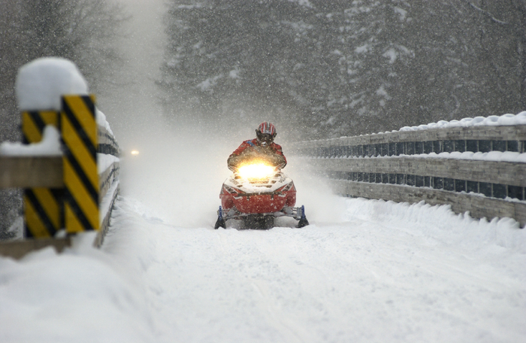
Snowmobile crossing one of the Firesteel trestles, Bill Nicholls trail, (Kenyon photo)

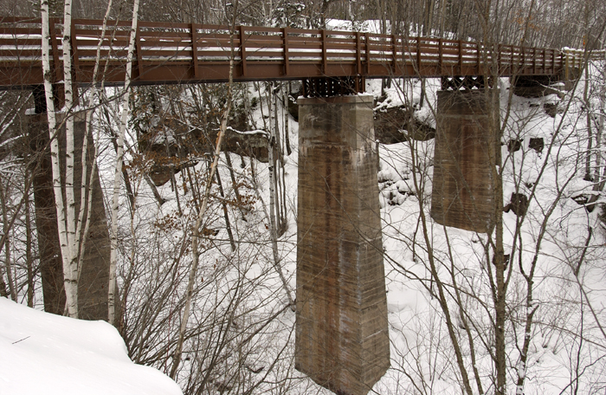
Bridge over Hungarian Creek (new in 2004)

The unit has five small campgrounds. Emily Lake State Forest Campground is within one of the compartments being reviewed this year (Compartment 53).
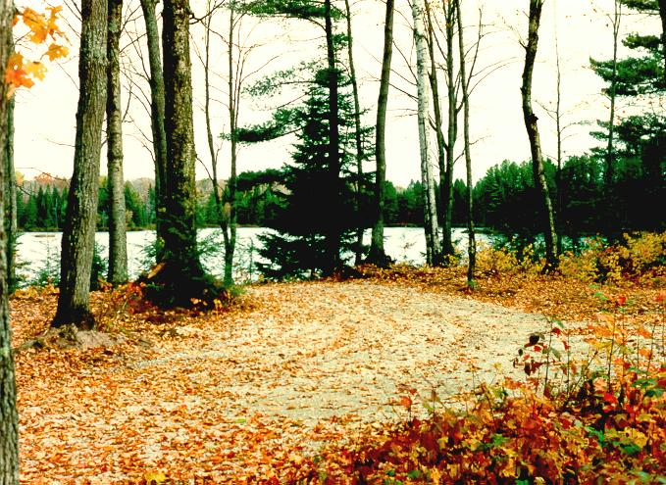

Emily Lake State Forest Campground

There is one ORV trail on the Baraga plains, and several ORV routes on railroad grades. ORV use is increasing on the railroad grades. ORV trail counts at Twin Lakes are about 4,000 per year.

The management unit has several Rail-Trails. The Bill Nicholls Rail-trail (Copper Range Railroad); The Hancock to Calumet Rail-trail (Mineral Range Railroad); Bergland to Sidnaw Rail-trail (Duluth, South Shore and Atlantic Railroad); and the Stateline Rail-trail (Chicago and Northwestern Railroad). There are two new acquisitions, the Chassell to Houghton grade, and a grade from the Portage Lift Bridge to Ripley.
CHASSELL TO HOUGHTON RAIL-TRAIL
The DNR acquired 8.64 miles of the Chassell to Houghton railroad grade in 2003. The other owners are Michigan Technological University and Michigan Department of Transportation. A citizen advisory committee was formed. They walked the trail, heard comments during public meetings, discussed options and made recommendations for use of this trail. These recommendations are being reviewed by DNR staff. The recommendations and the DNR response to those recommendations will be presented to the public (probably in early 2006).

LAND MANAGEMENT

The 8,731 acre block of land at the tip of the Keweenaw Peninsula – the Keweenaw Point Block is now State Forest Land. A citizen advisory committee met during 2004 and considered possible management and use options for this block. The series of meetings were well attended and included public comment periods. The committee made a series of recommendations for management of this block. These recommendations are being reviewed by DNR and a management plan incorporating the recommendations is being made. The three compartments will be reviewed this year during the compartment review.

The block has over 11 miles of Lake Superior shoreline at the tip, and includes the mouth of the Montreal River, waterfalls, inland lakes and several unique beaches and bays on Lake Superior (Fish Cove, Keystone Bay, and High Rock Bay).
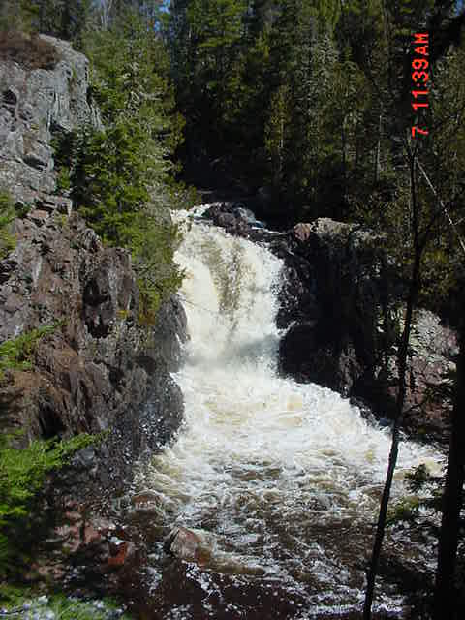
Falls on the Montreal River

The recommendations will be implemented over several years (dependent on funds available).
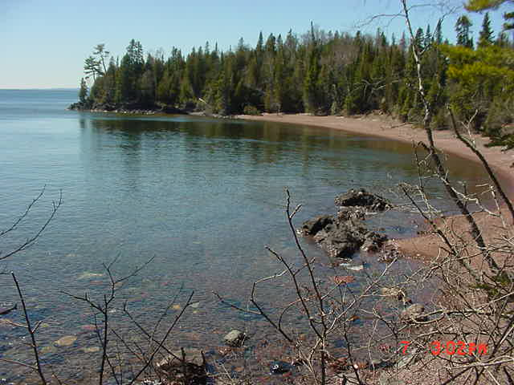

Fish Cove

TIMBER MANAGEMENT

Management is done on a compartment (land unit) basis. The entry year schedule for compartments was realigned in 2003 to balance the acreage of northern hardwood. The predominant timber cover type in the management unit is northern hardwood. This type (Sugar maple, red maple, Yellow birch, basswood, white ash, red oak) is managed with an individual tree selection cut. The cutting cycle is 20 years between cuts. For any one compartment about half of the northern hardwood type will be cut every ten years. Areas of steep slopes and riparian zones are removed from the area designated for cut.

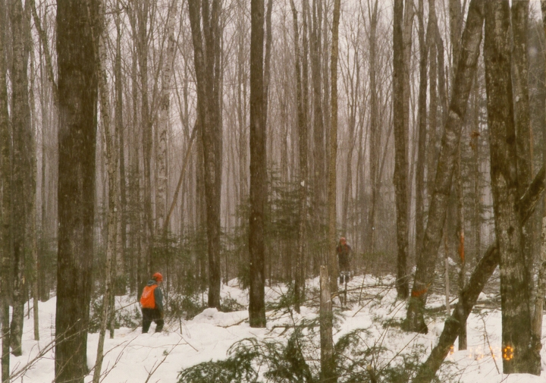
Selection harvest being cut in the winter

Minor types are aspen, upland spruce fir, and swamp conifers. There is a small (5,000 acre) area of jack pine in the Baraga Plains. Jack pine clear cuts and subsequent regeneration have resulted in large areas of young jack pine. These are attractive to Kirtland warblers, and they have frequently nested here.

Water quality is a prime concern. There are numerous streams and drainages as well as larger streams and rivers. Branches of the Otter River, Sturgeon River, Huron River, Misery River and the Ontonagon River cross state land. Proper stream crossings, buffer strips along rivers and streams, and best management practices for water protection are very important in this management unit.

The areas of deep snow limit the deer herd. There are moose within the unit, particularly in eastern Baraga County. Wolves are found throughout the unit. There is a healthy beaver population in most streams.

<a name="top"></a>

<p>The Baraga Unit manages state forest lands in Baraga, Gogebic, Houghton, Keweenaw, and Ontonagon Counties.

<center><img src="/images/BaragaMgtUnit_137757_7.gif" alt ="Baraga Management Unit"></center>

<p>The Baraga Unit's compartment review for YOE 2007 will be held on December 7, 2005, with an open house on November 10, 2005.

<p>You can reach Unit Manager Martin Nelson at 906-353-6651, or send an email to him at <a href="mailto:DNR-Baraga-FMU@michigan.gov">DNR-Baraga-FMU@michigan.gov</a>.

<p>The Baraga Forest Management Unit administers 142,900 acres of State owned land in the Western Upper Peninsula. Land management functions are handled out of the Baraga Operations Service Center. There are two field offices in Twin Lakes and Wakefield that are staffed mainly for fire control and snowmobile trails.

<p>This is an area of heavy lake effect snowfall from Lake Superior. The amount of snow varies depending on the distance from the lake and the elevation. Snow depths of five feet on the ground are common in the higher elevations in the snow belt. Snow frequently starts with scattered storms in October. The heavy snows start in December and last into early February. Snow remains on the ground into late March and sometimes into April and May.

<p>Much of the state owned land is in Baraga, Houghton and Ontonagon counties. There are smaller amounts in Keweenaw and Gogebic counties. Some of the lands are larger blocks of several thousand acres, but there are also scattered partial sections of State ownership. Much of the land came into State ownership through tax reversion (non-payment of taxes). This was an area of copper and iron mining. Many former mining sites reverted to State ownership. Some of the tax reverted parcels were sold to the public, with the State retaining mineral ownership. There are numerous mine shafts, adits, and test pits both on State land and on State minerals.

<p><center><b>RECREATION</b></center>

<p><img src=" /documents/Snowmobile_137746_7.jpg " alt = "Snowmobile crossing one of the Firesteel trestles, Bill Nicholls trail" align ="left">The management unit supervises a 945 mile snowmobile trail network. Much of this system is groomed and maintained under eight grants to local snowmobile clubs or chambers of commerce as well as DNR grooming at Twin Lakes. Snowmobile use has been heavy in the past three years. A trail counter in Twin Lakes (a heavy snowfall area) recorded over 53,000 snowmobiles in the winter of 2004 -5.

<p><center><img src="/images/emily_137744_7.jpg"alt=" Emily State Forest Campground"></center>The unit has five small campgrounds, <a href="http://www.michigandnr.com/parksandtrails/ParksandTrailsInfo.aspx?id=640">Big Eric’s</a>, <a href="http://www.michigandnr.com/parksandtrails/ParksandTrailsInfo.aspx?id=641">Big Lake</a>, <a href="http://www.michigandnr.com/parksandtrails/ParksandTrailsInfo.aspx?id=643">Beaufort Lake</a>, <a href="http://www.michigandnr.com/parksandtrails/ParksandTrailsInfo.aspx?id=642">King Lake</a> and <a href="http://www.michigandnr.com/parksandtrails/ParksandTrailsInfo.aspx?id=639">Emily Lake</a> State Forest Campgrounds which is within one of the compartments being reviewed this year (Compartment 53).

<p><center><p><img src="/images/hungarian_cr_bridge_137743_7.jpg" alt ="Hungarian Bridge"><br>Bridge over Hungarian Creek (new in 2005)</center><p>

<p>There is one ORV trail on the Baraga plains, and several ORV routes on railroad grades. ORV use is increasing on the railroad grades. ORV trail counts at Twin Lakes are about 4,000 per year. For <a href="http://www.michigan.gov/dnr/0,1607,7-153-10365_15070-38330--,00.html">maps of the ORV trails click here</a>.

<p>The management unit has several Rail-Trails. The Bill Nicholls Rail-trail (Copper Range Railroad); The Hancock to Calumet Rail-trail (Mineral Range Railroad); Bergland to Sidnaw Rail-trail (Duluth, South Shore and Atlantic Railroad); and the Stateline Rail-trail (Chicago and Northwestern Railroad). There are two new acquisitions, the Chassell to Houghton grade, and a grade from the Portage Lift Bridge to Ripley.

<p><b>CHASSELL TO HOUGHTON RAIL-TRAIL</b>
The DNR acquired 8.64 miles of the Chassell to Houghton railroad grade in 2003. The other owners are Michigan Technological University and Michigan Department of Transportation. A citizen advisory committee was formed. They walked the trail, heard comments during public meetings, discussed options and made recommendations for use of this trail. These recommendations are being reviewed by DNR staff. The recommendations and the DNR response to those recommendations will be presented to the public (probably in early 2006).

<p><center><b>LAND MANAGEMENT</b></center>

<p>The 8,731 acre block of land at the tip of the Keweenaw Peninsula – the Keweenaw Point Block is now State Forest Land. A citizen advisory committee met during 2004 and considered possible management and use options for this block. The series of meetings were well attended and included public comment periods. The committee made a series of recommendations for management of this block. These recommendations are being reviewed by DNR and a management plan incorporating the recommendations is being made. The three compartments will be reviewed this year during the compartment review. The recommendations will be implemented over several years (dependent on funds available).

<p><center><img src="/images/Falls_137751_7.jpg" alt ="Falls on the Montreal River"></center>

<p>The block has over 11 miles of Lake Superior shoreline at the tip, and includes the mouth of the Montreal River, waterfalls, inland lakes and several unique beaches and bays on Lake Superior (Fish Cove, Keystone Bay, and High Rock Bay).

<p><center><img src="/images/WatersEdge_137753_7.jpg" alt ="Fish Cove"></center>

<p><b>TIMBER MANAGEMENT</b>

<p>Management is done on a compartment (land unit) basis. The entry year schedule for compartments was realigned in 2003 to balance the acreage of northern hardwood. The predominant timber cover type in the management unit is northern hardwood. This type (Sugar maple, red maple, Yellow birch, basswood, white ash, red oak) is managed with an individual tree selection cut. The cutting cycle is 20 years between cuts. For any one compartment about half of the northern hardwood type will be cut every ten years. Areas of steep slopes and riparian zones are removed from the area designated for cut.

<p><center><img src="/images/MARKING-2_137756_7.jpg" alt ="Selection harvest being cut in the winter"><br>Selection harvest being cut in the winter</center>

<p>Minor types are aspen, upland spruce fir, and swamp conifers. There is a small (5,000 acre) area of jack pine in the Baraga Plains. Jack pine clear cuts and subsequent regeneration have resulted in large areas of young jack pine. These are attractive to Kirtland warblers, and they have frequently nested here.

<p>Water quality is a prime concern. There are numerous streams and drainages as well as larger streams and rivers. Branches of the Otter River, Sturgeon River, Huron River, Misery River and the Ontonagon River cross state land. Proper stream crossings, buffer strips along rivers and streams, and best management practices for water protection are very important in this management unit.

<p>The areas of deep snow limit the deer herd. There are moose within the unit, particularly in eastern Baraga County. Wolves are found throughout the unit. There is a healthy beaver population in most streams.

<p><a href="#top">Back to Top of Page</a></p>

