The Escanaba Unit manages land in Menominee Co. and the West part of Delta Co.

The Escanaba Unit’s compartment review for the 2007 Year of Entry will be held on December 19, 2005 with an open house on December 5, 2005.

For more information you can reach the Unit Manager, Eric W. Thompson at 906-786-2354 Ext 142, or send him an e-mail to DNR-Escanaba-FMU@michigan.gov

The Escanaba Management Unit is located in South Central Upper Peninsula. The Unit manages approximately 142,000 acres of state owned land in Menominee and Delta Counties. The Unit office is located in Escanaba with a satellite office located in Stephenson.

Recreation

The Escanaba Management Unit maintains two pathways for hiking, mountain biking, and cross-country skiing as well as a nature trail. The Days River Pathway located 3 miles northwest of Gladstone, Cedar River Pathway located at the North Cedar River State Forest Campground, and the Days River Nature Trail located 2 miles north of Kipling.
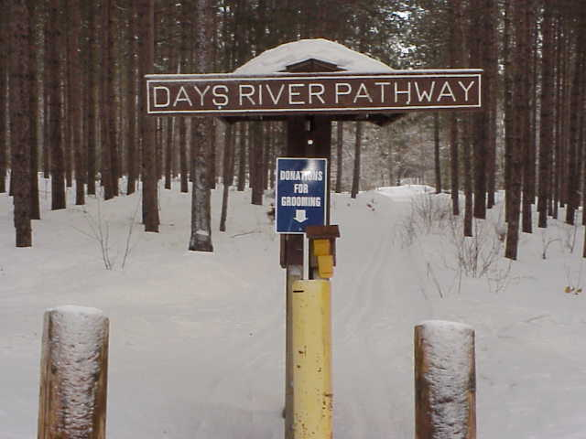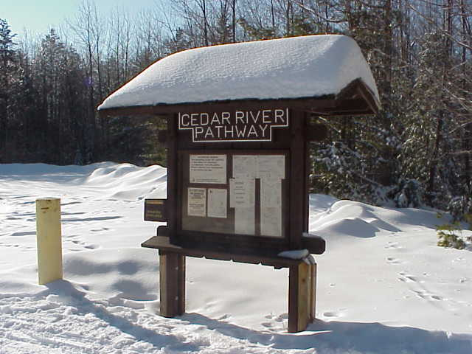

The Unit has one campground, North Cedar River State Forest Campground, which is located 6 miles northwest of the Village of Cedar River on County Road 551. The campground, situated on the Cedar River, has 18 sites.

The Escanaba Unit is responsible for 102 miles of groomed snowmobile trails and 78 miles of ORV/ATV trails
.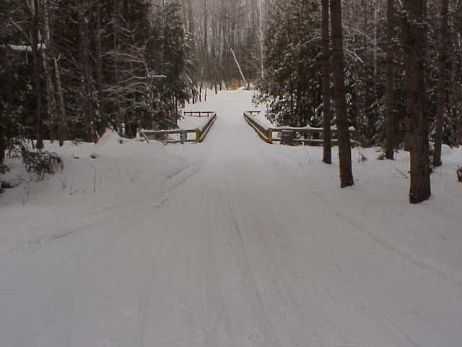

Fire

The Escanaba Unit provides wildfire protection for Menominee County and Western Delta County. During the snow free periods of the year burning permits are required for open burning. Weather forecast and predicted fire danger are monitored daily during the snow free time of the year. Burning permit time and length depend on forecasted fire danger each day. To obtain a permit to burn for Delta Co. call toll free 1-888-700-9830 and Menominee Co. 1-888-700-9716.

Forest

The forest cover types of the Escanaba Unit are very diverse. The major forest cover types are Aspen, Cedar, and Northern Hardwoods. Other cover types of significance are Mixed Swamp Conifer and Swamp Hardwoods. Minor cover types include Paper Birch, Upland Spruce/Fir, Hemlock, Oak, Balsam Poplar, Red Pine, Black Spruce, Tamarack, and White Pine.

Forest Roads

The Escanaba Unit maintains over 100 miles of forest roads to access the State Forest.
