The Gaylord Unit manages over 315,000 acres of state forest lands in Cheboygan (SW of Black River), Antrim, Charlevoix, Emmet, and Otsego Counties.

The Gaylord Unit's next open houses will be June 3, 2003 from 3:00 p.m. to 7:00 p.m. for the north portion of the unit and June 4, 2003 from 3:00 p.m. to 7:00 p.m. for the south portion. The next compartment review will be June 10, 2003 for the north portion and June 11, 2003 for the south. For more information, call Unit Manager Joyce Angel-Ling at 989-732-3541 ext.5440.

The Indian River Office (Gaylord North) is located in Cheboygan County and covers the western two-thirds of Cheboygan County, and all of Emmet County. Pellston Field Office in Emmet County is a one-person field station. Three campgrounds are managed out of the Indian River Office, along with ORV trails, snowmobile trails & rail trails, and the National North Country Hiking Trail.

The Gaylord Field office (Gaylord South) is located in Otsego County and covers the western two-thirds of Otsego County, all of Antrim and Charlevoix County. Bellaire Field Office in Antrim County is also a one-person field station. Natural gas development has been part of the land use in this area. Five campgrounds are managed out of the Gaylord and Bellaire offices, along with snowmobile trails and hiking and skiing trails.

Our unit has many miles of Great Lakes shoreline on both Lake Michigan and Lake Huron. This includes a number of islands, featuring the Beaver Island Archipelago and Bois Blanc Island located in the Straits of Mackinac. 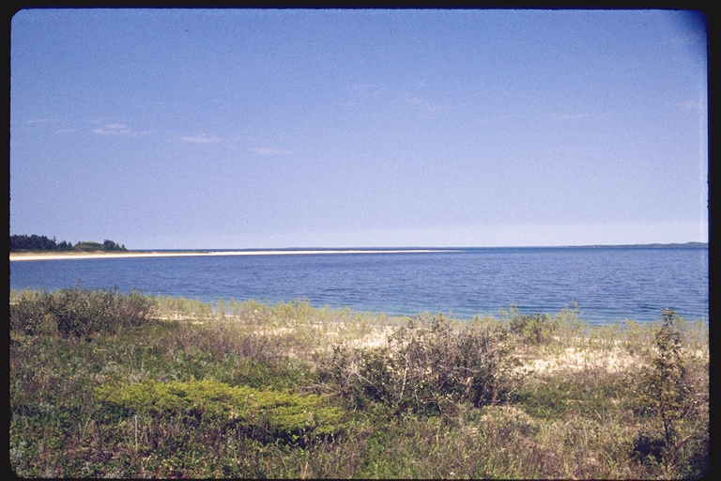

Land type varies from jack pine plains to rolling northern hardwood forests intersected by trout streams and dotted with numerous lakes. In fact, five world class trout streams have their origin in Otsego County: the Ausable, Manistee, Sturgeon, Pigeon, and East Branch of the Black.

The Jordan Valley Management Area located in northeast Antrim County is part of a Special Management Area.
The Jordan River is the first designated natural and scenic river in the state, and it offers panoramic views at both Deadman’s Hill and Landslide Overlook.

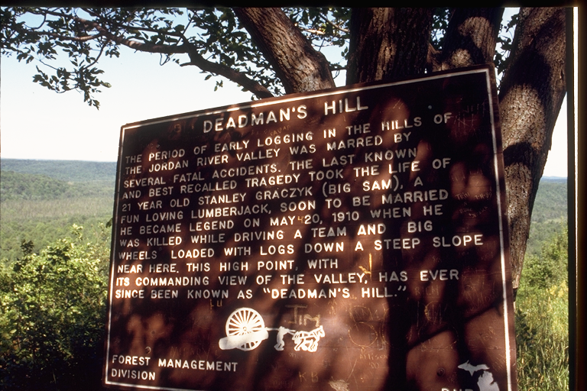
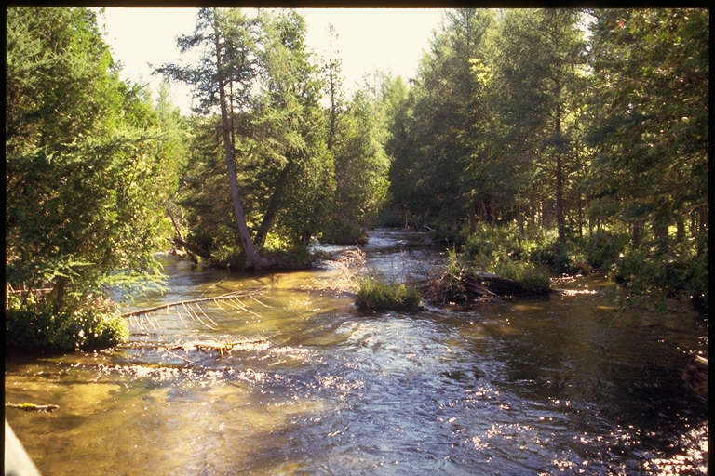
There are two other special management areas in Otsego County - the Crapo Lake Kirtland’s Warbler Management Area, comprised of 3,200 acres of jack pine plains, and part of the Camp Grayling National Guard Training Area with 4,500 acres in the Gaylord Unit.

Within our unit, we have a number of large inland lakes, which not only are homes to many species of waterfowl, fish, birds, and plants, but a great resource for many types of recreation. The two largest lakes on either side of I-75 are Mullet Lake and Burt Lake in Cheboygan County. These two beautiful lakes, along with the Indian River that connects them, are part of the Inland Waterway that stretches from Lake Huron nearly to Lake Michigan. 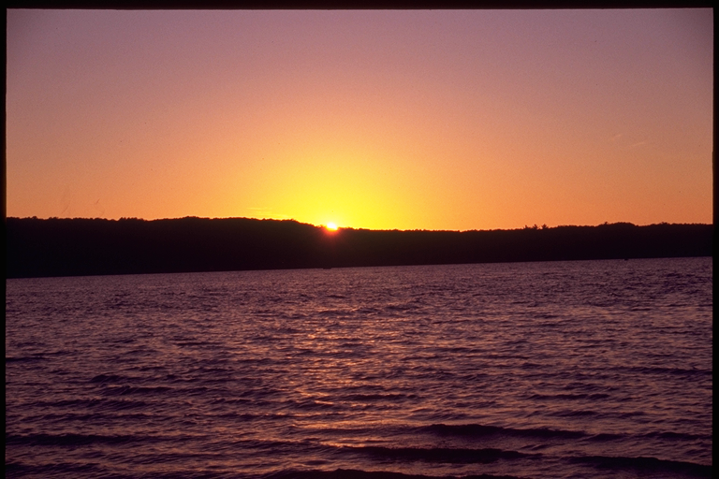

The Gaylord Management Unit offers a diverse collection of Natural Resources providing enjoyment for a variety of uses for the public.

