Gladwin Forest Management Area /Saginaw Bay Management Unit
Natural Resources County Profiles

Arenac County

1, 617 Acres – Wildlife Area ( Wigwam Bay )
47 Miles – Great Lakes Shoreline
156 Miles – Major River / Streams ( Rifle, Augres, and Pine )
32 Miles. Scenic Natural River
30,191 Acres - Public Recreation Lands

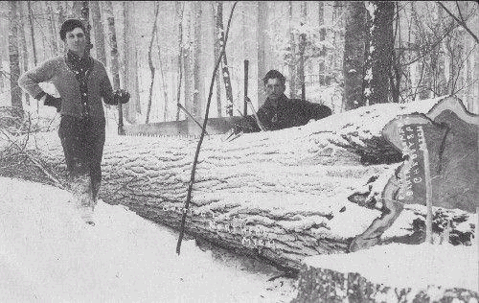
Arenac County – Sterling 1909
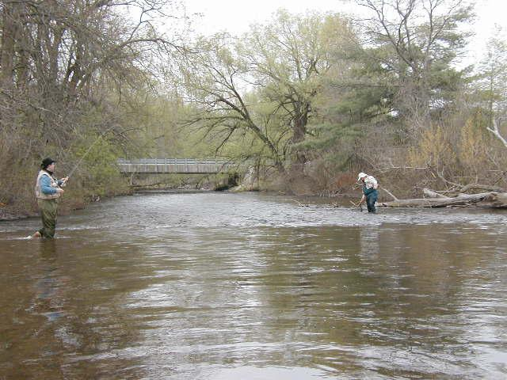
Rifle River – Steelhead Fishing

Bay County

50 Miles - Major River / Streams (Kawkawlin, Saginaw )
36 Miles – Great Lakes Shoreline
4,133 Acres – State Game / Wildlife Areas ( Tobico Marsh Nayanquing Point, and Crow Island )

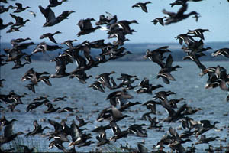
Tobico Marsh – Bay City Recreational Area
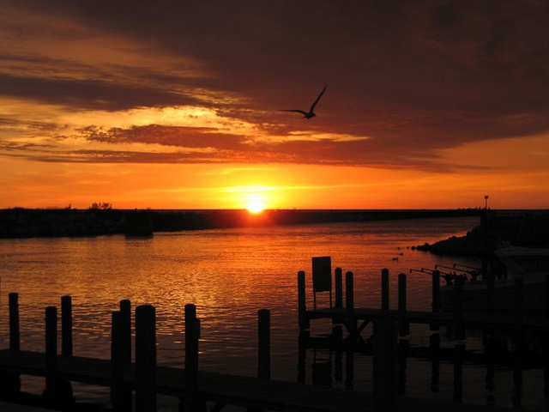
Bay City – Saginaw Bay

Iosco County

11, 191 Acres - Huron National Forest Lands
24, 907 Acres – State Forest Lands
259 Miles – Major River / Streams ( Au Sable, Au Gres, and Tawas )
9 Miles Federal Wild/Scenic/Natural River

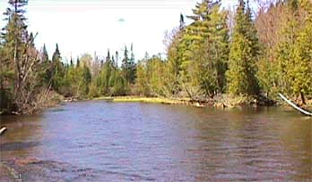
Au Sable River
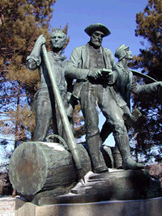
Lumberman’s Monument

Gladwin County

220,000 Acres – State Forest Lands
11,000 Lame Duck Foot Access Area
Gladwin Bird Dog Field Trial Area
House / Trout Lake State Forest Campgrounds
473 Miles - Major River / Streams ( Cedar, Tittabawassee, and Tobacco )

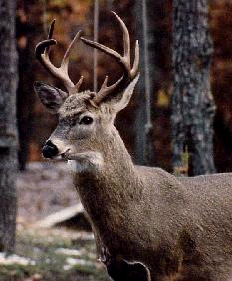
Gladwin County White – tailed Deer
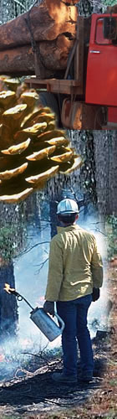
MDNR Fire / Forestry Programs

Midland County

41, 867 Acres – State Forest Lands
309 Miles – Major River / Streams (Chippewa, Pine, and Tittabawassee )

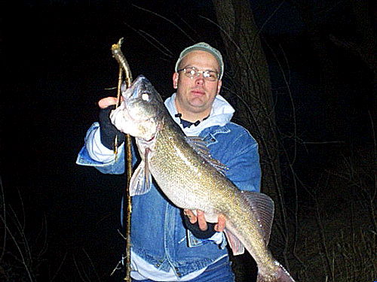
Tittabawassee River Spring Walleye
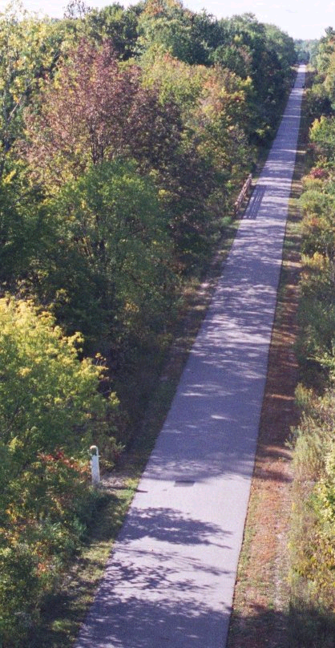
28 mile Pere Marquette Rail Trail traversing Midland and Isabella Counties

