The Grayling Forest Management Unit

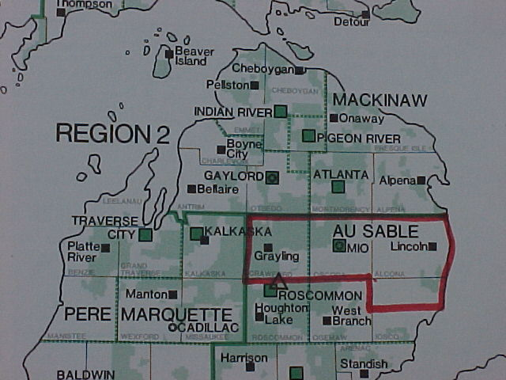

The Grayling Forest Management Unit …
encompasses approximately 279,000 acres of State-owned land within a four county region: Crawford, Oscoda, Alcona, and the north half of Iosco Counties. Unit staff are tasked with management activities on state forest lands, wildfire protection on all ownerships across the unit, and administration of an extensive motorized recreational trail system in the four counties. Central headquarters for the unit is located at the Grayling Field Office, with satellite offices located in the communities of Mio and Lincoln.

Overview:
The Area is unique in many respects. It
contains the entire watercourse of the AuSable River, a designated natural river and a nationally recognized trout stream. It also contains the headwaters area of the Upper Manistee River, another blue ribbon trout stream and designated Natural River. The Unit contains a wide variety of forest types, ranging from northern hardwoods to oak, aspen, and jack pine plains. Vast portions of the unit are covered by nearly continuous jack pine forests, making the area especially vulnerable to wildfires. 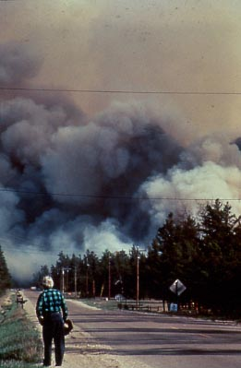
Crawford County was home to the famous Stephan Bridge fire in 1990. This fire burned 5,916 acres in less than five hours, wiping out homes and causing $5.5 million in damage. This combination of jack pine forests and

repeated fires helped establish the area as prime nesting habitat for the endangered
Kirtland’s Warbler. 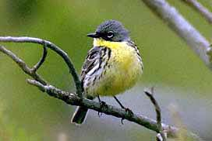
As a result, over 54,000 acres of land have been set aside in the Unit to be managed specifically for this tiny bird’s nesting habitat.
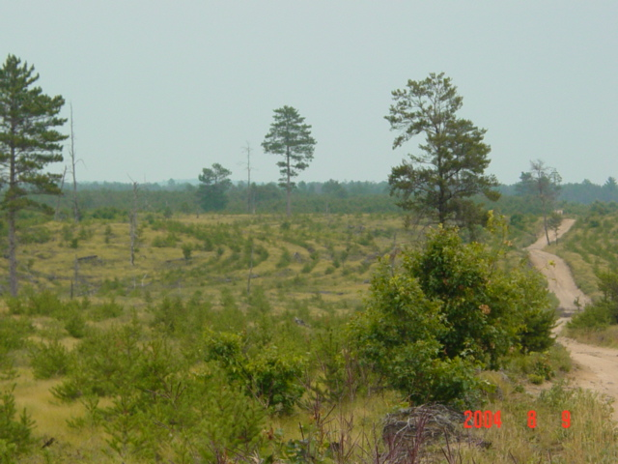
A recently harvested and replanted Kirtland’s Warbler Management Unit

The U.S. Fish and Wildlife Service sponsors guided warbler viewing tours during May and June. For more information, visit http://midwest.fws.gov/EastLansing/tour.html

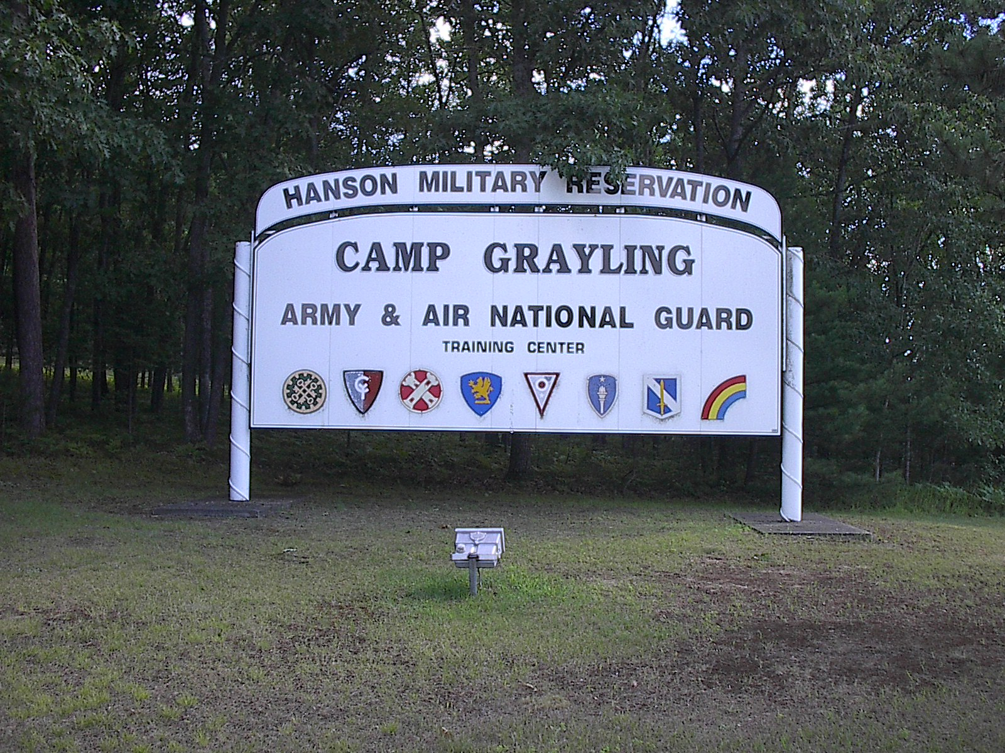
One feature that distinguishes the Unit is that it is home to Camp Grayling, training grounds for the National Guard. Some type of Military use agreement affects 47% of the total acres in the Unit. Crawford County contains approximately 132,000 acres of Camp Grayling National Guard Camp on
which the DNR manages the surface resources. Within those 132,000 acres, the Military has leased approximately 53,000 acres in perpetuity from the State of Michigan (i.e.; long-term lease lands) for training purposes. Approximately 20,000 more acres in Crawford County are under a short-term lease agreement, which is reviewed and renewed every ten years. The remaining lands are either part of the initial Hanson gift that established the camp, were purchased with Military Board funding, or ownership was transferred from the state of Michigan to Department of Military Affairs via a deed transfer. While the Military does not have absolute control over this entire acreage (specifically short-term lease lands), they do exert a significant influence on the management practices. For a map showing military lands, visit http://www.dnr.state.mi.us/spatialdatalibrary/PDF_Maps/Management_Areas/Military_Land.pdf

Timber Management:
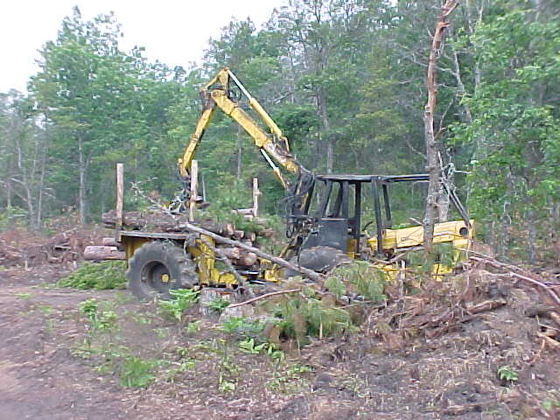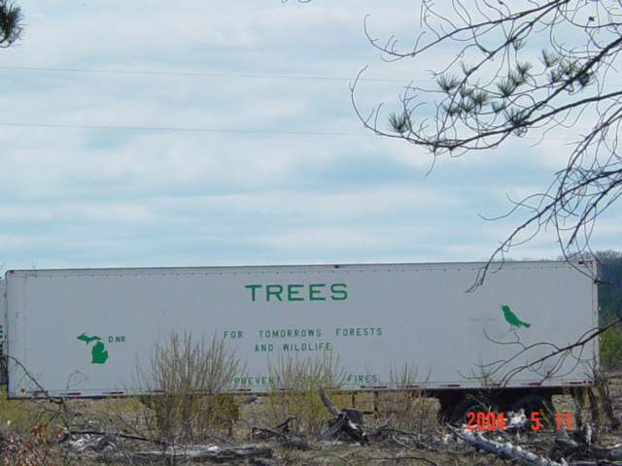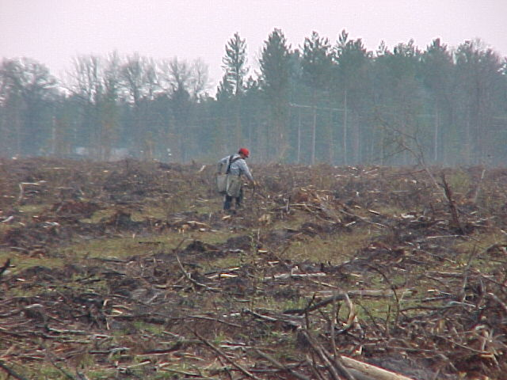
A final harvest and tree planting operation in Crawford County.
The Grayling FMU has a very active forest management program largely due to the fact it contains large acreages of forested lands that are centrally located near several wood mills. Harvests ranging from clearcuts of jack pine and aspen forests to thinning of oak and hardwood stands occur year around to regenerate stagnating forests and wildlife habitat while simultaneously providing wood products and commodities for public use. Averages of 4000-5000 acres are treated annually via some type of harvest and regeneration activity.

Recreational Opportunities & Management:

The Grayling FMU is heavily involved with recreational management: The unit contains 19 State Forest Campgrounds, including 3 horse trail camps and several canoe campgrounds. The Shore-to-Shore Riding and Hiking Trail traverses the unit, connecting three trail campgrounds.
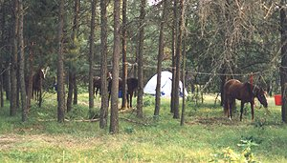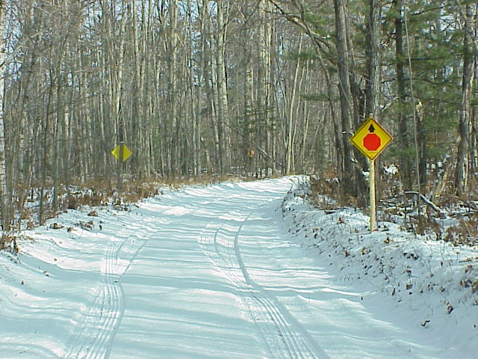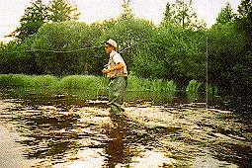
Snowmobiling is of great economic importance to the area, having approximately 165 miles of groomed snowmobile trails. The Unit also contains approximately 321 miles of ORV trail, 22 miles of ORV routes, and 89 miles of MCCCT trail. It contains several hiking and cross-country ski trails, including the Mason Tract Pathway and a portion of the Midland to Mackinaw Hiking Trail. The Grayling Area offers hundreds of acres of diverse wildlife habitat, creating wonderful hunting and trapping opportunities for deer, grouse, turkey, bear, and small game. The unit also contains many informal access points along the two river corridors, providing multiple access opportunities for fishing, canoeing, swimming, and other river recreation. Fishing opportunities abound with multiple quality trout streams, inland lakes, and access to Lake Huron.

Unique and Special Management Areas on the Grayling FMU:
The Grayling FMU is home to the following unique management areas:

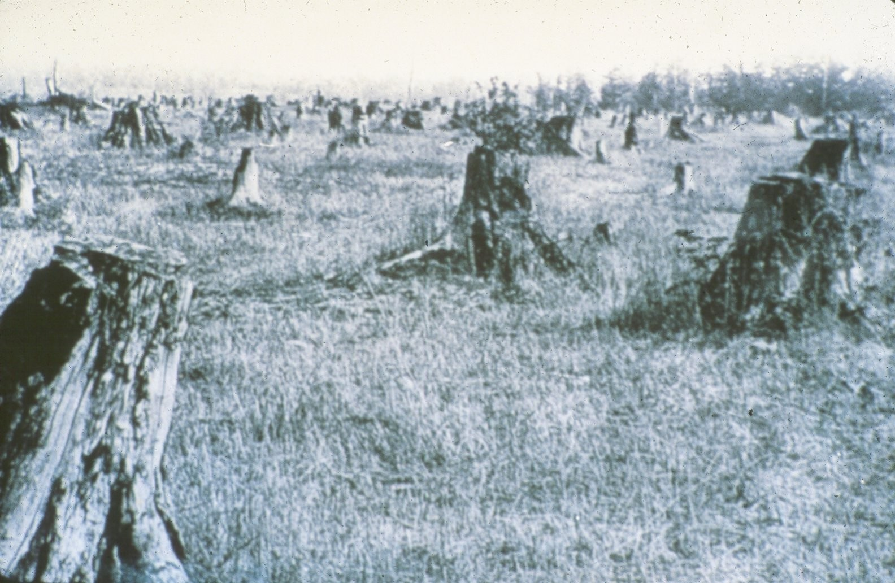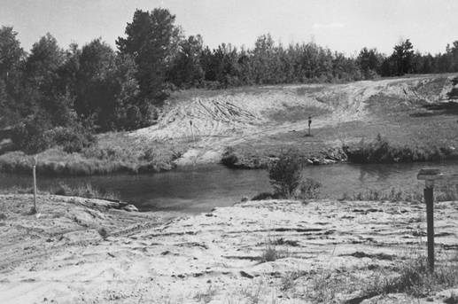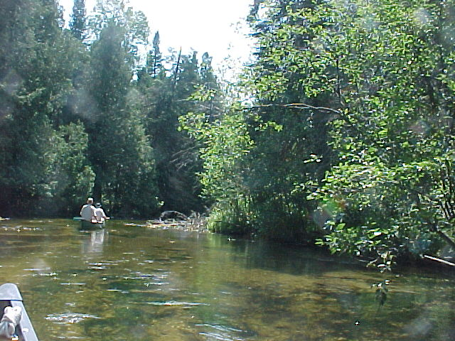
Historic Pine Stump Preserve DeWard Area in 1980 DeWard area in 2003
DeWard Tract: The DeWard tract is a 4,720 acre special management area located in Antrim, Crawford, Kalkaska, and Otsego Counties. Plagued by damage from motorized vehicles, this special area was designated in 1980 to protect the Upper Manistee River Corridor. Today lush vegetation and wildlife in the area attribute to the success of the protection measures put in place. A majority of the Tract (2,470 acres) is managed by the Grayling FMU. Access is restricted in the area to protect the Upper Manistee River corridor and to provide a “quality” fishing experience. Camping is limited to within 50 feet of roads posted as open to protect this sensitive river corridor. The area encompasses the site of the historic lumbering village of DeWard. It also contains the only Pine Stump Preserve in Michigan. In 1958 an area of 42.5 acres was dedicated as a Pine Stump Preserve in efforts to protect evidence of the early logging efforts in Michigan. Several foot access sites are maintained throughout the DeWard Tract providing user access to the river.

Hanson Game Refuge:
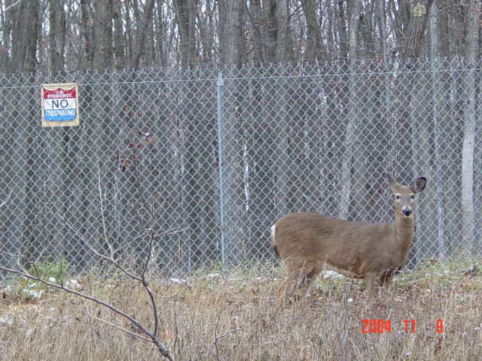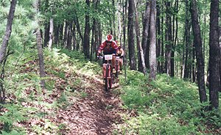
The Hanson Refuge is a tract of approximately 20,000 acres located in southwest Crawford County. Deed restrictions have designated these lands as a “game preserve”, deeming them as closed to hunting and trapping. The Hanson Refuge is also home to Hanson Hills Recreational Area. Managed by the Crawford County Recreational Authority, Hanson Hills provides an extensive cross-country ski and mountain bike trail system, as well as downhill skiing and other recreational trail programs. The DNR manages the surface resources of Hanson lands; hence management efforts have to be closely coordinated to minimize impact on these areas’ recreational trails and activities. For a map of the Hanson Refuge, visit xxx.xx.

Beal Plantation:

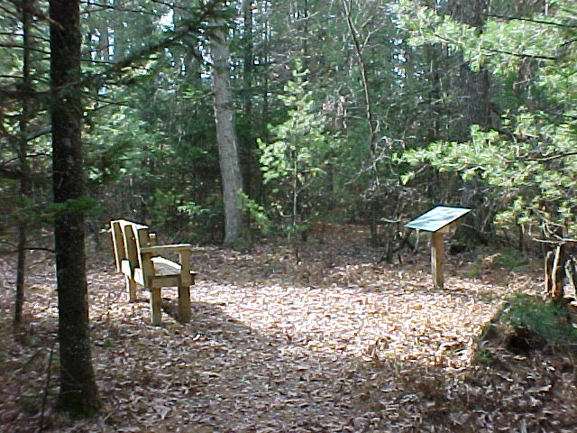

The Beal Plantation is possibly the oldest known plantation in North America. Professor Beal planted over 5,000 trees of 76 species in 1888. The plantation is home to multiple research activities. A parking lot was developed along with an ADA accessible interpretive trail in year 2000, highlighting the unique features of the plantation. For detailed directions to the Beal Plantation, visit www.grayling-mi.com/attractions.html#historical

.

Mason Tract Special Management Area:
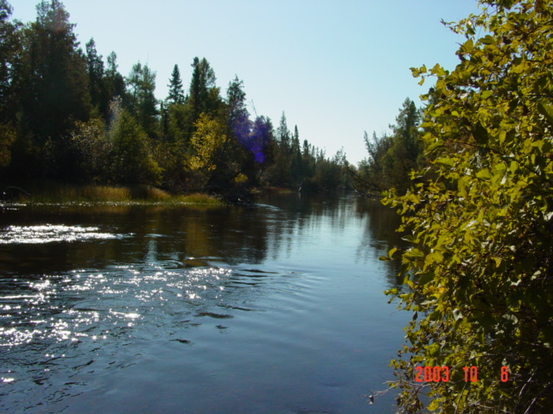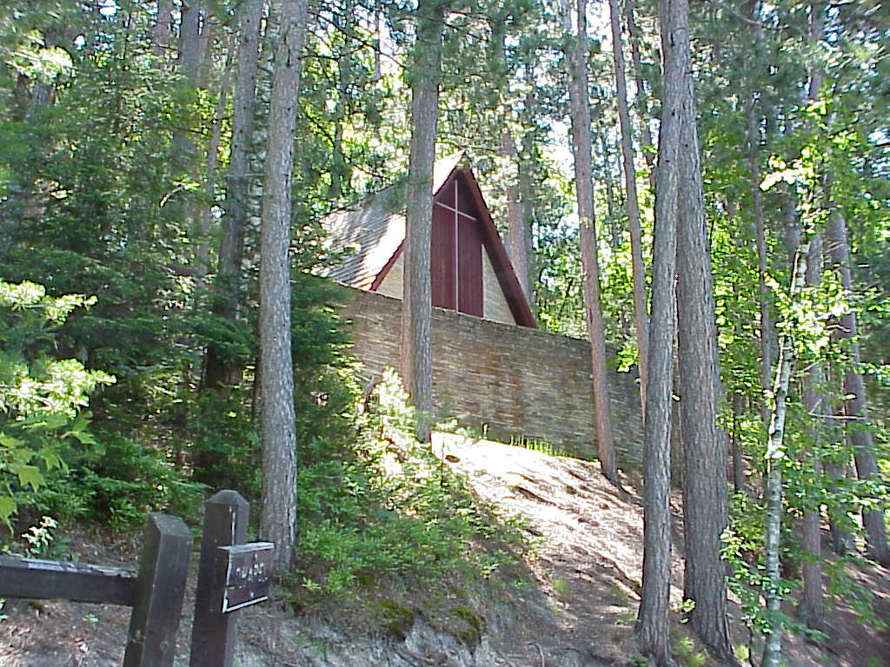
The South Branch of the AuSable River in the Mason Tract The Mason Chapel

A 4,493 acre special management area along the South Branch of the AuSable River designed to protect the quality fishing waters of this area. The Mason Tract originated from acceptance of a 1500-acre gift from The George Mason family in 1954. Over time, additional acreage has been acquired from the US Forest Service and private individuals through land exchanges. The Mason gift was contingent the area be used as a permanent game preserve, no part shall ever be sold by the state, and no camping be allowed in the area for 25 years. The State of Michigan has continued the no camping restriction in the Mason Tract. The only camping allowed is within Canoe Harbor State Forest Campground, located at the north end of the Tract on the AuSable River. The Mason Tract offers quality fishing, hunting, and canoeing opportunities. The Mason Tract is home to the pristine Mason Chapel. The Mason Family constructed the Chapel in 1960 to provide fishermen with a place of reverence and has developed into a popular tourist attraction. The Mason Tract also contains the Mason Tract Pathway, which is used for hiking and cross-country skiing. Mountain biking on the Mason Tract Pathway is prohibited via a Director’s Order. For a map of the Mason Tract, visit http://www.dnr.state.mi.us/spatialdatalibrary/PDF_Maps/Management_Areas/Mason_Tract.pdf

Pine Barrens Special Management Areas:

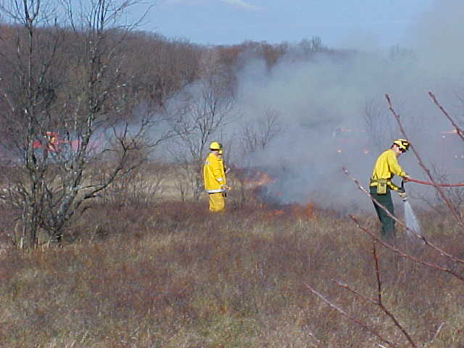
Prescribed burning is used to maintain Pine Barrens area.

The Grayling Unit currently has two areas designated for Pine Barrens management. Pine Barrens is currently a rare ecosystem that is typically inhabited by many threatened and endangered species. It occurs

in jack pine forests frequented by fire. In 1997, DNR staff worked to develop a management plan for the 1,400-acre “Frost Pocket” Pine Barrens area in Oscoda County. The “Frost Pocket” is one of the purest Pine Barrens systems remaining in Michigan. A detailed plan of timber harvesting and regular prescribed burning was outlined to restore this rare ecosystem. To date, active management and regular burns have occurred in the “frost pocket”. Most recently, a plan was developed to restore an additional 5,120 acres of pine barrens identified in Crawford County. This area occurs within Camp Grayling; so extensive planning with the National Guard has occurred. The “North Camp Grayling Pine Barrens Management Plan” has been completed and is awaiting approval of the National Guard and DNR Divisions before prescribed harvesting and burning practices are instituted.

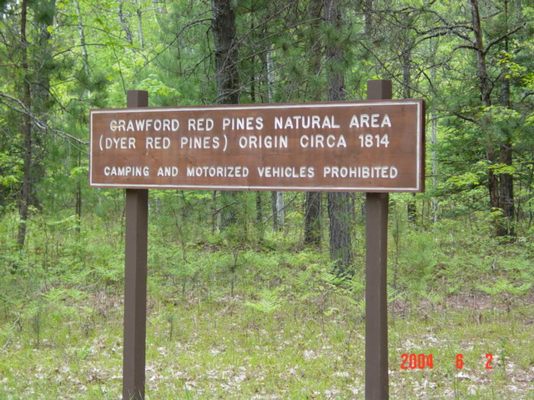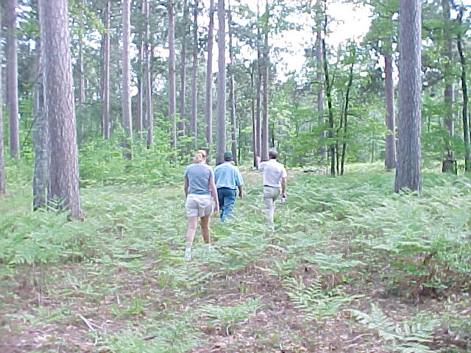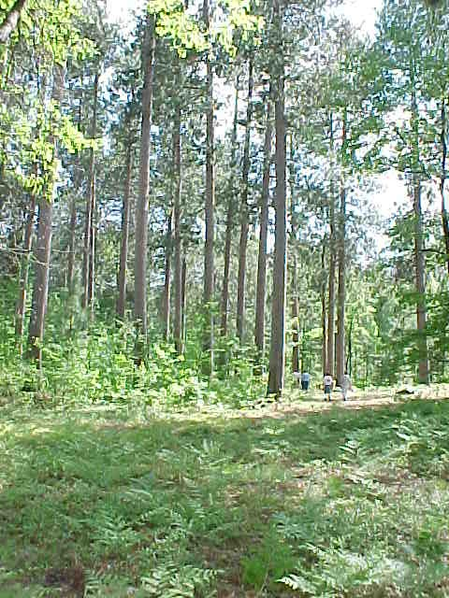
Dyer Red Pine Proposed Natural Area: A small parcel proposed as a natural area as it contains some remnant old growth red pine. For more information visit http://www.michigan.gov/dnr/0,1607,7-153-30301_31154_31260-54388--,00.html
Partnerships on the Grayling FMU: The Grayling FMU is part of multiple partnerships, helping to make many projects possible. Below are a few examples:

River Bank Stabilization and Restoration Efforts:
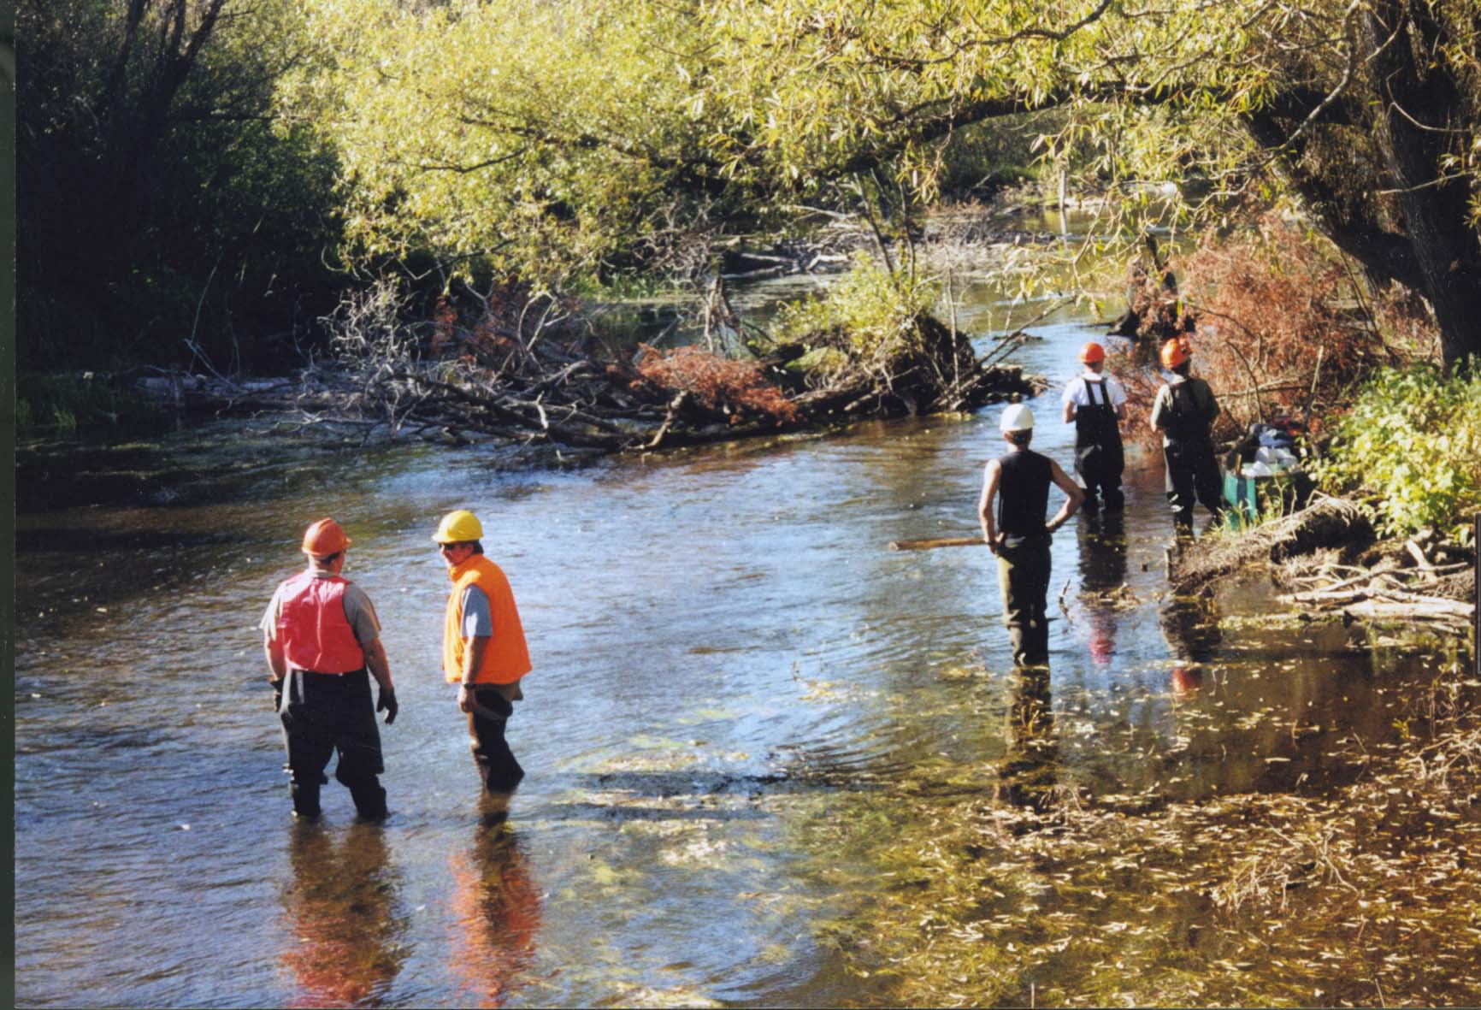
Cooperative efforts with local RC&D and SCD Offices, the AuSable River Restoration Committee, the Upper Manistee River Restoration Committee, and various Trout Unlimited Chapters have allowed restoration of many erosion sites along waterways.
In year 2000, many of these partners worked on a woody debris project, involving harvesting of whole trees, including roots, and placing them by helicopter along crucial stretches of the AuSable River in an effort to improve river habitat. This project was so successful; this type of restoration is being extended along other stretches of the AuSable and Manistee Rivers.
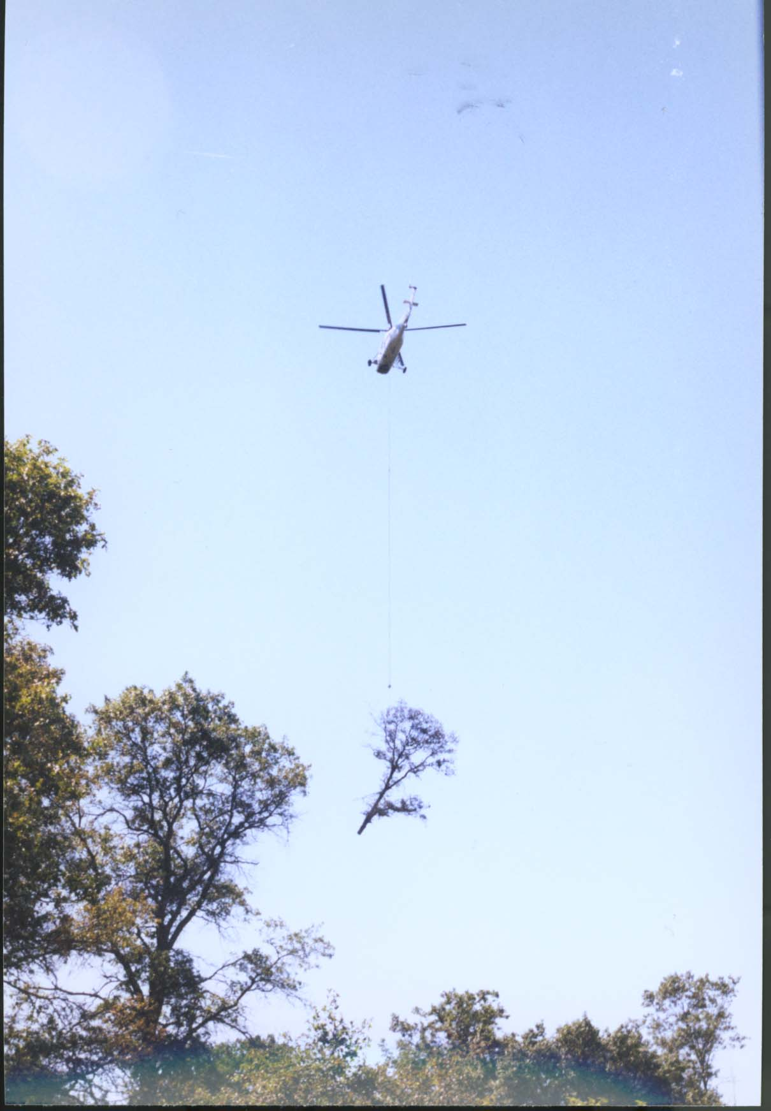

Hartwick Pines State Park:
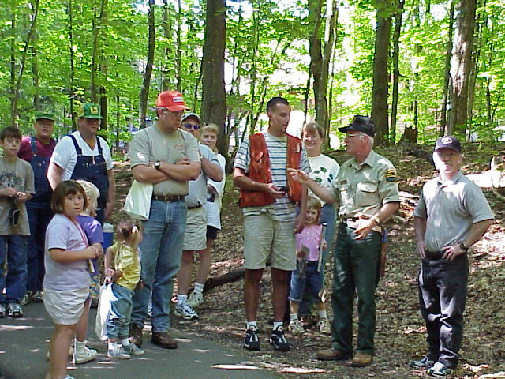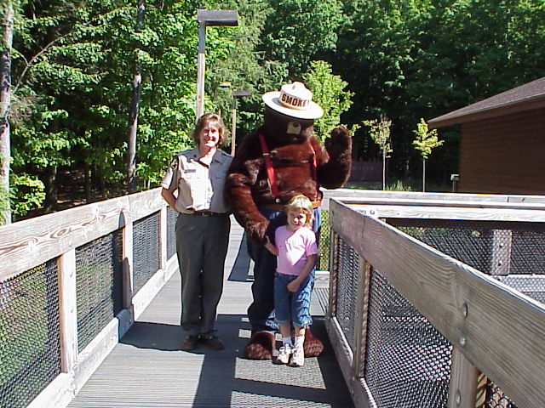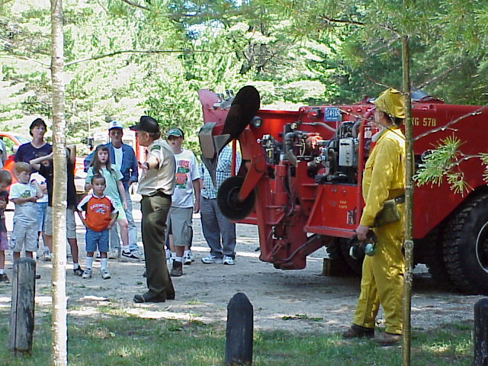
Grayling FMU staff regularly work with park staff providing forestry expertise and assisting with the park’s annual Forest Fest celebration.

The Mason Tract Northern White-Cedar Restoration Project:
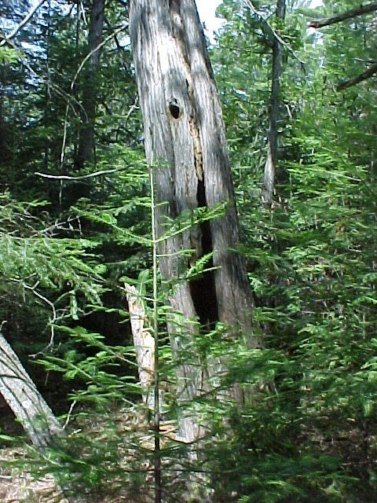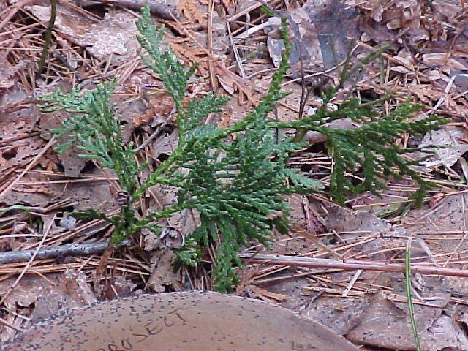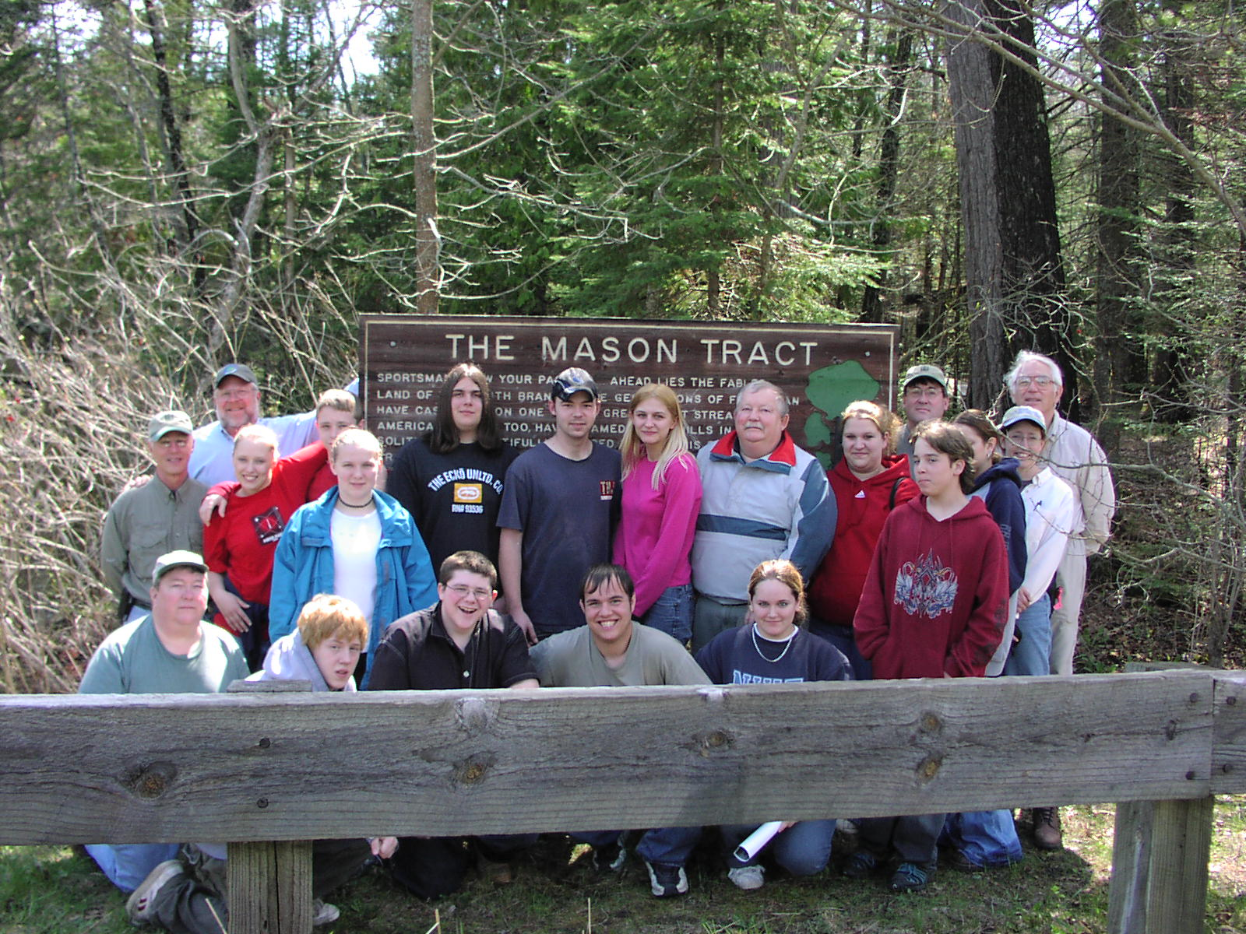
Long-lived Northern White-Cedar Trees are an important part of the ecosystem along river corridors. . It is felt juvenile cedars are missing due to browse from deer and hare. It is feared without intervention, the cedars will die and will no longer be a component of this ecosystem. Members of the Upper AuSable River Preservation Association and Huron Pines RC&D Area Council are working with the MDNR to try to re-establish young cedar seedlings along the AuSable River Corridor within the Mason Tract. This partnership involves having various groups planting cedar seedlings, caging planted and naturally existing seedlings for protection, and watering new plants to assist with establishment. Our goal is to plant and protect 2000 seedlings by year 2009 and remove enclosures within 15 years of planting. The project is still in its infancy, with the first plantings performed in 2004.

