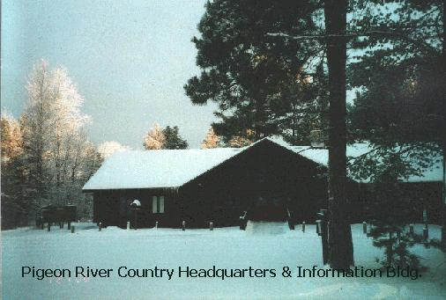

The Pigeon River Country FMU (PRC) is the smallest (105,049 acres) of the 15 Units in the State Forest System. It is also the Unit with the most contiguous state land ownership. The PRC is located east of Vanderbilt, in northeast Otsego county, southeast Cheboygan county and in a small portion of western Montmorency county.

Pigeon River Country FMU is a unique area whose management is guided by the Concept of Management. The PRC provides forest products as well as many wild land recreational opportunities and is in the heart of Michigan’s elk range. It is a place to hunt, fish, camp, hike, cross country ski, snowshoe, ride a horse or just take a drive in wild, undeveloped forest that has little private land mixed in.

The Unit has 6 campgrounds plus one horse trail campground and a group horse camp. Camping with horses outside of a designated campground is restricted to one of 15 sites that are marked throughout the Unit. Hiking and riding trails for both horses and hiking are maintained in the Unit. Bicycle riders and cross country skiers are welcome to use the trails.

Three rivers flow through the PRC: the Pigeon, Black and Sturgeon Rivers. There also a number of small lakes located throughout the Unit. The rivers provide good fishing opportunities for trout and the lakes have bass and pan fish. Canoes, kayaks and other small watercraft work best for navigating these small waters.

Pigeon River Country FMU is home to a wide variety of wildlife ranging from elk to songbirds.

The Pigeon River is a designated Natural River. The Unit also has three areas nominated for legal dedication: the Dog Lake Wild Area, the Grindstone Creek Wild Area and the Pine Natural area.

Pigeon River Country FMU is a special area providing many different opportunities for just about everyone who enjoys wild country.

