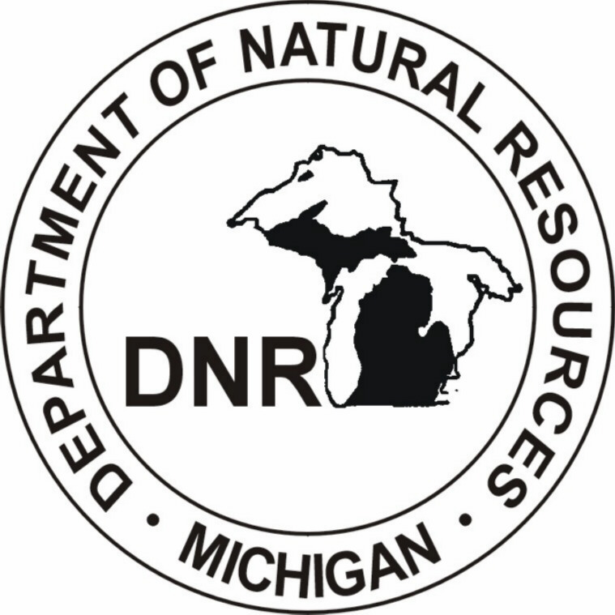 | Michigan Department of Natural Resources - Forest, Mineral and Fire Management  Stakeholder’s Guide to  Regional State Forest Management Planning

The Michigan Department of Natural Resources (DNR) uses a 3-tiered planning structure for the management of Michigan’s State Forest resources: statewide, regional and unit levels. The Michigan State Forest Management Plan (SFMP) and Regional State Forest Management Plans (RSFMPs) are intended to provide landscape-level analyses and direction to enable decisions for management of forest stands and compartments at the Forest Management Unit (FMU) level. The aggregate of all forest prescriptions from compartment reviews are contained in the Annual Plan of Work, which represents the tactical level of planning for State Forest operations.

The RSFMPs will provide focused direction for management of State Forest resources in each of the four eco-regions: the northern and southern halves of the Lower Peninsula, and the eastern and western halves of the Upper Peninsula. Multi-disciplinary planning teams of DNR staff in each eco-region (eco-teams) have been formed to develop two plans for the eco-regions in the Upper Peninsula, and one plan to address State Forest resources for the eco-regions in the Lower Peninsula. Timelines for the development of RSFMPs can be downloaded by clicking on the following links:

NLP/SLP RSFMP Timeline

EUP RSFMP Timeline

WUP RSFMP Timeline

Specific planning for the management of State Forest resources in each RSFMP will be accomplished by dividing the State Forest into distinct Management Areas (MAs). The MAs are essentially groupings of existing compartments (1,500-acre to 3,000-acre blocks of State Forest lands) that have similar attributes, such as vegetation types, proximity to key user markets, or portion(s) of landscape in different ownerships. Planning within the framework of management areas will help the DNR provide landscape level analyses and direction that will guide operational decisions made at each FMU, through the existing compartment review process.

In order to analyze and select State Forest lands for assignment to specific MAs, it is necessary to identify significant and common attributes that can guide the formation of MA boundaries. The selection attributes that the DNR are using for development of MAs are as follows:

Ownership Attributes:
- Adjacency to other public (including DNR parks and wildlife areas) or private ownerships, and also considering their varying intensity of stewardship and protection.
- Percentage of the landscape in different public and private ownerships.
- Consideration of ownership size and connectivity.
- Areas with existing DNR management plans.

Social/Economic Attributes:
- Proximity to wood product markets.
- Proximity to population areas and major transportation arteries.
- Trends in population growth and recreation demands.
- Proximity to known historical/cultural sites.
- Degree of access.

Ecological Attributes:
- Similar site potential as expressed by habitat type.
- Historic vegetative composition.
- Current vegetative composition and structural characteristics.
- Wildlife species distribution patterns for select species (including threatened and endangered species and those defined by the Michigan Wildlife Action Plan (WAP)).
- Proximity to known ecologically sensitive sites.
- Existing forest connectivity or fragmentation.
- Analyses of watersheds and the climate, bedrock geology, glacial landform and soils in Ecological Classification Systems.

The process for formulating management direction for each MA is a multiple-step process involving landscape analysis using the above criteria, meetings with DNR unit-level staff and the public to develop initial concepts of management, writing of specific management direction by eco-teams, and internal DNR and public review of draft and final plans. Each eco-team has completed landscape analyses and a series of workshops with DNR foresters and wildlife and fisheries biologists within each FMU to develop initial concepts for management of forest resources within each MA. Public and stakeholder organization participation in the development of initial concepts of management has been completed for the Lower Peninsula and the Western Upper Peninsula. Public and stakeholder organization participation in the development of initial concepts of management for the Eastern Upper Peninsula is now underway through May 15, 2009.

A public open house has been scheduled by the EUP ecoteam to provide an opportunity for the public and stakeholder organizations to:

- Engage with DNR staff on the application of MAs in RSFMPs,
- Provide input on concepts of management for MAs, and
- Provide additional knowledge and background information specific to MAs and sites therein.

Initial concepts of management will aid in drafting specific management direction for each MA and provide guidance for the operational management of the State Forest.

Public review of draft RSFMPs is expected to occur in April through September of 2010. Final public review of plans is expected to occur in October 2010 through February 2011.

CURRENT MEETING SCHEDULES ARE AS FOLLOWS:

Eastern Upper Peninsula
April 14, 2009, 4:00 to 8:00 p.m. The meeting will be held at the DNR Newberry Operation Service Center, at 5100 State Highway M-123, Newberry, MI. The focus of the meeting will be on all Management Areas in the entire eastern Upper Peninsula Ecoregion.

The DNR currently welcomes public comments on initial concepts of management direction for all MAs in the EUP eco-regions. Draft maps of State Forest MAs, summary documents of initial concepts of management direction for each MA, and contact information for submittal of web-based comments to the DNR EUP eco-regional planning team may be viewed at the following link:

EUP Management Areas

The public comment period on the EUP MAs is open until May 15, 2009.

The public comment period for NLP/SLP and WUP MA’s has been closed, but documents may still be viewed at:

NLP/SLP Management Areas

WUP Management Areas

