8 Mile Corner Management Area Summary

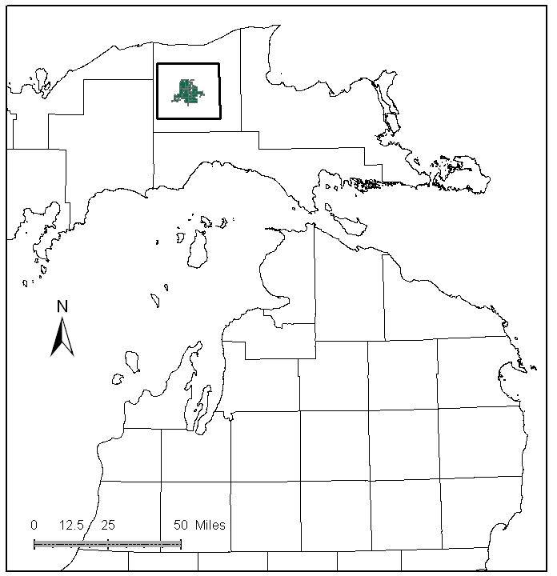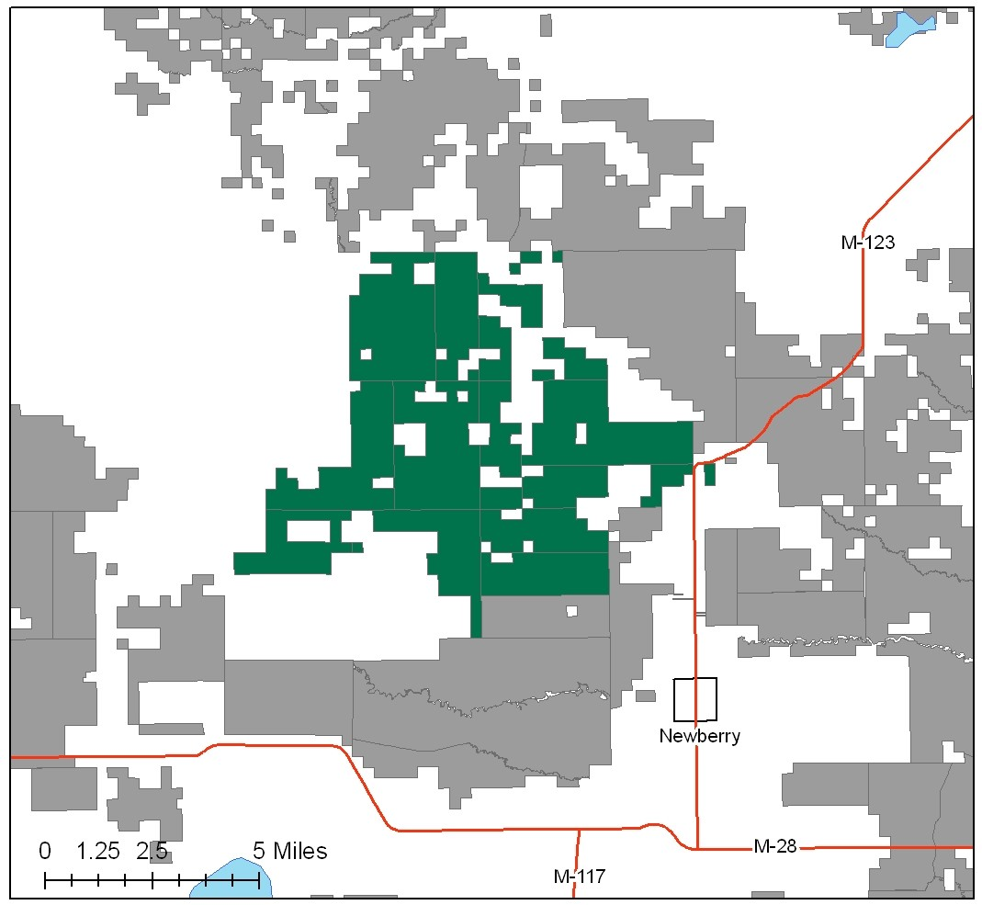

Attributes

The 8 Mile Corner Management Area (MA) is located in the central portion of the Eastern Upper Peninsula (EUP) in Luce County. It has approximately 26,249 acres of state-owned land. The attributes which were important in identifying this MA include:

- Ecological Classification - The MA falls primarily within the Grand Marais Glaciofluvial moraine complex sub-section of the EUP Ecoregion as classified by Cleland (2006).

- Landforms – The dominant landform consists of sandy outwash and till plain between the Two-hearted and Tahquamenon river systems.

- Cover Types – This is the primary attribute for this management area. A large opening within this MA is a reflection of human induced disturbances from past logging and farm practices. Part of this opening now contains red pine and portions are in medium quality upland hardwood. Currently, northern hardwoods and aspen are the predominant forest type. Formerly, white pine and upland hardwood mixes made up most of the acreage.

- Social / Economic - County Road 407, a paved road that runs through this MA, provides recreational access and access to timber markets. Opportunities for wildlife recreation include hunting for ruffed grouse, deer and bear. Recreational facilities within the MA include: snowmobile trails, and Sno-Pine Stump and Silver Creek ORV trails. Bass Lake State Forest Campground is near this MA.

- Special Features - Special protection trout streams within this MA include: Silver Creek, Auger Creek headwaters and South Branch Two Hearted River. Other angling opportunities include: East Creek, Camp One Creek, Wolverine Lake, Silver Creek Pond, and Brockies Pond. The large opening complexes provide habitat for open-land species such as sharp-tailed grouse and upland sandpiper. Although there are potential Biodiversity Stewardship Areas (BSA) in this MA, at this time there are no known Special Conservation Areas (SCAs).

- Ownership size and connectivity – This management area contains a large contiguous block of state forest ownership and is managed by the Newberry Forest Management Unit.

Major Cover Types

- Upland hardwood – Covers 6,584 acres of this MA. Almost three-quarters of the acreage is uneven-aged, with the remainder being in second growth even-aged stands. Kalkaska sands and similar soils support the hardwood, so productivity is not as high as with hardwoods elsewhere.

- Aspen – Occurs on 5,917 acres in this MA. Aspen is often mixed with hardwood, white pine and other species. A spike in the 10 to 29 year old aspen is evident.

- White Pine – Is found on 2,104 acres in the MA. Over half of the acreage is in uneven aged stands, with the remainder of the stands being even age condition. The even age stands tend to be 60 years and older. They are a reflection of the man-made disturbances in this landscape. Formerly, white pine and upland hardwood mixes made up most of the acreage.

- Red pine – Occurs on 2,018 acres in this MA. Red pine grows very well on these sites and yields very high value products. Because of a large number of planted stands, there is a spike in the 50 to 59 year old age class.

- Mixed Swamp Conifer – Covers 1,778 acres of the MA. There is a tendency for this type to be older, and there is an age spike in the 70 to 79 year old stands.

- Grass and Upland Brush – Grass covers 1,630 acres and Upland brush covers 1,011 acres of the MA. Many of these stands have important wildlife values. Hardwoods are becoming established in some small areas formerly typed as open.

Total 26,249

Other Types include: Treed Bog, Paper Birch, Hemlock, Marsh, Non Stocked, and Tamarack

Concepts of Management

- Upland Hardwood (25% of the MA) – For uneven aged upland hardwood, use single-tree selection harvest methods. Consider shelterwood or other even aged treatments in lower quality stands. Consider underplanting disease resistant beech or oak in upland hardwood forests to replace lost hard mast. Where present, retain a component of mesic conifer species in the canopy and some large diameter aspen. Dead and down woody debris and snag/cavity trees are an important component of this community and they should be retained or created if necessary.

- Aspen (23% of the MA) - Within the aspen acreage, plan harvests for regeneration with an eye to working towards balancing age class distribution in the area. Retain a conifer component within this vegetative type and larger scattered trees for budding by grouse.

- White Pine (8% of the MA) – Use shelterwood/seed tree harvests to promote natural regeneration. Retain a component of older age classes within this type.

- Red Pine (8% of the MA) - Manage red pine through thinning and other methods. Work towards a balanced age class distribution, where stands are accessible. At rotation harvest, red pine stands will be evaluated as to site potential; some stands may be liquidated to consolidate openings, some replanted to red pine, and some may be allowed to convert to other types when the site is more suited to that cover type.

- Mixed Swamp Conifer (7% of the MA) - Retain a component of older age classes within this type. Harvest where regeneration would be successful and access is available.

- Grass (6%) and Upland Brush (4% of the MA) - Continue to consolidate small openings for open land species. Maintain large openings through prescribed fire and mechanical cutting. Some of the smallest openings will be allowed to convert to aspen or hardwoods.

