Battydoe Deer Yard Management Area Summary

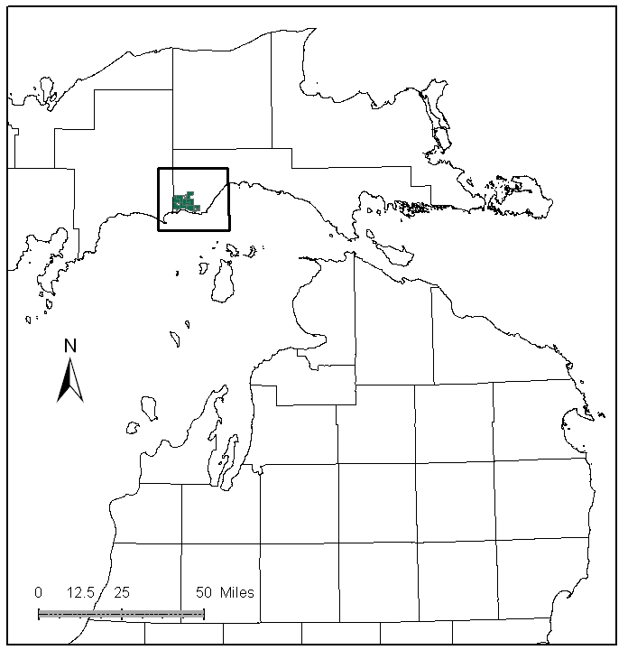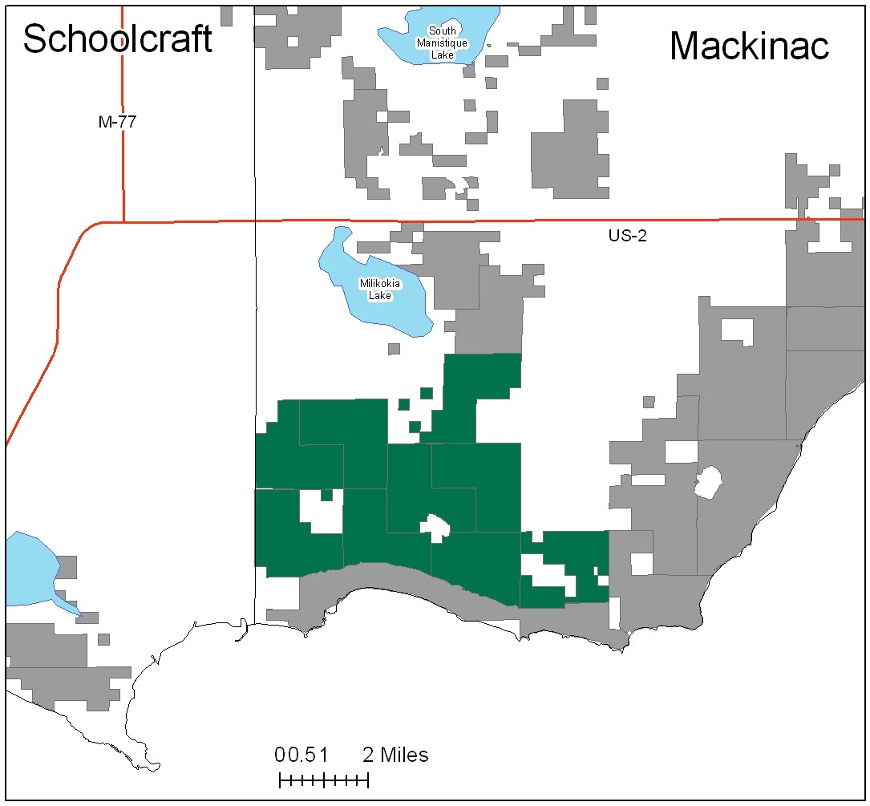

Attributes

The Battydoe Deer Yard Management Area (MA) is located in the central part of the Eastern Upper Peninsula (EUP) in Mackinac County. It has approximately 16,692 acres of state-owned land. The attributes which were important in identifying this MA include:

- Ecological Classification - The MA falls within St.Ignace Lake Plain sub-section of the EUP Ecoregion as classified by Cleland (2006).

- Landforms – The dominant landform consists of extensive conifer-dominated wetlands on sandy lake plain.

- Cover Types - Cedar and lowland swamp conifer are the dominant cover types within the MA.

- Social / Economic- There are some local markets for white cedar. Norton-Oglebay Limestone Quarry is adjacent to the west and north of the MA. Hunting and trapping are an important form of recreation in this MA. Illegal ORV activities are troublesome in this MA.

- Special Features – The majority of this management area is designated as a Special Conservation Area (SCA), critical habitat for wintering white-tailed deer and other associated species. This is the primary attribute for this MA. There are three trout streams within the MA: Nelson Creek, 405 Creek, and the Milakokia River. The Milakokia River in this MA supports natural reproduction of Lake Michigan potamodromous fishes.

- Ownership size and connectivity – The state forest land in this MA is concentrated; it is managed by the Sault Management Unit.

Major Cover Types

- Cedar – There are 5,310 acres of cedar in this MA, all of which is within deer wintering habitat. Almost all of the cedar is over 70 years old.

- Upland Hardwoods - Of the 3,636 acres of upland hardwood, 65% of which is being managed as uneven aged.

- Aspen – Most of the 2,024 acres of aspen are in the 0-39 year age classes, with a slight imbalance in the 10-29 year age classes.

- Mixed Swamp Conifers – Covers 1,047 acres in the MA. Almost 70% of these stands are over 80 years old.

- Lowland Poplar – About half of the 901 acres of lowland poplar is in the 0-39 year age classes.

Total 16,692

Other Types include: Tamarack, Bog or Marsh, White Pine, Marsh, Hemlock, Upland Mixed, Treed Bog, Lowland Mixed, Upland Brush, Upland Mixed Conifers, and Non Stocked

Concepts of Management

- Cedar (32% of the MA) - Primary management of this cover type is for critical winter habitat for white-tailed deer. It is desirable to maintain a system of closed canopy stands so there will be few opportunities to harvest cedar in the near future, unless associated with a comprehensive deeryard management plan. Regeneration challenges may include deer browse or changes in growing conditions.

- Upland Hardwoods (22% of the MA) – For the uneven aged stands, continue with selective harvesting to further diversify stand structure and composition. Continue to work toward balancing the age class distribution in the even aged stands, planning regeneration harvests where possible. Dead and down wood, snags, and cavity trees are important components within this type. Following the Within Stand Retention Guidelines, protect mesic conifers within the canopy and individual large diameter trees, particularly aspen to benefit wildlife.

- Aspen (12% of the MA) – Continue regeneration harvests to balance the age classes. In the 80-89 year age classes, where it is managerially desirable, aspen should be targeted for harvest. Inaccessible aspen will convert to more shade tolerant species. Consider upland game management strategies for species such as hare, ruffed grouse, deer and woodcock.

- Mixed Swamp Conifers (6% of the MA) – As with the cedar type, most of these stands will be managed for winter deeryard values. Harvest of cedar will be considered where deer yard habitat is not impacted and cedar regeneration is likely

- Lowland Poplar (5% of the MA) – Continue working toward a balanced age class distribution. In inaccessible areas, stands will convert to more shade tolerant species.

- Other - Law enforcement patrols for illegal ORV use in this area should be enhanced.

