Bullock Ranch Management Area Summary

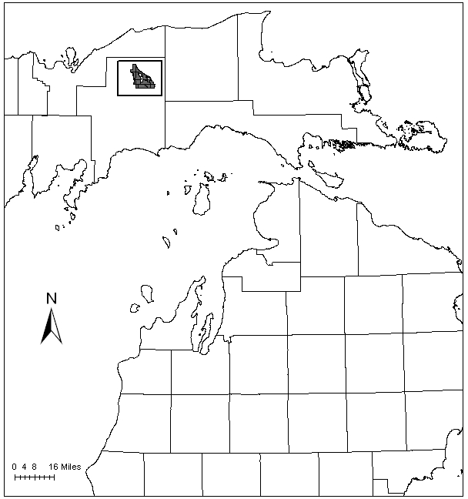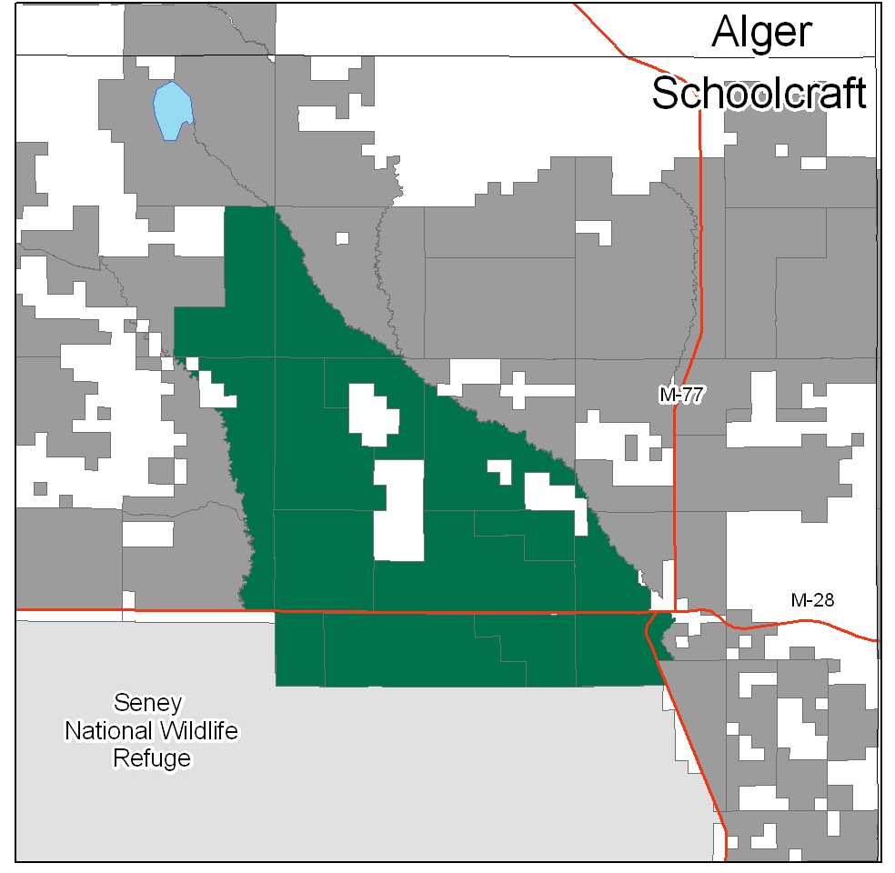

Attributes

The Bullock Ranch Management Area (MA) is located in the Eastern Upper Peninsula (EUP) in Schoolcraft County, along the Seney Stretch of M-28, with the town of Seney in the southeast. There are approximately 29,894 acres of state-owned land. The attributes which were important in identifying this MA include:

- Ecological Classification - The majority of this MA falls within the Seney Lake Plain sub-section of the EUP Ecoregion as classified by Cleland (2006).

- Landforms - The dominant landform consists of ancient lake plain, with wet organic soils.

- Cover Types – This is a highly altered landscape. Historically, marshes, peatlands, and low productivity swamps were the predominant vegetation on the very poorly drained topography. The current cover types are primarily jack pine, red pine, and open land.

- Cultural - Much of this area was drained during the early 1900’s in a failed effort to convert the area to farmland. The altered hydrology resulted in organic soils that are hydrophobic or unable to hold water, which makes prescribed burning difficult to control.

- Social / Economic - Recreational facilities within the MA include: the Fox River Pathway, Fox River State Forest Campground, snowmobile trail, and the Seney Township Campground. In addition, it is heavily used for deer, bear and grouse hunting.

- Special Features - Flowing through this MA are the Fox River, Little Fox River and the Driggs River, which are all trout streams and have excellent groundwater resources in their watersheds. The Fox River system is a state designated Natural River, and the corridor is a High Conservation Value Area (HCVA). There is an Ecological Reference Area (ERA) of dry northern forest, and a potential Biodiversity Stewardship Area (BSA) within the MA. The Bullock Ranch is one of several large openings within the EUP that are managed for a suite of open-land species including sharp-tailed grouse, merlin and upland sandpiper. These special features are primary attributes for this management area.

- Ownership size and connectivity - The state land in this MA is concentrated. Due to the large areas of marsh and lowland brush, a large portion of the MA is without roads. The Seney National Wildlife Refuge borders the MA to the south. The Shingleton Unit is responsible for management.

Major Cover Types

- Jack Pine - Occurs on 8,801 acres in this MA, with 65% of the acres in the 0-29 year age classes. The majority of stands over 50 years old are inaccessible upland islands within a wetland matrix.

- Red pine - This cover type has 5,478 acres, with a spike in the 50-59 age class. All of the older age classes are well represented. Many of these acres are on islands in bogs and may not be accessible.

- Marsh, Lowland Brush, and Grass - The MA contains a large amount of nonforested land cover types: marsh with 4,621 acres, lowland brush with 4,317 acres, and grass with 1,937 acres. Wildlife management goals in these types focus on open land species, including sharp-tailed grouse.

Total 29,894

Other Types include: Upland Hardwoods, Upland Brush, Oak, Swamp Hardwoods, Scotch Pine, Spruce Fir, Bog or Marsh, and Hemlock

Concepts of Management

- Jack Pine (29% of the MA) - Look for opportunities to improve age class diversity. Use scarification for natural regeneration where possible. Inaccessible islands of jack pine will eventually convert to other climax species.

- Red Pine (18% of the MA) - Work towards balancing the red pine age class distribution, where stands are accessible. Small islands of red pine dispersed in marsh areas may never have access for harvesting, and will be allowed to reach biological maturity. Prescribed burning for regeneration will generally not be prescribed due to the difficulty of managing fire in the organic soils.

- Marsh, Lowland Brush, and Grass (15%, 14%, and 6% of the MA) - Continue to maintain openings for open land species. As resources allow, work on decreasing the amount of spotted knapweed and other invasive plants in the large opening complexes.

- Other-
  - Conform to the requirements of the Fox Natural River plan.
  - Continue Driggs River stream bank erosion control cooperative projects to promote improvement of trout habitat. Continue to monitor stream quality of the Driggs and other waters in this MA.
  - ERA’s will be managed to protect and enhance their conservation values, as directed by site-specific management plans for each ERA.

