Carp River Red Pine Management Area Summary

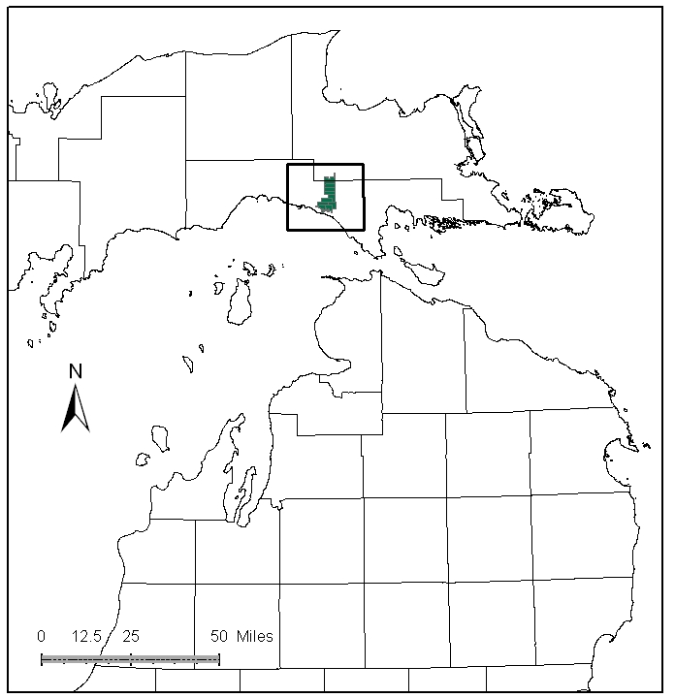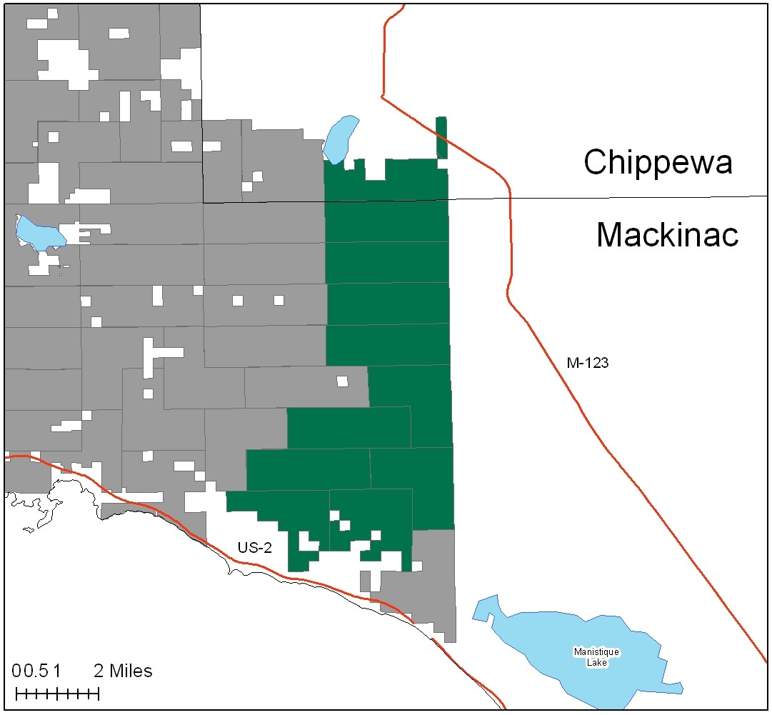

Attributes

The Carp River Red Pine Management Area (MA) is located in the south central portion of the Eastern Upper Peninsula (EUP), in Mackinac and Chippewa Counties. It has approximately 20,708 acres of state-owned land. The attributes which were important in identifying this MA include:

- Ecological Classification - The MA falls within the St. Ignace Lake Plain sub-section of the EUP Ecoregion as classified by Cleland (2006).

- Landforms – Various landforms of glacial lacustrine origin characterize the sub-subsection, including flat lake bed, deltaic deposits of sand, with cold water trout streams, parabolic dune fields, and shallow embayments containing transverse dunes.

- Cover Types – Red pine, aspen, upland hardwoods, and lowland brush are common here. These cover types are a result of disturbance and subsequent planting after the 1800’s logging era. This MA was delineated for its intensively managed red pine.

- Cultural - The river system was used as a pre-historic transportation route, and historically for log transportation. Mixed pine plantations were planted by Rexton CCC camp, after the failure of pre-depression era farms. Blueberry picking is popular in some locations

- Social / Economic - The primary attribute of this MA is its intensively managed red pine. Recreation facilities in this MA include: snowmobile trails, and the Brevort-Trout Lake Motorcycle Trail and trailhead. Beaver Control and bank stabilization projects have been done along the Carp River. Deer, snowshoe hare and ruffed grouse hunting, and brook trout fishing are popular.

- Special Features - Several Ecological Reference Areas exist: a hardwood-conifer swamp, a poor fen, and an intermittent wetland. There are several known archeological sites in the area. The Carp River is a designated natural river on adjacent USFS lands to the east. Trout streams in the MA include: Little Brevort River, S. Branch Carp River, Ozark Creek, and Carp River.

- Ownership size and connectivity – State land in this MA is consolidated in a large block. The Sault Unit is responsible for management. US Forest Service lands border to the east.

Major Cover Types

- Red pine – Red Pine is the largest cover type in the MA, and occurs on 4,401 acres. There have been thinnings, clearcuts and replanting in this management unit resulting in several younger age classes. A spike of planted stands remains in the 70 to 79 year old age class, due to planted stands.

- Aspen – Occurs on 3,269 acres in the MA. Much of the aspen acreage is in the 10 to 29 year age classes.

- Upland Hardwoods – This type covers 2,476 acres, the majority of which are classified as uneven aged.

- Lowland brush – Occurs on 1,613 acres in the MA. Much of this occurs along cold water stream corridors and adjacent swamps.

- Grass – Covers 1,556 acres of the MA. Many areas are kept open for wildlife use.

Total 20,708

Other Types include: Hemlock, White Pine, Upland Mixed, Treed Bog, Lowland Poplar, Tamarack, Upland Mixed Conifer, Water, Upland Mixed Deciduous, Oak, Swamp Hardwoods, and non stocked.

Concepts of Management

- Red pine (21% of the MA) – The major focus of this management area will continue to be for red pine, with increased harvesting in the 70-79 year age class. Stand prescriptions will include partial or regeneration cuts, controlled burning for site prep, or herbicide treatment before or after planting. Follow recommendations in the red pine project guidelines. It will take several decades of work to balance the age class distribution.

- Aspen (16% of the MA) - Continue to work on balancing aspen age classes where opportunities allow, using regeneration harvests in older age classes where operable. It is expected to take several decades of work to balance the age class distribution. Consider upland game management strategies for species such as hare, ruffed grouse, deer and woodcock.

- Upland Hardwoods (12% of the MA) - The quality of the upland hardwood is variable in this management area. Look for treatments options suitable to the site such as single tree selection or even-age management. Harvesting will increase in the next decade, as stands reach basal areas over 110 square feet. Following the retention guidelines, retain scattered individual aspen and mesic conifers.

- Lowland brush (8% of the MA) – Continue to manage for wildlife species that use this cover type by maintaining this habitat type where appropriate. Passive management will allow many of these areas to be maintained.

- Grass (8% of the MA) - Wildlife Division will continue to evaluate these openings and recommending treatments during compartment reviews.

- Other –
  - Protect cold water trout streams using buffers, with exact distances and treatments worked out with the fisheries biologist.
  - ERA’s will be managed to protect and enhance their natural vegetative and wildlife communities, as directed by site-specific management plans for each ERA.

