Charcoal Grade Management Area Summary

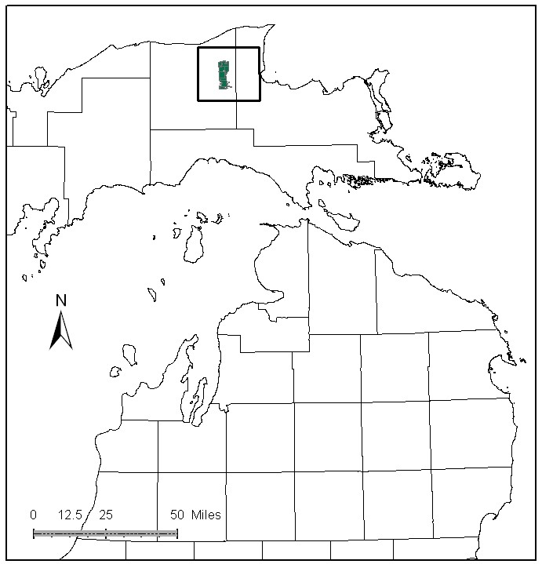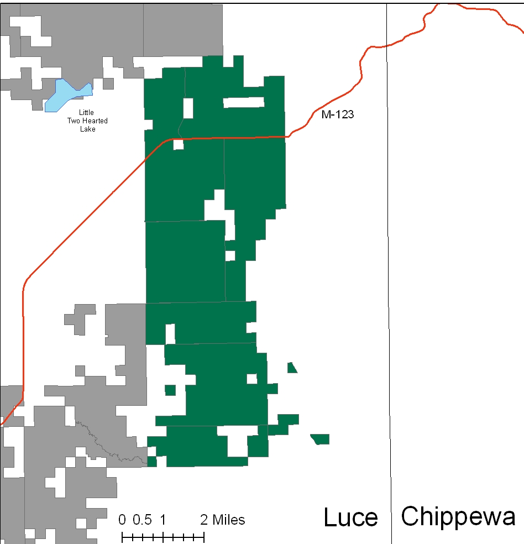

Attributes

The Charcoal Grade Management Area (MA) is located in the central portion of the Eastern Upper Peninsula (EUP) in Luce County. It has approximately 17,132 acres of state-owned land. The attributes which were important in identifying this MA include:

- Ecological Classification - The MA falls within Grand Marais Glaciofluvial Moraine complex sub-section of the EUP Ecoregion as classified by Cleland (2006).

- Landforms – The dominant landform consists of sandy ridges of end moraine and pitted outwash. The poorly drained deposits are concentrated in northern Luce County. These are of the same age and support vegetation similar to that of the more extensive peatlands of Sub-subsection VIII.2.1.

- Cover Types – Moraine features support northern hardwood and aspen types, excessively drained sand ridges are dominated by white and red pine. Peatlands are dominated by spruce, northern white cedar and tamarack.

- Cultural - Hardwoods in this MA were historically cut to support a charcoal kiln in the Newberry area. This cutting altered the composition and structure of the hardwood stands. There are historic logging camps within the MA, and other known archeological sites. The influence of the historical management on this area is the primary attribute for selection of this MA.

- Social / Economic - The area has a major snowmobile route connecting southern snowmobile trails through the village of Newberry. Hunting is a popular form of recreation here. The Camp 7 gravel pit is within the MA.

- Special Features - The northern most part of the MA touches upon a candidate Ecological Reference Area (ERA) of Muskeg. Some wildlife species of note in the MA include black bear, moose and furbearing species. Trout streams in this MA include: Savage Creek, Baird Creek, and the main stem of Linton Creek. The Tahquamenon River forms the eastern border of the MA.

- Ownership size and connectivity – This is a fairly well blocked in piece of state land north of the town of Newberry and is managed by the Newberry Forest Management Unit.

Major Cover Types

- Upland Hardwood – Of the 6,416 acres of upland hardwood in this MA, the majority of it has been managed as uneven aged. The soils are quite variable. Timber quality is generally poor, with an area of higher quality on the west side of the management area.

- Aspen – Covers 2,365 acres in this management area. Aspen is often mixed with hardwood, white pine and other species. There is approximately 425 acres of aspen over age 60; most of which will be available for harvest in the next decade.

- Mixed Swamp Conifers – There are approximately 2,322 acres of mixed swamp conifers, most of this cover type is over 70 years of age. Younger age classes are under-represented.

- Lowland Brush – Covers 1,234 acres in this MA and provides moose habitat.

- Cedar – There are approximately 833 acres of cedar in the MA. There haven’t been any recent harvests in this cover type, and most of the acres are over 80 years old.

Total 17,132

Other Types include: Marsh, Lowland Poplar, Red Pine, Bog or Marsh, Paper Birch, Non Stocked and Sand Dune

Concepts of Management

- Upland Hardwood (37% of MA) – A large number of acres will be available for treatment in the next decade. On higher quality sites, continue single-tree selection harvests. Consider shelterwood or other even aged treatments on sites with poor timber quality. On low quality sites, consider conversion to other types, while retaining areas with high wildlife values. Retention of dead and down woody debris and snags are important in this type. Retention of large diameter aspen and conifers within the canopy is desirable.

- Aspen (14% of MA) - Continue to plan regeneration harvests to balance the age class distribution. Follow the Within Stand Retention Guidelines to maintain the conifer component within these aspen types.

- Mixed Swamp Conifers (14% of MA) – Begin working toward age class distribution through regeneration harvests. Plan cutting of smaller acreage stands with adjacent larger hardwood stands. Winter sales will be common to avoid problems with wet soils and access issues.

- Lowland Brush (7% of MA) – Continue to manage these areas for wildlife values.

- Cedar (5% of the MA) - Opportunities to manage for this type may exist in this MA due to the lack of wintering white-tailed deer. Consider regeneration harvests in areas that will not adversely impact wetland soils.

