County Line Hardwoods Management Area Summary

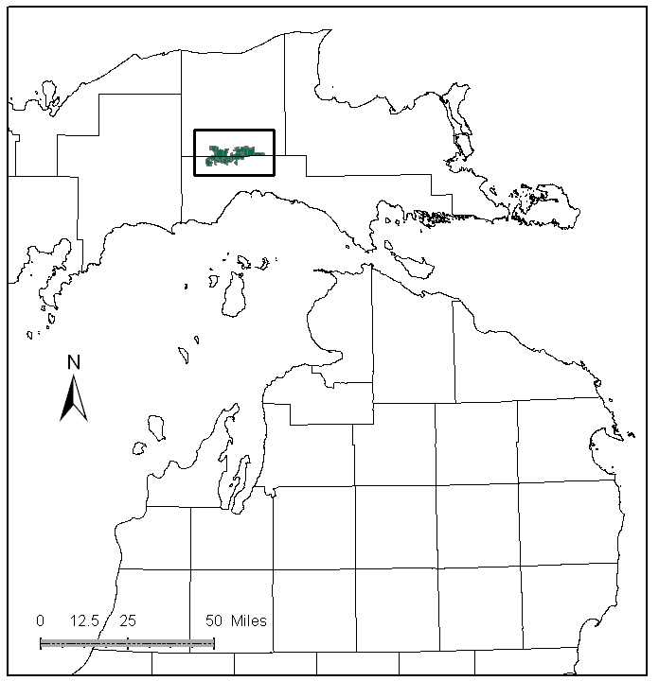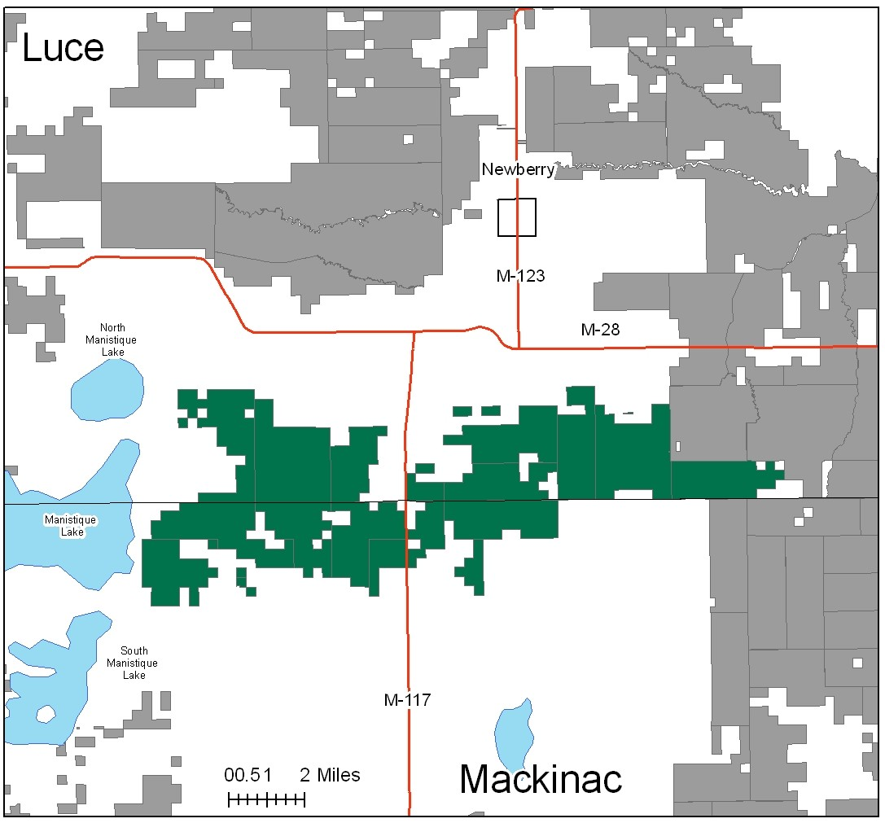

Attributes

The County Line Hardwoods Management Area (MA) is located in the central portion of the Eastern Upper Peninsula (EUP) in Luce and west Mackinac Counties. It has approximately 26,698 acres of state-owned land. The attributes which were important in identifying this MA include:

- Ecological Classification - The MA falls within St.Ignace Lake Plain sub-section of the EUP Ecoregion as classified by Cleland (2006).

- Landforms – The dominant landform consists of moraine lake bed complex, outwash plain and moraine.

- Cover Types – The historic and current northern hardwood vegetative composition dominated by sugar maple and American beech. Hemlock was a more common component circa 1800 than it is today. This MA was selected for intensive timber management, particularly for hardwoods and red pine.

- Cultural – There remains evidence of old farms on former homesteads after logging era in some areas of the MA.

- Social / Economic – As this MA is close to Newberry, recreation use is very high. There are many recreational facilities within the MA including: snowmobile trails, Newberry-Rexton motorcycle trail and Sandtown motorcycle trailhead and trail, and Canada Lake Ski trail/ pathway. Waterfowl hunting, bird watching, trapping and fishing are common uses of the resources in this MA. Boat access sites on Kak’s Lake, East Lake, Big Manistique Lake and Twin Lakes are nearby.

- Special Features - The Black Creek Wildlife flooding Special Conservation Area (SCA) is within this MA. Associated with the flooding is deer critical wintering habitat in the cedar and lowland swamp conifer types, which is another SCA. Angling opportunities include the following trout streams: Locke Creek, Upper Black Creek, First Creek, West Branch Sage River, McAlpine Creek, Skunk Creek, and Upper Millecoquins River. Millecoquins Pond also provides angling opportunities for brook trout.

- Ownership size and connectivity – The ownership is in a relatively contiguous block of state forest land, with good proximity to wood product markets for intensive hardwood management. It crosses the Luce and Mackinac County Lines, so management is shared with the Sault and Newberry Management Units.

Major Cover Types

- Northern Hardwoods - Covers 11,647 acres on moraine ridges or till, including a variety of site conditions from dry-mesic to mesic/poor-medium to very rich nutrient sites. Approximately one third of the upland hardwood acres stands have a basal area between 81-110 square feet. Another 2,600 acres of upland hardwood can be found in denser stands of 111-170 square feet of basal area. There is a component of American Beech in these stands with Beech Bark Disease.

- Aspen – Aspen is the next most common cover type with 5,022 acres in the MA. It is distributed throughout the management area on the moraine ridges, and till plain, with some on wet sites. Approximately 80% of the aspen found here is younger than 49 years old, with a peak in the 20-29 year old age class. There is some aspen mixed in the uneven aged stands of northern hardwood.

- Cedar - There are 1,733 acres of northern white cedar stands. The majority of this cedar is older than 70 years, and most of it is in the 90 to 99 year old age class.

- Mixed Swamp Conifer - The mixed swamp conifer type (which may contain northern white cedar, white spruce, black spruce, balsam fir, tamarack, hemlock, white birch, red maple, and lowland aspen) makes up 1,278 acres in this MA. Some of this type is in younger age classes, but the bulk of this type is older than 70 years. The slow growth makes it difficult to determine when young trees will become merchantable, and site conditions make some stands inaccessible.

- Red Pine - Natural and planted red pine of generally high quality composes approximately 1,127 acres. Natural regeneration is generally less successful than planting because of competition on the better quality sites. Quite a bit of the planting was done on old farm homesteads that were marginal operations in the 1920’s and came to state ownership through tax reversion in the 1930’s. This era of planting has resulted in a pronounced spike of acres in the 50-59 age class.

Total 26,698

Other Types include: Marsh, White Pine, Paper Birch, Swamp Hardwoods, Bog or Marsh, Hemlock, Tamarack, Jack Pine, Non Stocked, Lowland Mixed, Upland Mixed, Upland Mixed Conifers

Concepts of Management

- Upland Hardwoods (44% of the MA) - Intensively manage hardwoods as uneven aged generally, with options for even-age management where desirable. Keep an American Beech component for mast, nest cavities and stand diversity, while salvaging beech infected with Beech Bark Disease. Keep scattered individual older aspen for snags. Consider adding northern red oak, white pine, and hemlock to this cover type. Consider retaining a selected conifer component in the hardwood stands for diversity and wildlife habitat. As stock becomes available, under-plant disease resistant beech seedlings in upland hardwood stands where appropriate. Dead and down wood and snags are important in this cover type and should be retained or restored where deficient. There are significant vernal pools in many of these stands that may need buffers as part of a strategy for retention.

- Aspen (19% of the MA) - Managers should continue regeneration harvests to balance age classes on accessible acreage. This will take several decades to achieve. There may be a gradual loss of aspen acres in the 70-89 year old age classes through understory recruitment to other species over the next several decades in inaccessible areas. This will create or enhance a component of down wood and standing snags.

- Northern White Cedar (6% of the MA) - The primary management goal will focus on providing critical winter habitat for white-tailed deer. Harvest will be limited to assure that a closed canopy structure is maintained and will be considered where deer yard habitat is not impacted and cedar regeneration is likely.

- Mixed Swamp Conifer (5% of the MA) – Continue regeneration harvests to work on balancing out the age classes where opportunities exist. Natural regeneration will be used in this cover type. Consider managing for biodiversity with longer rotations and incorporation of natural disturbance processes for the benefit of wildlife. Harvest of cedar within this type will be considered where deer yard habitat would not be impacted and cedar regeneration is likely.

- Red Pine (4% of the MA) – Red pine in this MA will be managed intensively. Follow the Red Pine Management Guidelines to balance the age class distribution. Maintain red pine on suitable sites by replanting after final harvest. Maintain natural red pine as a component in these stands and try to encourage natural regeneration and to improve stand structural diversity. Consider use of prescribed fire for regeneration and to control competition.

- Other – Maintain most of the grass and upland brush, allowing succession in some smaller openings.

