Danaher Kingston Outwash Management Area Summary

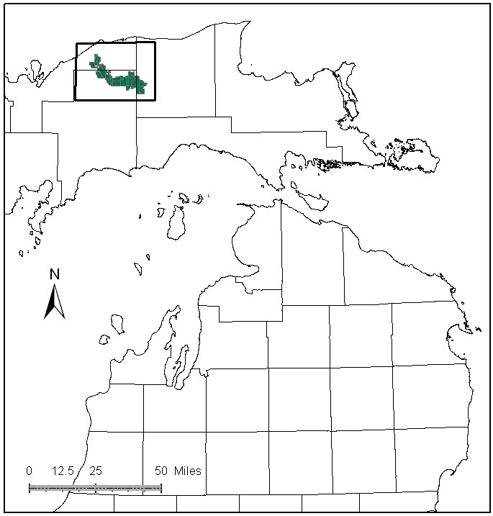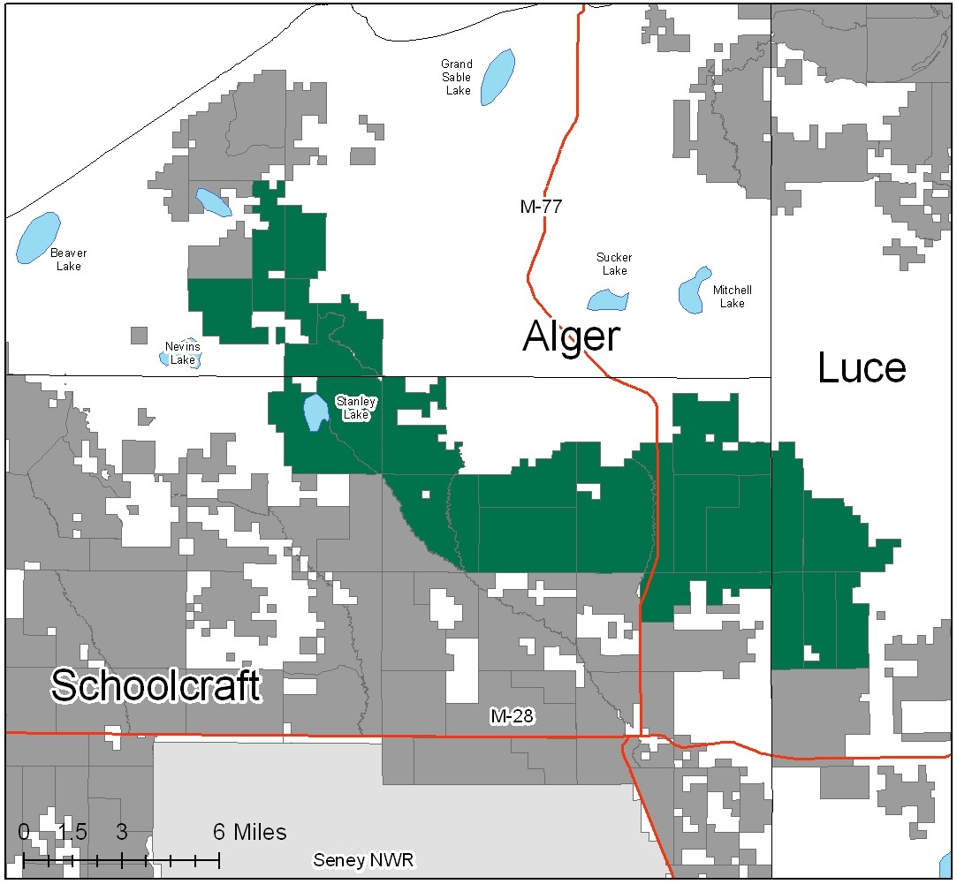

Attributes

The Danaher Kingston Outwash Management Area is located in the northwest part of the Eastern Upper Peninsula in Alger, Luce and Schoolcraft counties and has approximately 58,720 acres of state-owned land. The attributes which were important in identifying this MA include:

- Ecological Classification - The MA falls within the Grand Marais Glaciofluvial Moraine Complex sub-section of the EUP Ecoregion as classified by Cleland (2006).

- Landforms - The dominant landform consists of sandy outwash plains, with corridors associated with streams.

- Cover Types - The original forests of hemlock, upland hardwoods and mixed pine were altered by 1800’s logging, subsequent forest fires, and planting in the 1960’s to the current jack and red pine dominated forests. Large openings were created by historic logging and fires, and are maintained as habitat for open-land dependent wildlife species. The current vegetative cover is mainly grass, red pine, jack pine and white pine, with smaller amounts of aspen and hardwoods. Open land and pine management are primary attributes in this MA.

- Cultural - Remains of old railroad grades and pine camps can still be found. Kingston Plains, a large opening with pine stumps from the historic logging days, and other old logging openings are found within this MA. A CCC camp was located north of Seney, near M-77.

- Social / Economic - This MA includes the following recreation facilities: Fox River Pathway, East Branch Fox River State Forest Campground, Danaher ORV trail and trailhead, and snowmobile trails. Blueberry picking, hunting, trapping and wildlife viewing are popular here.

- Special Features - High quality, special protection trout streams that occur in this MA are the Fox River, Little Fox River, Camp Seven Creek, East Branch Fox River, and Tahquamenon River. The Fox River, and East Branch Fox River are state designated Natural Rivers. Management for trout streams is another primary attribute. A dam creates the Stanley Lake wildlife flooding. This flooding also provides angling fisheries (Yellow Perch and Northern Pike). Fisheries Division manages two trout ponds in this MA. This MA contains one of several large open-land complexes in the EUP, and management for wildlife species including sharp-tailed grouse and upland sandpiper is a priority. This MA also contains a historic pine barrens natural community.

- Ownership size and connectivity - The state land in this MA is concentrated into large ownership blocks. Shingleton and Newberry Units share management responsibility.

Major Cover Types

- Red Pine - Red pine grows on 13,139 acres of this MA. Most of the acres in the 40-59 year age classes are planted stands. Red pine in older age classes are generally natural stands.

- Grass - Grass covers 12,968 acres of this MA, including the historical stump fields of the Kingston Plains.

- Jack Pine - Jack pine makes up 9,272 acres of this MA. There is a spike in the 40-49 year age class. In recent years, jack pine budworm outbreaks have adversely affected some stands in this MA.

- White Pine - White pine is the next most common cover type with 7,296 acres. White pine is often found in association with aspen, upland hardwood, and other pine species.

- Aspen - Aspen grows on 5,841 acres, 35% of which is in the 10-19 year age class. Aspen tends to grow slowly on these dry sites.

- Upland Hardwoods - Mixed hardwood stands grow on 4,725 acres. Most of this is a red maple/beech association, with white pine and hemlock mixed in. Beech Bark Disease is prevalent.

Total 58,270

Other Types include: Treed Bog, Upland Brush, Spruce Fir, Marsh, Hemlock, Non-stocked, Paper Birch, Swamp Hardwoods, Scotch Pine, Oak, Cedar, and Tamarack

Concepts of Management

- Red Pine (23% of the MA) - Where it is desirable and suitable sites exist, increase the acreage of red pine. Many of these plantations were done as strip plantings or 40 acre blocks. It is desirable to consolidate these for ease of management and to provide larger patches of contiguous habitat. Many of these plantations will be available for thinning this decade. Some of this red pine was planted on xeric (dry) sites that are too infertile for optimum red pine growth, and conversion to Jack Pine or open land should be considered.

- Grass (22% of the MA) - Maintain the historic value of the Kingston Plains stump fields through opening maintenance in key areas, thus benefiting open-land wildlife species. Consolidate small grass openings into larger blocks to enhance landscape values for open-land species. Continue to maintain large wildlife openings. Some areas of grass may be converted to red or jack pine to consolidate the acreage of those forest types for larger habitat blocks and ease of management.

- Jack Pine (16% of the MA) - Continue efforts to balance age classes in this decade. Where appropriate, harvest jack pine in large blocks (greater than 100 acres), especially concentrating on those areas directly adjacent to large openings. Consider regenerating some of these larger cut blocks to more dense stands of jack pine to encourage use by jack pine dependent wildlife species. Consider using natural regeneration techniques, including prescribed fire, to regenerate jack pine. Some areas of jack pine may be converted to grass to consolidate cover type acres into larger stands.

- White Pine (13% of the MA) - Generally white pine is managed using shelterwood harvesting systems. Allow natural succession of grass to white pine where site conditions favor quality white pine and they are outside of the large wildlife openings. Retain some large super canopy trees within these stands.

- Aspen (10% of the MA) - Maintain aspen acreage through timber sales, continuing to balance the age classes. Following retention guidelines, leave scattered trees and snags to benefit bird species such as common nighthawk and whip-poor-will.

- Upland Hardwoods (8% of the MA) - Encourage size and species diversity. Use single tree selection where quality warrants, and consider shelterwood or other even age treatments in lower quality stands. On lower quality sites, consider maintaining or increasing the hemlock and white pine component, and allow selected individual white pines to become super canopy trees. Follow Beech Bark Disease guidelines when harvesting, leaving some large beech trees to benefit wildlife. Consider underplanting oak or disease resistant beech to increase hard mast in these stands.

- Other –
- Maintain buffers along high quality trout streams, conforming to the requirements of the Natural River plan.
- Continue to remove scotch pine from this MA.

