Deer Park Management Area Summary

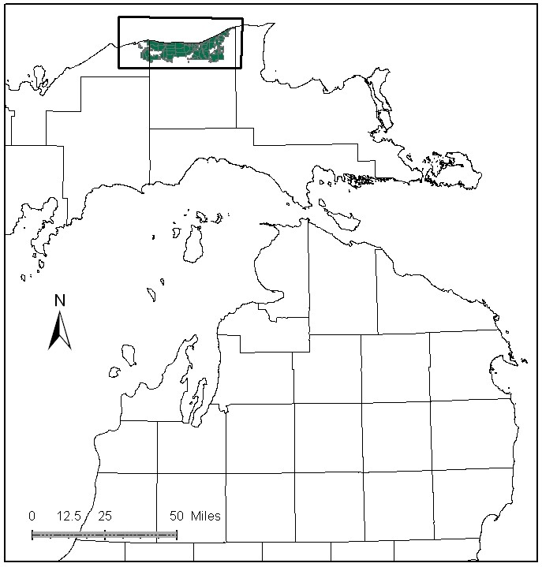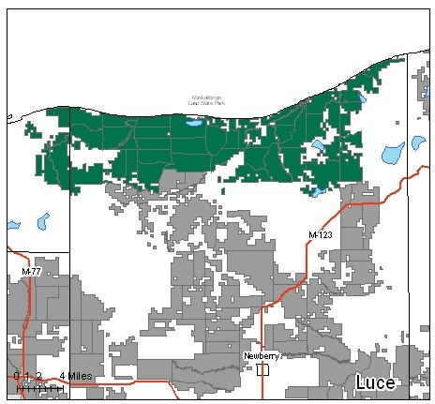

Attributes

The Deer Park Management Area (MA) is located in the center of the Eastern Upper Peninsula (EUP) east of Grand Marais, along the Lake Superior Shoreline. It is in Alger and Luce Counties and has approximately 93,528 acres of state-owned land. The attributes which were important in identifying this MA include:

- Ecological Classification - The MA falls within Grand Marais Glacio-fluvial Moraine Complex sub-section of the EUP Ecoregion as classified by Cleland (2006).

- Landforms - The major landforms consist of lacustrine sand and gravel.

- Cover Types – Both planted and natural red and jack pine are the most prevalent cover types in this MA. Natural mixed pine stands are also common. These pine types are intensively managed for timber, and it is one of the primary attributes in this MA.

- Cultural - Blueberry picking is popular here. The MA contains the Crisp Point Lighthouse site, the site of the Perch Lake CCC camp, and several known archeological sites.

- Social / Economic - Recreation and aesthetics are important factors of management, as many people visit to enjoy the natural mixed pine stands along Lake Superior. Recreational facilities include: the North Country Trail and trailhead, the Bodi Lake Pathway, and the following State Forest Campgrounds: Bodi Lake, Culhane Lake, Highbridge, Holland, Mouth of the Two-Hearted River, Reed and Green, Pike Lake, Perch Lake, Headquarters Lake, Lake Superior, and Blind Sucker 1 and 2. Both the Pine Ridge and Two-heart ORV Trails are found here, along with several snowmobile trails. Bear hunting, trapping of furbearing species, and wildlife viewing are popular in this MA. Recreation and aesthetics are also primary attributes of this MA.

- Special Features – Trout Streams with special protection include the following: Sucker River, North Branch Two Hearted River, Two Hearted River, East Branch Two Hearted River, and the Little Two Hearted River. Other trout streams include the Blind Sucker River and Wabash Creek. There are many lakes with angling fisheries including: Blind Sucker Flooding, Muskallonge Lake, Perch Lake, Chris Brown Lake, Muskrat Lakes, Pike Lake, Tank Lake, Holland Lake, Little Perch Lake, Culhane Lake, Bodi Lake, and Little Lake. The Two-Hearted River is a designated Natural River, and the surrounding buffer is included in a High Conservation Value area (HCVA). Other HCVA’s include the critical dunes/barrier dunes, and the critical coastal habitat of piping plovers. The Barfield Lakes Complex Ecological Reference Area (ERA) plan is complete. Intermittent wetland and bog ERAs, dry northern forest, dry mesic northern forest, and muskeg candidate ERAs have been identified in this MA. In addition, there are potential Biodiversity Stewardship Areas (BSA) in the MA, and a visual management area near Tahquamenon State Park.

- Ownership size and connectivity - The state land in this MA is concentrated. The Newberry and Shingleton Units are responsible for management.

Major Cover Types

- Jack Pine - Jack pine covers 33,464 acres of this MA. There are spikes in the 0-9 and 30-39 year age classes. Significant pest problems, such as budworm, have been detected in the older jack pine.

- Red Pine – Stands of predominately red pine cover 17,837 acres in this MA. Some of this red pine was planted by CCC camp workers. The age class distribution is imbalanced, with about 68% of the red pine stands being over 70 years old. Uneven aged stands have developed as a result of past harvesting practices, including the removal of jack pine from the stands.

- White pine – Covers 9,086 acres in this MA. Almost half of the acreage is in multiple aged stands with mixed species. About 42% of the stands are over 70 years old.

- Upland Hardwoods - Covers 6,988 acres in this MA. The quality of the upland hardwood is variable within this MA. Most of these acres are managed as uneven aged.

- Treed Bog - Covers 3,691 acres in this MA. Many of these acres are within HCVA or ERA designated areas.

- Aspen - Covers 3,396 acres in this MA. Even though almost 60% of the aspen is less than 30 years old, there are still opportunities for regeneration harvests in older age classes.
Total 93,528

Other Types include: Oak, Hemlock, Bog or Marsh, Sand Dune, Swamp Hardwood, Upland Brush, Non Stocked, Scotch Pine, Lowland Poplar, and Tamarack

Concepts of Management

- Jack Pine (36% of the MA) - To continue working toward balancing the age classes, a large number of acres of pure jack pine will be harvested in this decade, concentrating on stands damaged by budworm. Due to site conditions near Lake Superior, jack pine stands may be managed on longer rotations than those used in other areas (70-80 years). To benefit jack pine dependent wildlife species, increase the size of some harvest areas to greater than 100 acres in size and consider increasing stem density within those stands.

- Red Pine (19% of the MA) – Many natural red pine stands have other pine species mixed in, and will be managed to maintain the mixed composition. Within planted areas, follow general red pine guidelines to thin pole stands. Work toward balancing age class distribution, using shelterwood or seed tree harvests to promote natural regeneration.

- White Pine (10% of the MA) - Use shelterwood/seed tree harvests to naturally regenerate white pine. Continue selection harvests in multiple aged mixed pine stands. Thin white pine pole stands with high BA. Retention of supercanopy white pine in these stands and mixed pine stands is an important habitat feature.

- Upland Hardwoods (7% of the MA) - Look for treatment options suitable to the site, such as single tree selection where quality warrants, and shelterwood or other even-age treatments in lower quality stands. Due to the low percentage of upland hardwood in this MA, maintaining the current acreage is important for wildlife. Stand level diversity, dead and down wood, and cavity/snag trees are necessary to maintain these high values for wildlife.

- Treed Bog (4% of the MA) – This community is valued ecologically as habitat for numerous species of plants and animals. Management activities conducted within this cover type should follow approved ERA management plans to preserve these values.

- Aspen (4% of the MA) – Follow general guidelines to conduct regeneration harvests after age 50, and continue to work on balancing the aspen age class distribution where opportunities allow. Inaccessible aspen stands will succeed to shade tolerant cover types.

- Other –
  - ERA’s will be managed to enhance and protect their natural vegetative and associated wildlife communities as directed by site-specific management plans for each ERA.
  - Following the director’s order to protect nesting shorebirds, Law Enforcement Division will place special emphasis on protecting nesting shorebirds by investigating complaints of illegal ORV use along the Lake Superior shoreline.
  - Continue efforts to remove scotch pine and other invasive plant species.

