Drummond Island Management Area Summary

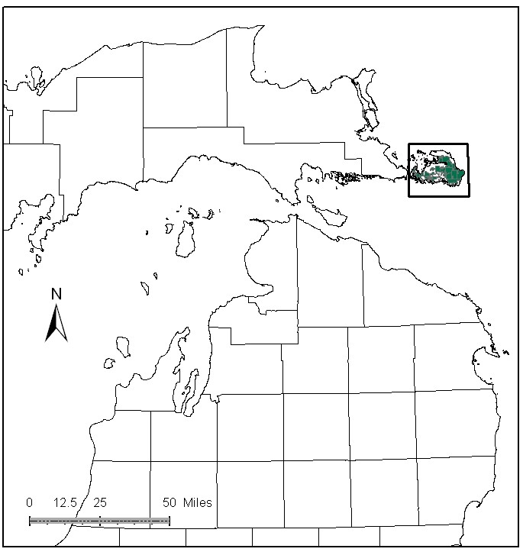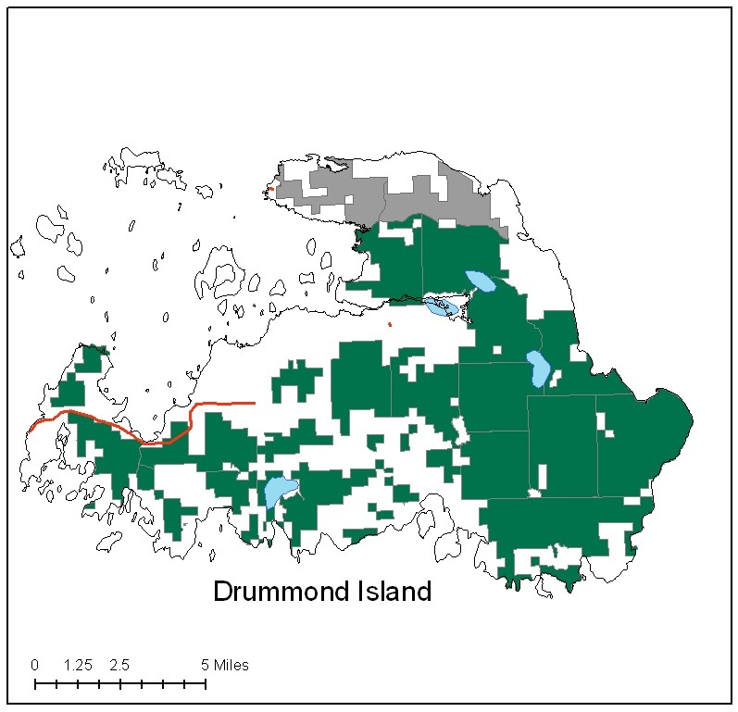

Attributes

The Drummond Island Management Area, located in Chippewa County, has approximately 43,359 acres of state-owned land. The attributes which were important in identifying this MA include:

- Ecological Classification - The MA falls within St. Ignace Lake Plain sub-section of the EUP Ecoregion as classified by Cleland (2006).

- Landforms – The dominant landform is part of the Niagaran Escarpment spanning Lake Michigan and Lake Huron; underlying limestone bedrock is typically less than 50 feet below the surface. Limestone bedrock is exposed in many places, especially along the coastline. This southern portion of Drummond Island has deeper soil over the limestone substrate and less area of Alvar, as compared to the north part of the island, known as Maxton Plains. Landform is one of the primary attributes in selecting this MA.

- Cultural – Drummond Island is the site of historic Fort Drummond, used by British Forces, circa 1812. There was a large Indian village on the island before the Fort was built here, and there are many additional known archeological sites within this MA.

- Social / Economic - Recreational facilities within the MA include: snowmobile trails, ORV trails, ORV route, and a boat launch. This area is popular for kayaking, fishing, hunting and trapping. There are several full sized vehicle off-road events held on the island each year under DNR permit. The ferry system was upgraded to allow logging of pulpwood during the late 1980’s and 90’s. Hunting for deer, grouse and bear are important forms of recreation. Social economic considerations are primary attribute in this MA.

- Special Features – Within this MA is the Potagannissing River and a number of small, mostly shallow, lakes. Protection of marsh habitat for northern pike spawning is important in the Potagannissing system and McCormick’s marsh. The Potagannissing wildlife flooding is managed primarily for waterfowl, marsh birds and aquatic furbearing species. Most of the Special Conservation Area (SCA) deer wintering areas on the island is within this MA in cedar and lowland conifers along the coast. The coastal zone is habitat for several rare, threatened and endangered Great Lakes endemic species. Use by neotropical migratory birds is heavy along the southern coast. This MA has several Ecological Reference Areas (ERA’s) including sinkholes, boreal forest, alvar, limestone pavement lakeshore, and great lakes marsh. Candidate ERA’s include: limestone, bedrock glade, limestone bedrock lakeshore, and mesic northern forest.

- Ownership size and connectivity – The State Forest land in this MA is confined to Drummond Island, in both small and large parcels. The Sault Management Unit is responsible for management.

Major Cover Types

- Aspen – Covers 15,059 acres in this MA. Aspen has been harvested since ferry improvements, and improved markets on the mainland. Over 60% is over age 50; much of this is growing in association with Northern White Cedar.

- Cedar – Cedar covers 8,370 acres, and is often mixed with overtopping old aspen. Most stands are 100 or more years old; there are very few areas of young cedar. High deer populations may be preventing establishment and regeneration of cedar in some areas.

- Upland Hardwoods – Upland Hardwoods grow on 6,743 acres of the M.A, with almost all of the acreage being uneven-aged. Much of the hardwood was cut over in the 1920’s. Soils are productive but shallow, so growth is slower than on deeper soils. Maple regeneration is sparse in many areas due to moderate to severe browsing, and this has allowed beech to become the predominant species in many places.

- Lowland Poplar – Occurs on 2,248 acres of the MA. Some management has been completed in the last two decades, though there are still many acres over age 80. Access and the component of cedar affect management options.
Total 43,359

Other Types include: White Pine, Swamp Hardwoods, Tamarack, Non Stocked, Red Pine, Rock, Bog or Marsh, and Black Spruce

Concepts of Management

- Aspen (35% of the MA) – Continue to work toward balancing age classes, as markets allow. Following the Within Stand Retention Guidlines, maintain some stand level diversity of species. Consider upland game management strategies for species such as hare, ruffed grouse, deer and woodcock.

- Cedar (19% of the MA) – Within the winter deer habitat SCA’s, the primary management goal will focus on providing critical winter habitat for white-tailed deer. Harvest of cedar/aspen or cedar/poplar mixed stands will be limited. Retention of these stands will assure that a closed canopy structure is maintained. Attempt to identify areas of successful northern white cedar regeneration in inventory notes. Harvest will be considered where deer yard habitat is not impacted and cedar regeneration is likely. These efforts should be part of a comprehensive deeryard management plan.

- Upland Hardwoods (16% of the MA) – In upland hardwood, use single-tree selection where quality warrants, and consider shelterwood or other treatments in lower quality stands. Dead and down wood, snags, and cavity trees are important components within this type. Following the Within Stand Retention Guidelines, retain mesic conifers within the canopy and individual large diameter trees, particularly aspen, to benefit wildlife.

- Lowland Poplar (5% of the MA) – In accessible areas, continue to work toward balancing age classes. Lowland poplar in inaccessible areas will succeed to more shade tolerant species.

- Other –
  - Monitor the impacts of deer densities, forest management practices, and site condition on forest health and regeneration status.
  - ERA’s should be managed to protect and enhance their natural vegetative and associate animal communities, as directed by site-specific management plans for each ERA.
  - The limestone cliff ERA and associated rare species at Marblehead should be protected and monitored to ensure that damage from recreational activities is not occurring.
  - Monitor ORV and Jeep trails for ecological damage and repair trails as needed.
  - Continue partnerships and collaborations from Drummond Island ORV Workgroup to ensure recreational activities are compatible with resource protection.

