Fox River Complex Management Area Summary

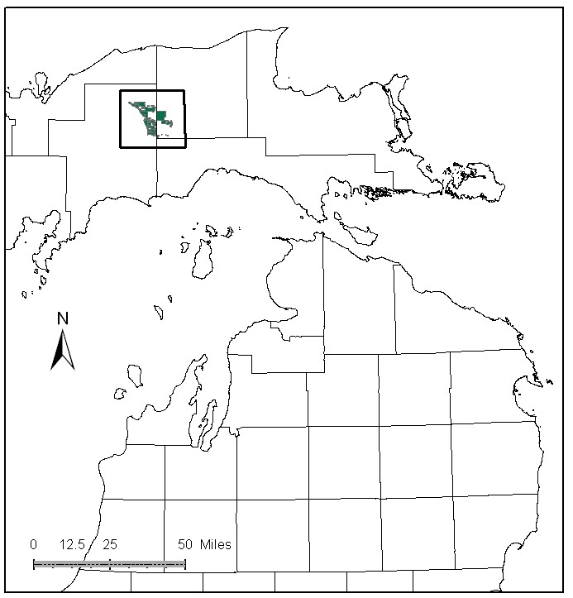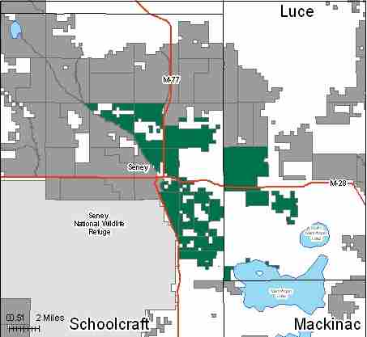

Attributes

The Fox River Complex Management Area is located in the west part of the Eastern Upper Peninsula in Schoolcraft and Luce Counties, surrounding the town of Seney. It has approximately 27,217 acres of state-owned land. The attributes which were important in identifying this MA include:

- Ecological Classification – The majority of the MA falls within the Seney Lake Plain sub-section of the EUP Ecoregion as classified by Cleland (2006).

- Landforms – Landforms of lacustrine origin. Broad, poorly drained embayments contain beach ridges and depressions (swales), sand spits, transverse sand dunes, and sand bars. Deltaic deposits occur along the northern margins of the embayments, where glacial meltwater streams carried massive amounts of sand into the shallow waters.

- Cultural – The famous author, Ernest Hemmingway, fished the Fox River and wrote about his experiences in the story titled “Big Two-Hearted River”. The town of Seney was at one time a large logging community.

- Social / Economic – The town of Seney is in this MA at the intersection of highways M-28 and M-77. Recreational facilities found here include: snowmobile trails and boat launches on Manistique Lake and the Fox River. Fishing and hunting are very popular forms of recreation in this MA. Special fishing regulations apply to the Fox River system. There is a mineral lease for a sand pit north of Seney.

- Special Features – The Fox River, East Branch of the Fox and their tributaries are designated as Natural Rivers, and their corridors are considered High Conservation Value Areas (HCVAs). The Fox River and the East Branch of the Fox are also trout streams. There are large potential Biodiversity Stewardship Areas (BSA) identified within the MA, and a Special Conservation Area (SCA) deer wintering yard near Manistique Lake. These special features are primary attributes for this MA.

- Ownership size and connectivity – The state land in this MA is concentrated into large blocks, with private holdings scattered throughout. This management area borders the east side of the Seney National Wildlife Refuge. Shingleton and Newberry Units share management responsibility.

Major Cover Types

- Mixed Swamp Conifer – There are 5063 acres of Mixed Swamp Conifers in the MA, and over 65% is over age 60. Access is often difficult due to wet sites.

- Lowland Brush / Bog or Marsh / Marsh – Lowland brush covers 3,501 acres, bog or marsh occurs on 1,879 acres and marsh covers 1,758 acres of the MA. These cover types contribute to the access issues in the MA. These cover types also contain important habitat components, including breeding cover and winter food sources, that are used by a number of wildlife species. Uncommon songbird, owl, and plant species are found in these types. This MA has some very old tag alder sites.

- Black Spruce – Over 80% of the 2,495 acres of black spruce in this MA is over age 60. Harvest opportunities in some of these stands are limited by wet ground, or other access issues.

- Aspen – Covers 1,848 acres in this MA. Over 75% of the aspen is in the 0-29 year age classes. Most of the aspen acres in the older age classes are inaccessible.

- Northern White Cedar – Of the 1,847 acres of Cedar in the MA, most is over 70 years old, and half is over 100. Access and other conservation values have influenced the amount of harvesting in this cover type.

- Upland Hardwoods – Covers 1,722 acres in the northwest and southern portions of the MA. The majority of these stands are being managed as uneven aged.

- Red Pine – A large amount of natural red pine stands exist on 1,709 acres in this MA. Many of these stands are found on small islands within marshes, and are often hard to access. There are a few planted stands of red pine as well.

Total 27,217

Other Types include: Lowland Poplar, Non Stocked, Water, Spruce Fir, Hemlock and Upland Brush

Concepts of Management

- Mixed Swamp Conifer (19% of the MA) and Black Spruce (9% of the area) – Where possible, conduct regeneration cuttings in a manner that will not adversely impact wetland soils or deer wintering habitat.

- Lowland Brush (13% of the MA) / Bog or Marsh (7% of the MA) / Marsh (6% of the MA) – Continue to manage these large roadless areas for wildlife and other ecological concerns, primarily by allowing natural processes to occur.

- Aspen (7% of the MA) – Continue to work toward balancing the age classes where access allows. Allow inoperable aspen areas to succeed to late successional species.

- Cedar (7% of the MA) – Maintain closed canopy cedar within the deer wintering areas, and do not harvest cedar where cedar regeneration is unlikely. Chipping operations in other cover types adjacent to deer yards may be restricted.

- Upland Hardwoods (6% of the MA) – In upland hardwood, use single-tree selection where quality warrants, and consider shelterwood or other treatments in lower quality stands. Underplant oak and disease resistant beech on suitable sites. Retain dead and down wood, snags and cavity trees within this type. Consider retaining a mesic conifer component within the canopy of these stands.

- Red Pine (6% of the MA) – Manage the natural red pine stands using shelterwood/seed tree systems when possible to encourage natural regeneration. Some small island stands of red pine may never be harvested due to size and lack of access, and will be allowed to reach full biological maturity.

- Other –
  - Observe Natural River Guidelines.
  - Continue the cooperative glossy buckthorn control project with the Seney National Wildlife Refuge, and the removal of scotch pine and other invasive plant species as resources allow.

