Garden Thompson Plains Management Area Summary

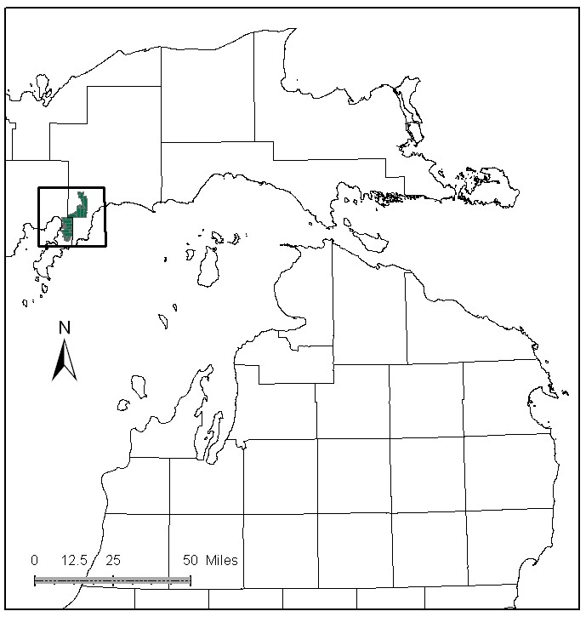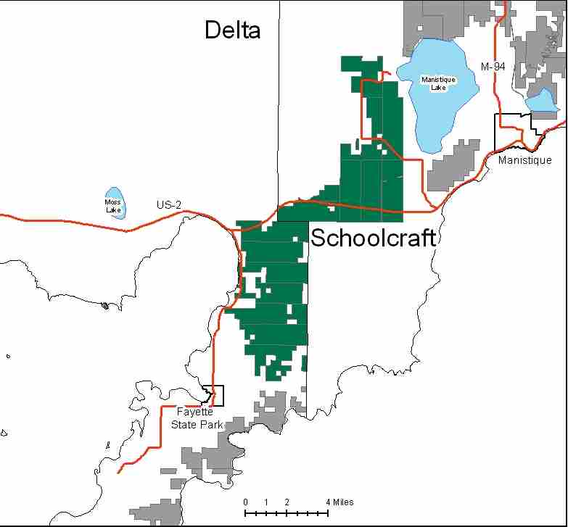

Attributes

The Garden Thompson Plains Management Area is located in the western part of the Eastern Upper Peninsula in Schoolcraft and Delta Counties. It has approximately 27,408 acres of state-owned land. The attributes which were important in identifying this MA include:

- Ecological Classification - The MA falls within the Escanaba Lake Plain and Thin Till sub-section of the EUP Ecoregion as classified by Cleland (2006).

- Landforms - The dominant landform consists of sandy lake plain and limestone bedrock at or near the surface.

- Cover Types - The upland forest types within this area are intensively managed mainly due to excellent access. There is a core area along US-2 which is managed for red pine. In addition, there is a large opening complex which is managed for wildlife; these are the primary attributes of this MA.

- Cultural - A sesquicentennial pine stand was planted along US-2 in 1997. Historic Fayette State Park is nearby. There are several known archeological sites within the MA.

- Social / Economic - US-2 runs through this area providing good transportation to mills and markets; resulting in high prices received for wood from this area. Illegal ORV use and trash dumping are prevalent, due to proximity to population centers. There are snowmobile trails and a ski trail in the MA. Palms Book and Indian Lake State Parks are nearby. Hunting is very important, especially in the early successional cover types.

- Special Features - This MA contains several Michigan Natural Features Inventory (MNFI) recognized element occurrences including: wooded dune and swale, northern fen, intermittent wetland, and bog. There are Special Conservation Area (SCA) deer wintering areas within the MA. This management area has a unique climate along Lake Michigan. Coniferous species and red maple near Lake Michigan have a high value to neotropical migrating bird species. Autumn Olive eradication efforts have been conducted in this MA. Trout streams in the MA include: Dufour Creek, Silver Creek, and the headwaters of the Fishdam River. A small portion of wooded dune and swale Ecological Reference Area (ERA) is within this MA, and two intermittent wetland ERA’s. The Thompson Plains is one of several open-land complexes that span across the EUP. Primary values associated with the plains are the maintenance of an herbaceous community suitable for species such as sharp-tailed grouse and upland sandpiper.

- Ownership size and connectivity - The state land in this MA is concentrated. Most of the MA was acquired in a land exchange with the Federal Government for State in-holdings within the Hiawatha National Forest. The Shingleton Forest Management Unit is responsible for management.

Major Cover Types

- Aspen - Aspen is the most common cover type with 8,552 acres. Harvesting of aspen has been intensive, and 78% of the aspen cover type is in the 10-39 year old age group. Some of this acreage is the result of treating stands that contained a mix of aspen and other species, with the aspen becoming dominate after treatment.

- Upland Hardwoods - Upland hardwoods make up 3,586 acres, over 70% of which is managed as uneven aged. The majority of the hardwood is found in the northern portion of the MA, and is of good quality. In the Garden Peninsula, hardwood quality is generally poor, so stands are not all managed as uneven aged. Since beech is a major component in these hardwood stands, the stands will be severely impacted by beech bark disease.

- Red Pine - Red pine occurs on 2,986 acres. Much of this red pine is of planted origin on high quality sites, and is intensively managed. Most stands have been thinned more than once, and several have been regenerated by planting.

- Cedar - Northern white cedar occurs on 2,091 acres in this MA. Over half of these stands are over 100 years old. Most of this acreage is in uneven age stands, and provides important wintering habitat for deer.

- Grass - Grass openings occur on 1,830 acres in this MA. These areas are intensively managed, mainly through prescribed burning, for open-land species including sharp-tailed grouse.

- Mixed Swamp Conifer - This cover types occurs on 1,295 acres, 80% of which is over 60 years old. Very little harvesting has occurred in this cover type, and younger age classes are under-represented.

- Jack Pine - Jack pine grows on 1,069 acres, most of which is of planted origin. Over half of the acres in this cover type are 0-29 years old, reflecting recent intensive harvesting. Due to high site quality, most of the historic planted jack pine has been converted to red pine and is now reflected in that cover type. The young stands provide habitat for species including the Kirtland’s warbler.

- Oak - There are 1,023 acres of oak stands in this MA, and oak is found in other cover types as well. The distribution is currently exclusive to the 60-89 year age classes. This is one of the few locations within the Shingleton Management Unit where oak grows, and some limited harvesting has occurred in an attempt to expand the cover type. It provides an important source of hard mast for a variety of wildlife species including deer and bear in this landscape.

Total 27,408

Other Types include: Lowland Poplar, Spruce Fir, Non stocked, White Pine, Treed Bog, Marsh, Swamp Hardwoods, Water, Bog or Marsh, Scotch Pine, Tamarack, Upland Brush and Rock

Concepts of Management

- Aspen (31% of the MA) - Continue regeneration harvests, working towards balanced age class distribution, harvesting older age groups when possible. During harvesting, follow the Within Stand Retention Guidelines, leaving scattered conifers and oak.

- Upland Hardwoods (13% of the MA) - In upland hardwood, use single-tree selection where quality warrants, and consider shelterwood or other treatments in lower quality stands. Due to Beech Bark Disease, salvage cuts will likely be necessary; with underplanting of disease resistant beech or oak to follow, to replace mast producing trees.

- Red Pine (11% of the MA) - Timber management of planted red pine is a strong focus here, with stands scheduled for final harvest being replanted to red pine. Work toward balancing the age class distribution of these stands.

- Cedar (8% of the MA) - Cedar stands will be managed to maintain wintering habitat for deer in yarding areas and to retain this forest type in the landscape. Maintaining a closed canopy provides important cover for deer, reducing snow depths within the stands. Given the difficulty of successfully regenerating cedar, retention of most or all stands is warranted.

- Grass (7% of the MA) - Intensive management of grass openings will be maintained, using prescribed burning and mechanical treatment to encourage early successional plants and associated open-land wildlife species. Discourage non-native invasive species by using appropriate control methods where feasible and practical.

- Mixed Swamp Conifer (5% of the MA) - Harvest of this cover type has not been a focus in the recent past, though it will become more important as most of these stands are reaching rotation age. When planning harvests near the Lake Michigan shoreline, consider the value of this cover type for migrating neotropical bird species, and yarding deer.

- Jack Pine (4% of the MA) - Continue to work toward balancing the age class distribution, regenerating older stands when possible. Manage stands to encourage habitat for early successional jack pine dependent species.

- Oak (4% of the MA) - Encourage oak regeneration whenever possible. Maintain oak as a component within all stands where it occurs.

- Other –
  - ERA’s will be managed to enhance and protect their natural vegetative and associated wildlife communities, as directed by site-specific management plans for each ERA.
  - Work with Law Enforcement Division on trash dumping and illegal ORV use issues.

