Gogomain Management Area Summary

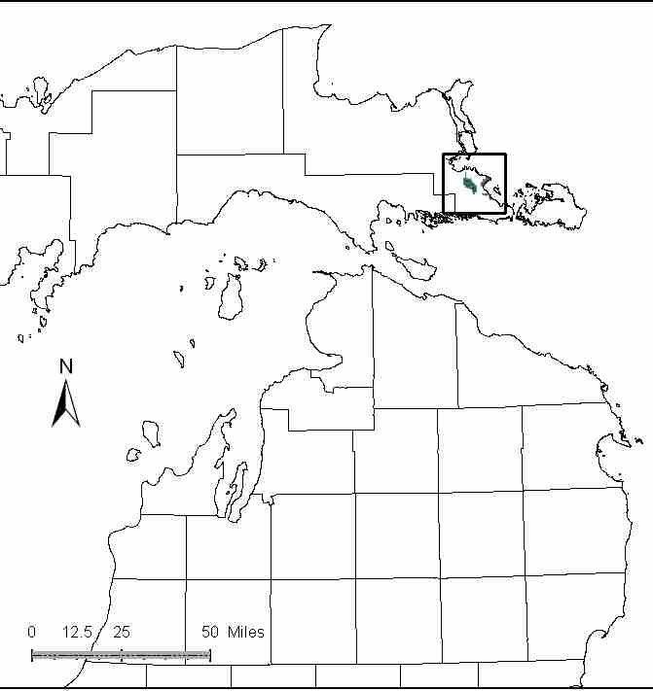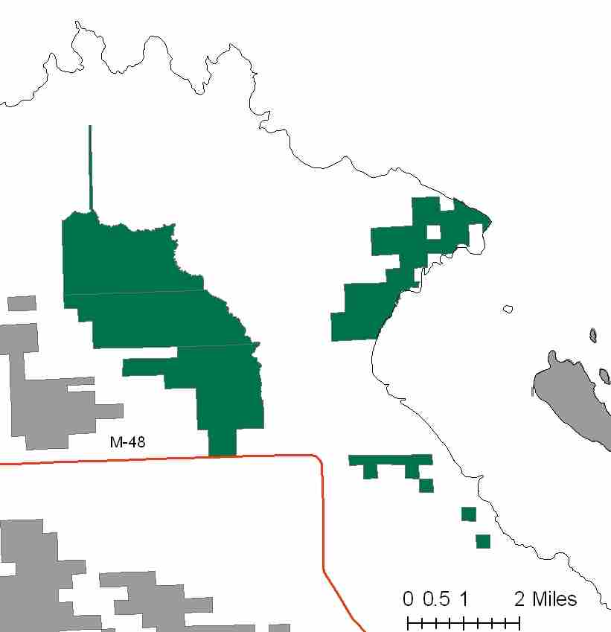

Attributes

The Gogomain Management Area is located in the far south-eastern portion of the Eastern Upper Peninsula in Chippewa County. It has approximately 7,226 acres of state-owned land. The attributes which were important in identifying this MA include:

- Ecological Classification - The MA falls within the St.Ignace Lake Plain sub-section of the EUP Ecoregion as classified by Cleland (2006).

- Landforms – The dominant landform consists of clay lake plain modified by glacial outwash- known as the Rudyard clay flats.

- Cover Types – The dominant cover type in this MA is cedar.

- Cultural - Past history includes the location of lumber camps. Much of this property was recent acquisition for wintering deer. In part of the MA, a portion of ancient lake bed is exposed.

- Social / Economic – The snowmobile trail passes to the northeast of the deer yard complex. Some illegal ORV use is occurring in this MA.

- Special Features - A large portion of the historic Gogomain Deer yard is within the MA. This was a recent acquisition of state forest land. A detailed inventory was performed in 2008 and it was determined that a large portion of the acquisition is the largest high quality Rich Conifer Swamp in the State and is a candidate ERA. Several T&E species were also located. There is a Great Lakes Marsh natural community ERA along this coast, where some fish spawning occurs. The Gogomain swamp is headwaters for small trout streams, but these streams warm as they flow to the St. Mary’s River. Due to the unique geology of the lakeshore, there is an exposed area of fossil beds along the St. Mary’s River. Special features are the primary attributes in this MA.

- Ownership size and connectivity – Most of this area was recently purchased with wildlife funds. This is the primary purpose for ownership and for selection as a management area. There are other lands in this area under consideration for purchase to enhance the deer yard/wildife use capability. An effort had begun in 2007 for the DNR Service Forester and Landowner Incentive Program biologist to meet with private landowners to discuss private land management. This effort was halted in 2007 due to funding elimination. The Sault Unit is responsible for management.

Major Cover Types

- Northern White Cedar - This cover type dominates 4,394 acres, and is the most widely represented cover type in this Management Area. None of the other cover types come close in size. Cedar is also found in other cover types as a minor species. Northern white cedar stands are most common in the basin portion of the MA. The closed canopy cedar provided winter thermal protection for white-tailed deer as well as cover for many other species of wildlife. Much of the cedar is over 70 years old and most is in the 100+ age class.

- Swamp Hardwoods – Covers 416 acres in this MA. While there are stands in most of the age classes, almost half of this cover type is within the 60-69 year age class.

- Upland hardwoods – Upland hardwoods are found on 414 acres of the management area. Most of the stands are currently in the 81 to 110 square foot basal area range, and may not be entered until the next decade.

- Lowland Mixed and Mixed Swamp Conifer – Lowland mixed types are found on 339 acres, and mixed swamp conifer stands are found on 332 acres in this MA. A significant portion of both of these cover types is over 100 years of age.

Total 7,226

Other Types includes: Upland Mixed Deciduous, Marsh, Black Spruce, Upland Mixed, Upland Mixed Conifers, Grass, Red Pine, Water, Non Stocked, Upland Brush

Concepts of Management

- Northern White Cedar (61% of the MA) – A large portion of this cover type is in an advanced stage of natural regeneration by layering and seeding. There may be some opportunities to manage cedar along the eastern part of the MA, where operations would not destroy the current regeneration and high quality rich conifer swamp community. In cooperation with adjacent landowners, work to develop a deer yard management plan.

- Swamp Hardwoods (6% of the MA) – Conduct regeneration harvests, working toward balancing the age class distribution.

- Upland Hardwoods (6% of the MA) – Use single tree selection where quality warrants, and consider shelterwood or other treatments in lower quality stands. When adjacent to deeryards, consider winter harvest to feed deer. Retention of dead and down wood, snags/cavity trees, and mesic conifers in the canopy is beneficial to wildlife species. Retain a component of large diameter trees to increase structural diversity.

- Lowland Mixed (5% of the MA) and Mixed Swamp Conifer (5% of the MA) – Conduct regeneration harvests in areas with probable success and where deeryards and high quality rich conifer swamp natural community will not be impacted. Focus on balancing the age class distribution, where possible.

- Other –
- Continue to work toward balancing the age class distribution within the remaining minor cover types in this MA.
- Work with Law Enforcement Division to control illegal use of ORVs in this area.

