Great Lakes Islands Management Area Summary

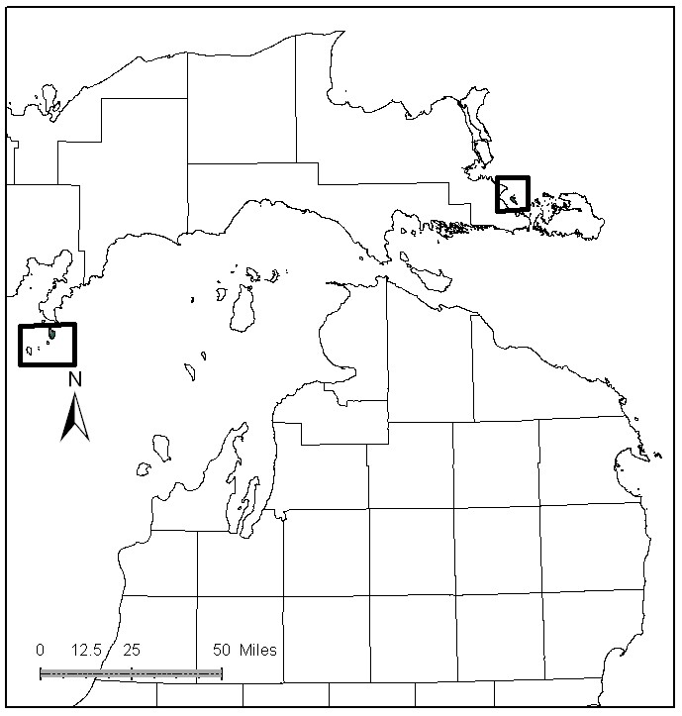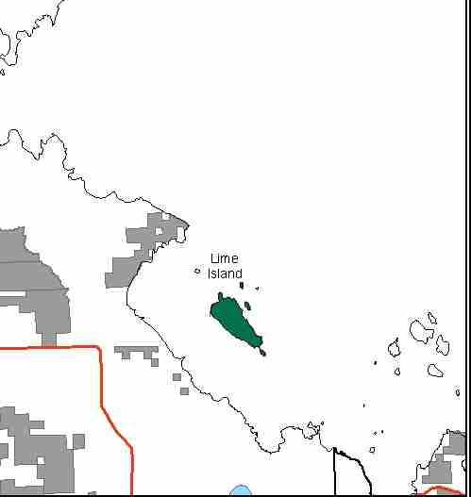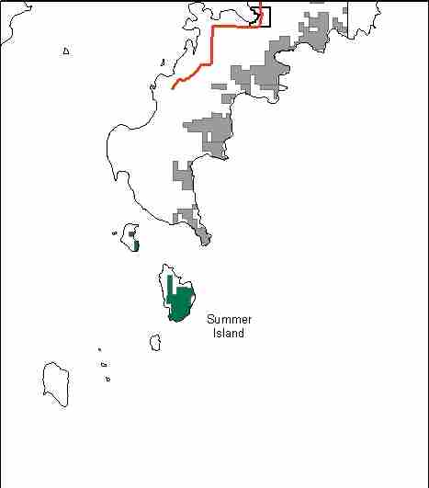

The management of all state owned islands within the ecoregion is primarily the same, so all of the islands were included within this MA, with the exception of Drummond Island. The Management Area was selected for the unique features of Great Lake Islands which are associated with State Forest Lands. These include the Summer Islands (off the Garden Peninsula), Mable Annette Island and Saddlebag Island (West of Detour), and islands in the Lime Island Group (Lime, Little Lime, Love, and Hart Island). There are also a few small islands in Lake Superior including Round and Tahquamenon Island. In addition, there is also non-compartmentalized state forest land on predominately private islands, such as on Sugar, Neebish, and Marquette Islands. It is important to realize that the value of a collection of islands is much greater than the sum of the individual islands’ resources (Soule, 1993), and that management should be considered at an ecological landscape scale.

Excluding Drummond Island, there are approximately 2,346 acres of state-owned land in the MA. The attributes which were important in identifying this MA include:

Attributes

- Ecological Classification - These islands are found along the shores of all three of the Great Lakes in the MA and in the St. Mary’s River in a variety of ecological sub-sections.

- Landforms – The landforms of Great Lakes islands are variable, but many in Lakes Michigan and Huron are characterized by limestone bedrock at or near the surface.

- Cultural - Lime Island Group of islands have historic and prehistoric values

- Social/Economic - Management of Lime Island has a large recreational focus, with rental cabins and a protected harbor. Islands may also provide an area for rest or refuge for recreational boaters. Lime Island specifically is used as an area of refuge for small boats fishing this stretch of the St. Mary’s River.

- Special Features – Coastline areas are important, as shallow, near shore area of islands can provide important fish spawning and nursery habitat. Many plants and animals find unique habitats on these islands. Critical seasonal use occurs, such as spawning shoals and migration stops. Many islands are used by colonial nesting water birds such as ring-billed and herring gulls, common and Caspian terns, black-crowned night heron, and the double-crested cormorant. Many of the islands with forest inventory data have been designated as Special Conservation Areas (SCA) for potential Biodiversity Stewardship Area (BSA) stands. In years of lower water levels small sand and gravel spits and bars are created. These are very important to nesting and migrating shorebirds.

- Ownership – The Sault and Shingleton Management Units are responsible for management.

Major Cover Types

- In the west part of the MA, in Delta County, Summer and Little Summer Island are dominated by cedar, upland hardwood, and birch. All stands on both islands are listed as potential Biodiversity Stewardship Areas (BSA). Both islands contain Ecological Reference Areas (ERAs), and are portions of a deer yard. Both are on the limestone bedrock associated with the Niagara Escarpment which runs across the ecoregion.

- In the east part of the MA, in Chippewa County, Mable Annette Island and Saddlebag Island are just east of the M-48/M-134 intersection. They are very small islands. Mable Annette is entirely state forest land (1.3 ac.), and Saddlebag Island has only 4.5 acres of state forest land. Natural white pine and lowland brush is found here.

- The Lime Island Group is located off the east tip of the mainland, and to the north of Drummond Island. These islands have historic and prehistoric values. Vegetative cover types are a mixture of northern white cedar, lowland hardwoods and upland hardwoods. The cedar and upland hardwoods are greater than 90 years of age. Michigan Natural Features Inventory has many element occurrences on these islands. The islands are associated with two potential Biodiversity Stewardship Area (BSA) listings.

- Sugar, Neebish and Marquette Islands are almost entirely in private ownership. Although, they all get use by boaters, hunters, and fishermen, Sugar and Neebish are reached by scheduled ferry service. Marquette can only be reached by boat. Cover types are mostly upland hardwoods with some cedar and lowland hardwood. Opportunities for active timber management have always been limited.

For Islands with inventory data:
Total 2,346

Concepts of Management

- As a general rule, there will be no intensive vegetative management of great lakes islands within this MA. The focus will be on protection and enhancement of Great Lake Islands’ special features and ecological functions. The vegetative types will be managed in an old growth condition. The only exception will be for some prescriptions on Lime Island, near the recreation facilities.

- Some islands in the MA including: Naubinway Island, Paquin Island, Snake Island, some islands in the Les Cheneaux chain, and Gem and Rock Island in Lake George on the St. Mary’s River have been managed to control double-crested cormorant populations through egg-oiling procedures, harassment of adults and lethal take. Care should be taken to ensure that non-intended consequences to co-nesting species are minimized. Intentional release of predators in an effort to “control” cormorants on the islands is illegal and needs to be discouraged.

- The degree of human impacts on Great Lakes islands should decrease in proportion to the increasing ecological and/or historical and cultural sensitivity.

- Some islands, such as Summer Island, are experiencing illegal ORV activity that will need to be addressed by Law Enforcement Division (LED).

