Hiawatha Moraine Management Area Summary

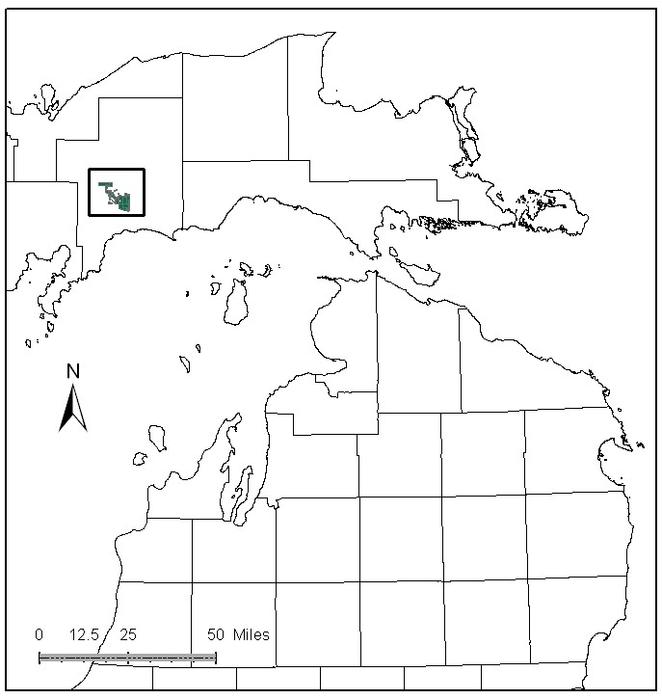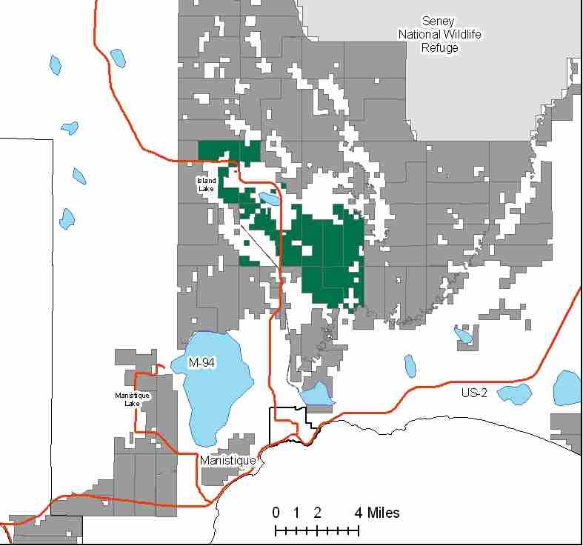

Attributes

The Hiawatha Moraine Management Area is located in the Central Upper Peninsula, north of the city of Manistique, in Schoolcraft County. It has approximately 13,374 acres of state-owned land. The attributes which were important in identifying this MA include:

- Ecological Classification - The MA falls within Seney Lake Plain sub-section of the EUP Ecoregion as classified by Cleland (2006).

- Landforms - The dominant landforms consist of lacustrine sand and gravel.

- Cover Types - This is a productive upland almost surrounded by the Seney Manistique Swamp Management Area. This MA is intensively managed for timber, and contains a large open-land complex for open land wildlife species; these are the primary attributes for this MA.

- Cultural - The High Rollaways, a historic pine logging area along the Manistique River, and the Smith Lake CCC camp are within the MA. This area is used for blueberry picking.

- Social / Economic - Some illegal ORV use is occurring, especially near small lakes and ponds of the northwest portion. Snowmobile trails, including the Haywire Grade, run through this management area.

- Special Features - There are public access sites at Dodge Lake and Island Lake; Smith Lake is also in the MA. Trout streams in the MA include: Brace Creek, Hiawatha Creek, and Southside Creek. The Manistique River and Stutts Creek support warm-water fish communities (walleye, northern pike, etc.) and provide habitat connectivity between upper and lower stream reaches due to the absence of dams and other barriers in the Manistique River watershed. There is a Special Conservation Area (SCA) deer use area within the MA. Also, there are potential Biodiversity Stewardship Areas (BSA) within the Manistique River corridor. The High Rollaways is part of an extensive open-land complex in the EUP. Management of this site is focused primarily on providing habitat for open-land wildlife species such as sharp-tailed grouse and upland sandpiper.

- Ownership size and connectivity - The state land in this MA is fairly concentrated, though surrounded by private ownerships. The Shingleton Unit is responsible for management.

Major Cover Types

- Aspen - Aspen occurs on 3,371 acres, 80% of which are in the 0-39 year age classes.

- Red Pine - Occurs on 2,464 acres in the MA, 60% of which are in the 40-59 year age classes due to planted stands. Many of these acres will be available for thinning over the next ten years.

- Upland Hardwood - Upland hardwoods cover 2,122 acres, most of which is managed for an uneven-aged structure. There are some quality hardwoods to the southeast and east, and by lake moraines. Beech Bark Disease is becoming an issue here.

- Grass - Grass openings cover 1,068 acres. Some of the large openings are filling in with aspen and other species. Prescribed burning has been done to create better conditions for deer coming out of the yards in late winter and early spring; opening maintenance also benefits sharp-tailed grouse and other open-land wildlife species.

- Jack pine – Jack pine grows on 685 acres in this MA. There are some jack pine planted stands in the south near the red pine stands but most of the acres are natural stands in the north part of the MA.

- White Pine – White pine is located on 659 acres of the MA. Most stands are of planted origin, but some natural, uneven-aged stands are also present. There has been no regeneration in the past two decades.

- Mixed Swamp Conifers – Mixed swamp conifers grow on 643 acres of the MA. Most stands are in the 60-89 year age classes. There are been some recent harvesting and regeneration of the type.

Total 13,374

Other Types include: Paper Birch, Swamp Hardwoods, Non stocked, Tamarack, Water, Lowland Poplar, Marsh, Spruce Fir, Hemlock, Bog or Marsh, and Treed Bog

Concepts of Management

- Aspen (25% of the MA) - Although most of the aspen has already been regenerated, continue working toward balancing the distribution of the age classes, by harvesting older age classes. Maintain inclusions of aspen within the other cover types where possible.

- Red Pine (18% of the MA) - Maintain the red pine acres within the MA. Harvest available stands through thinning, but look for opportunities to begin balancing the age class distribution with regeneration harvests. Maintain or enhance diversity within these stands by retaining other species where possible, particularly mast producing species.

- Upland Hardwood (16% of the MA) - Harvest using single tree selection, maintaining structural and species diversity within the stands. As Beech Bark Disease becomes more prevalent, when harvesting leave some large beech to benefit wildlife. Consider planting disease resistant beech seedlings and red oak for future mast. Retention of dead and down, snags/cavity trees is important in this type.

- Grass (8% of the MA) - Continue to maintain large openings for wildlife using effective methods including prescribed burning. Experiment with chipping operations to accomplish opening maintenance.

- Jack Pine (5% of the MA) - Maintain jack pine cover types where applicable. Focus on balancing the age class distribution.

- White Pine (5% of the MA) – There will be some harvest of mature stands in this decade, using shelterwood/seed tree harvests to provide for natural regeneration. Thinning may occur in younger stands to promote uneven-aged structure.

- Mixed Swamp Conifers (5% of the MA) – Begin to harvest some stands where accessible. Inaccessible stands will be subject to natural successional processes.

- Other –
  - Continue efforts to control access to sensitive areas. Expand work with Law Enforcement Division to address illegal ORV use as budgets allow.
  - When resources allow, attempt to purchase more critical wildlife habitat, such as the recent purchase within the Sturgeon Hole Deer Yard.
  - Encourage regeneration of oak to provide mast for wildlife.

