Kincheloe Highlands Management Area Summary

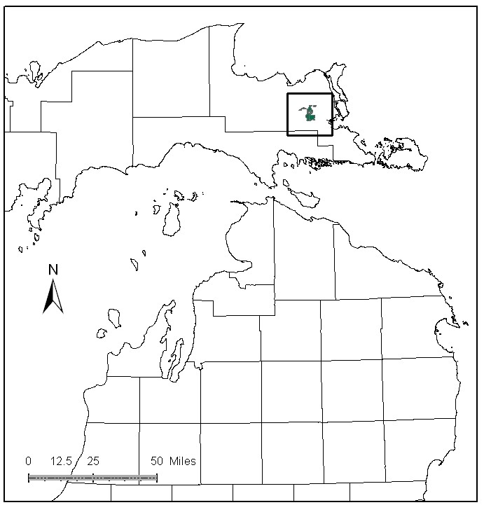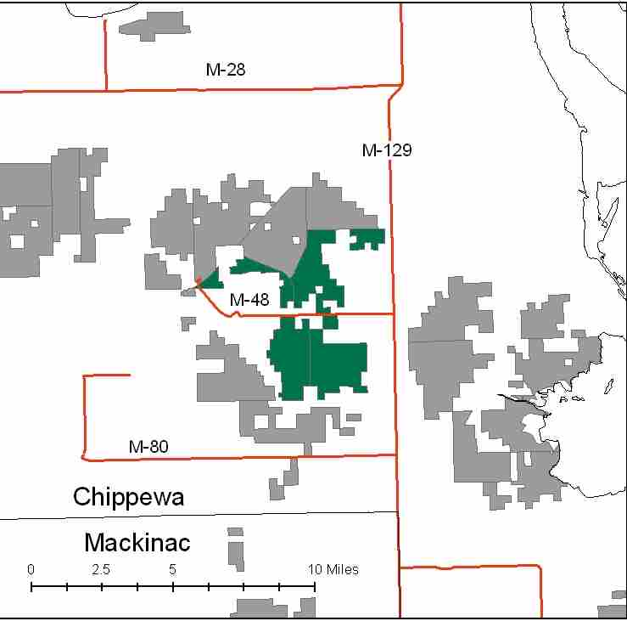

Attributes

The Kincheloe Highlands Management Area is located in the east central portion of the Eastern Upper Peninsula, in Chippewa County. It has approximately 7,786 acres of state-owned land. The attributes which were important in identifying this MA include:

- Ecological Classification - The MA falls within Rudyard Silty Lake Plain sub-section of the EUP Ecoregion as classified by Cleland (2006).

- Landforms –This is a small area of sand lake plain in the center of a broad clay lake plain. Within this small area of sand plain, there is a series of ancient beach ridges and swales, many miles from the present Great Lakes shorelines

- Cover Types – This area is selected for different site potential from adjacent state forest lands to the west. For instance, red pine, jack pine and northern red oak occur here, but are not common in adjacent MAs. There is a northern red oak seed orchard here. Timber production is a primary attribute for this MA.

- Cultural - This management area is surrounding the former Kincheloe US Air Force Base. There are some known archeological sites in the area. This area had prehistoric human use.

- Social / Economic – Recreational facilities in this MA include: motorcycle trails, snowmobile trails, and a cross country ski trail. The area is heavily used by local hunters. There have been numerous trash clean-ups, and trash dumping is a continual problem. The former Kincheloe Air Base now has several businesses and is the home of the Chippewa International Airport. It also has two prison complexes, a race track and the County Fairgrounds. This MA is where a new cellulosic ethanol production plant is proposed. Social and economic influences are primary attributes of this MA.

- Special Features – This MA contains part of the Little Munuscong River, which is trout habitat farther down stream, in addition to the headwaters of some cold water tributaries to the Charlotte River. There are also several small lakes and streams. Dukes Lake is stocked each year with trout. There is a northern red oak seed orchard in the MA. At this time, there are no known Special Conservation Areas (SCAs). The open marsh areas, lowland brush and agricultural fields attract influxes of boreal species such as snowy owls, hawk owls, boreal chickadees, and rough-legged hawks in the fall and winter months.

- Ownership size and connectivity – The state land in this MA is fairly concentrated surrounding Kincheloe. The Sault Management Unit is responsible for management.

Major Cover Types

- Red Pine – With 1,759 acres, red pine is the most common cover type in the MA. There are more red pine plantings here than in any other area east of I-75; over half of the red pine acres are in the 40-49 year age class. Most of this acreage will be available for thinning in the next decade.

- Aspen – Covers 1,382 acres in this MA. There is a spike in the 20-29 age class

- Upland hardwoods – The majority of the 1,134 acres of hardwoods has been managed as uneven aged. There are 600 acres in the 80 to 110 Basal Area class, but perhaps only a quarter of these will offer an opportunity for treatments. In the next decade, more opportunities for balancing age classes will exist.

- Northern Red Oak – Occurs on 618 acres; but most of this oak is found in uneven age stands in conjunction with other tree species. There are a high percentage of northern red oak and white pine mixes.

- Lowland Brush – Covers 589 acres and is often associated with beaver activity.

Total 7,786

“Other Types” include: Hemlock, Non Stocked, Lowland Poplar, Bog or Marsh, Water, Upland Brush, Paper Birch, and Treed Bog

Concepts of Management

- Red Pine (23% of the MA) – Following standard guidelines, continue to thin planted stands as they become available. Consider regeneration harvests to attempt to balance age classes. Older and uneven-aged stands will be harvested using shelterwood/seed tree methods to promote natural regeneration. Where over-mature red pines are limited on the landscape, consider leaving a component at the edge of stands.

- Aspen 18% of the MA) – There are limited opportunities to harvest additional aspen in this decade, however work should continue to balance age classes as opportunities allow, thus benefiting species such as hare, ruffed grouse, deer and woodcock. The spike in the 20-29 yr old age class will be reduced over several decades. Some 100+ year old aspen will succeed to more shade tolerant species.

- Upland Hardwoods (15% of the MA) – Look for opportunities to do single-tree thinning or selection sales where the upland hardwood quality is good. Consider shelterwood and other sale types where quality is poor. Dead and down wood, snags, and cavity trees are important components within this type. Following the Within Stand Retention Guidelines, protect mesic conifers within the canopy and individual large diameter trees, particularly aspen, to benefit wildlife. On suitable sites, underplant oak and disease resistant beech to replace mast lost to Beech Bark Disease.

- Oak (8% of the MA) – Oak provides excellent mast for wildlife, and will be managed with a special emphasis on wildlife and forest health.

- Lowland Brush (8% of the MA) – Continue to manage for wildlife values.

- Other -
- Trash dumping problem areas will have cleanups organized periodically. Roads will be blocked as needed to control illegal activity and potential vehicle damage to wetland soils.

