Kinross Bog Management Area Summary

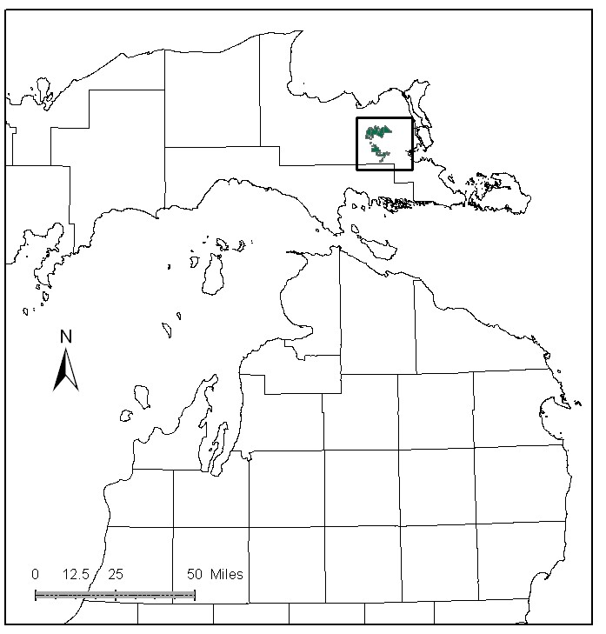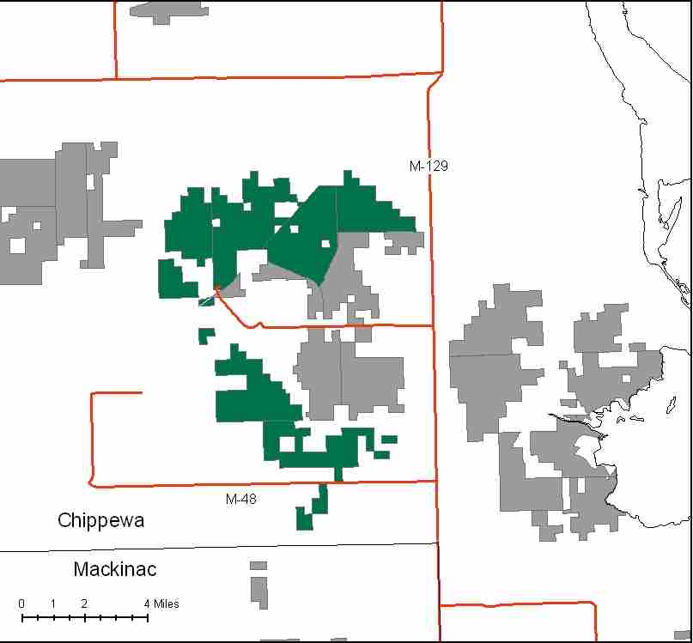

Attributes

The Kinross Bog Management Area is located in the east-central part of the Eastern Upper Peninsula, in Chippewa County. It has approximately 15,503 acres of state-owned land. The attributes which were important in identifying this MA include:

- Ecological Classification - The MA falls within Rudyard Silty Lake Plain sub-section of the EUP Ecoregion as classified by Cleland (2006).

- Landforms – The primary landform consists of lacustrine sand and gravel, with areas of lacustrine clay and silt. Almost the entire sub-subsection is a broad clay lake plain. A small area of sand lake plain is present in the center of the sub-subsection. Within this small area of sand plain, there is a series of ancient beach ridges and swales, many miles from the present Great Lakes shorelines.

- Cover Types – This is a basin in the Chippewa County landscape containing conifer dominated lowlands. The large coniferous bog, marsh, and lowland brush areas provide unique habitats for plants and animals.

- Cultural – This management area surrounds the former Kincheloe Air Force Base on the south, west and north sides.

- Social / Economic - This MA has access issues due to the wet conditions and other ownerships. There is a snowmobile trail in this MA. Interest in bird watching is increasing in this area. Hunting for deer and ruffed grouse is a popular form of recreation in this MA. Wildlife management is a primary attribute in this MA.

- Special Features - This MA contains the headwaters to the Little Munuscong River, which is a trout stream farther down stream. There are no significant lakes in this area. A Deer Yard Special Conservation Area (SCA) is within the western piece of the MA. The open marsh areas and agricultural fields attract influxes of boreal species such as snowy owls, hawk owls, boreal chickadees, and rough-legged hawks in the fall and winter months. Special features are a primary attribute in this MA.

- Ownership size and connectivity – The state land in this management area is generally in two general blocks, with some outlying parcels. The Sault Management Unit is responsible for management.

Major Cover Types

- Black Spruce - This cover type makes up 3,134 acres of the management area, and occurs mostly in bogs. The majority of the stands are over 70 years old. Many of these stands have poor access. Younger age classes reveal that some regeneration work has been successful.

- Lowland Brush – This vegetative cover is on 2,547 acres.

- Aspen – Covers 2,541 acres in this MA. There has been some recent work in the aspen type. There is a spike in the 10 to 29 year old age classes.

- Marsh – Found on 2,059 acres in this MA. Large areas of marsh provide habitat for waterfowl, shorebirds and other wildlife.

Total 15,503

Other Types include: Red Pine, Bog or Marsh, Grass, Paper Birch, Treed Bog, White Pine, Water, Non Stocked, Upland Brush, Oak, and Hemlock

Concepts of Management

- Black Spruce (20% of the MA) – Balance the age class distribution on accessible acreage. Inaccessible stands of black spruce will be allowed to reach biological maturity.

- Lowland Brush (16% of the MA) – Maintain water crossings and recreation to protect sensitive areas.

- Aspen (16% of the MA) - There are limited opportunities to harvest further aspen in this decade, however work should continue to balance the age class distribution as opportunities allow, by targeting the older age classes, thus benefiting species such as hare, ruffed grouse, deer and woodcock.

- Marsh (13% of the MA) – Continue management for special wildlife and plant habitat.

- Other -
  - Balance timber harvests with maintaining the integrity of this unique ecosystem.
  - Maintain closed canopy within deer yarding areas (compartments 44 and 45).
  - Where possible, attempt to acquire in-holdings and access to state forest land.

