Lake Michigan Shoreline Management Area Summary

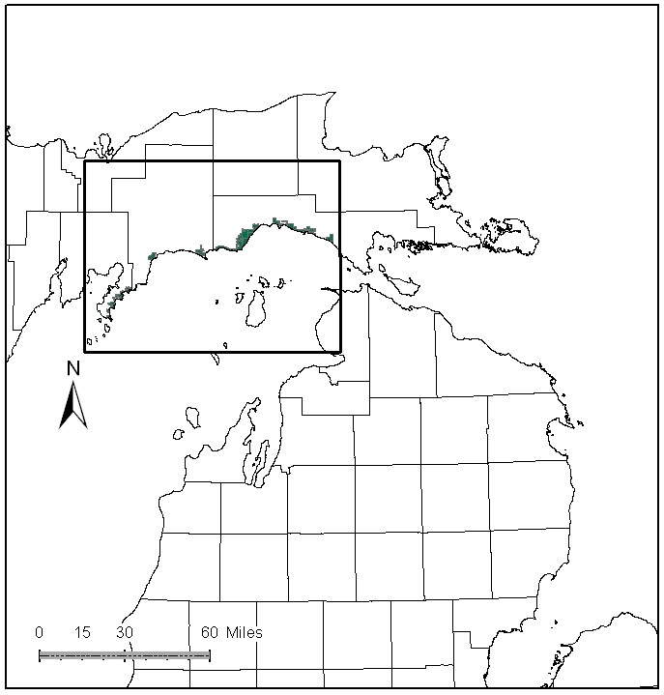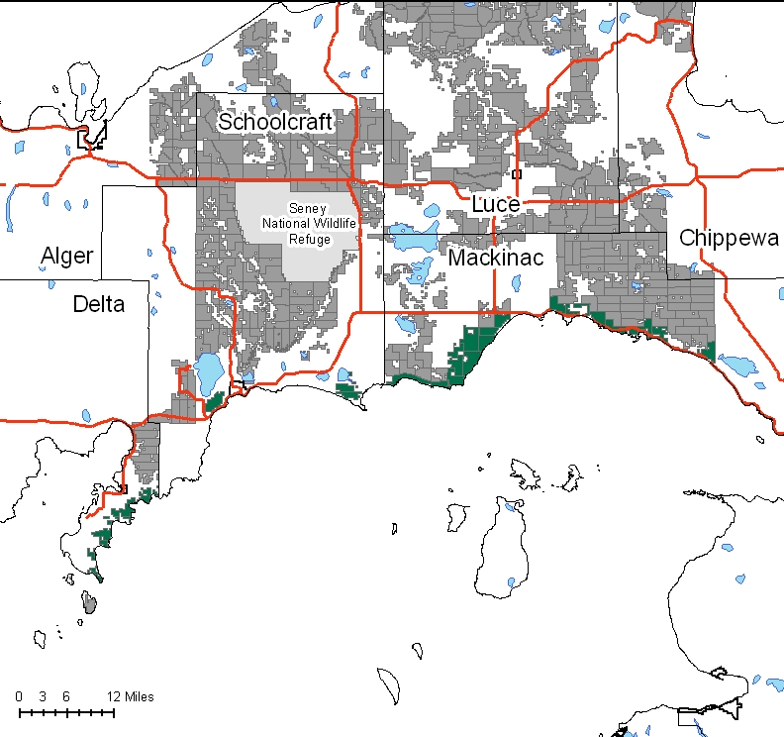

Attributes

The Lake Michigan Shoreline Management Area is located along the southern edge of the Eastern Upper Peninsula in Schoolcraft, Mackinac and Chippewa Counties. It has approximately 46,158 acres of state-owned land. The attributes which were important in identifying this MA include:

- Ecological Classification - The MA falls within the St.Ignace Lake Plain sub-section of the EUP Ecoregion as classified by Cleland (2006).

- Landforms – The major landform in this MA is the Niagran escarpment, an outcrop of dolimitic limestone that rings the Great Lakes basin. Other landforms include limestone bedrock pavement, cobble beach, and sand dunes. Landforms are a primary attribute.

- Cover Types – Sand dunes, cobble beaches, bare rock are unique cover types in this MA. Other cover types include: mixed lowland conifer, white pine, hemlock, lakeshore fens, and lowland brush.

- Cultural – Within this MA are traditional fishing villages, and areas of pre-historic, historic and current Native American Indian use. In the pre-settlement period of history the shoreline was important to the early French trappers and the fur trade. This was the historical eastern treaty boundary in the Wisconsin acquisition. Just west of Naubinway, the trading sloop Ranger was unearthed by archeologists in the early 1990’s. It was tied to a buried pier along the sandy bank of the Millecoquins River. Simmons Woods, an area south of Gould City, was associated with the Blaney Park tourist community of the early 1900’s.

- Social / Economic - There are many important forms of recreation within this MA including: snowmobiling, hunting, fishing, canoeing, kayaking, bird watching, and scenic overlooks. There are several state forest campgrounds and associated pathways along the lakeshore including: Little Brevort Lake north and south units, Hog Island Point, Big Knob and Portage Bay. US Highway 2 is part of the Lake Michigan Circle Tour that many people travel during the summer and fall months. There are several important fishing communities on the Lake Michigan shore.

- Special Features - Special features are primary attributes in this MA. This MA contains critical habitat designation for the federally endangered piping plover and populations of globally rare Great Lakes endemic plant species such as Lake Huron Tansy, Lake Huron Locust, Houghton’s goldenrod, Dwarf Lake iris and Pitcher’s thistle. Many other rare and uncommon plant and animal species are closely associated with the lakeshore. In addition, there are multiple occurrences of high quality natural communities including wooded dune and swale, rich conifer swamp, bedrock glade, and Great Lakes marsh which are included in DEQ designations of Environmental Areas and Critical Sand Dunes. The Simmons Woods Special Management Area is located within this MA. The “Mackinac County Shoreline Site Conservation Plan” provides information and management considerations for many of the high quality natural communities within the MA. Little Brevort Lake Natural area is an HCVA within the MA. Special Conservation Area’s (SCA’s) within the MA include: Seiner’s Point, Point Detour, the Crow River Mouth proposed natural areas, and extensive critical wintering deer habitat. The northern Lake Michigan shoreline is of critical importance to neo-tropical migratory birds, particularly in coniferous communities adjacent to the shoreline. Trout streams within the MA include: Newton Creek, Pt. Patterson Creek, Hudson Creek, Rock River, O’Niel Creek, Black River, East Branch Black River, Paquin Creek, Davenport Creek, Hog Island Creek, Cut River, Little Brevoort River, Crow River, and Scrams Creek. Many of the streams in this MA support natural reproduction of Lake Michigan potamodromous fishes.

- Ownership size and connectivity – This MA covers a large area geographically. It comprises the state-owned portions of the Lake Michigan Shoreline from Mackinac County to the Garden Peninsula in Delta County. The Sault and Shingleton Management Units are responsible for management in this MA.

Major Cover Types

- Cedar – Covers 11,703 acres of the MA. The alkaline conditions caused, in part, by the limestone bedrock create favorable conditions for cedar. Most of the cedar is over 60 years old, and over 60% of the acreage is greater than 100 years old and provides critical wintering habitat for deer yarding in these stands. There was some harvest and regeneration work 30 to 60 years ago in northern white cedar. Increased deer numbers have limited regeneration success since then.

- Upland Hardwoods – Are found on 6,333 acres of the MA. Most of this is in uneven age stands, with some impacts from Beech Bark Disease and from windthrow, due to Lake Michigan storm events.

- Aspen – Covers 6,091 acres in this MA. Harvesting has been done in aspen for the last 40 years. The age class distribution is imbalanced with a spike in the 20-29 year age classes and very few acres in the 40-59 year age classes. Some of the aspen is on ground that is difficult to access.

- Paper Birch – Is found on 3,426 acres of the MA. Some harvest and regeneration work has been done, but most of this cover type is greater than 70 years old and is in decline due to difficulty in access. In some areas of the MA, regeneration of paper birch is problematical in the MA because of its age, accessibility and increased deer numbers.

- Spruce/Fir – Occurs on 2,933 acres of the MA. Work has been done in accessible stands to harvest and regenerate this type. Because it is not favored deer browse, harvested cedar stands tend to come back to this type.

- Red Pine – Grows on 2,052 acres in this MA. The age class distribution is unbalanced, with a very few acres in the 0-9, 20-29, and 40-59 year age classes. Recent treatments have been prescribed when access allows. Many of the remaining acres of older red pine are natural stands on swamp ridges.

- Mixed Swamp Conifer – Covers 1,964 acres of the MA. Harvesting has been accomplished in this type when access allows, but younger age classes are under represented. This cover type is especially important along the lakeshore to migratory birds. Some of these stands provide important snow intercept value to wintering deer.
Total 46,158

Other Types include: Bog or Marsh, Non Stocked, Sand Dune, Black Spruce, Swamp Hardwoods, Tamarack, Upland Brush, Treed Bog, Lowland Mixed, Upland Mixed Deciduous, Rock, and Oak

Concepts of Management

- Cedar (25% of the MA) – The primary management objective for this type will focus on providing critical winter habitat for white-tailed deer. Harvest will be limited to assure that a closed canopy structure is maintained but will be considered where winter deer yard habitat is not impacted and cedar regeneration is likely.

- Upland Hardwoods (14% of the MA) – Use single tree selection where quality warrants, and consider shelterwood or other treatments in lower quality stands. In areas where large amounts of beech have been lost to beech bark disease, consider underplanting of disease resistant beech and oak to maintain a hard mast component on the landscape. Dead and down wood, snags, and cavity trees are important components within this type. Following the Within Stand Retention Guidelines, retain mast producing species (oak, cherry and beech), mesic conifers within the canopy and individual large diameter trees, particularly aspen, to benefit wildlife.

- Aspen (13% of the MA) – Where accessible, continue to work toward balancing the age class distribution, thus providing habitat for species such as ruffed grouse and woodcock. A component of mesic conifers should be represented in aspen types and some mature trees left for budding trees and cavity trees. Especially consider the winter harvest of aspen near deer yards for a food source. Where aspen is inaccessible, it will succeed to more shade tolerant species.

- Paper Birch (7% of the MA) - Where found along the shoreline, this type should be retained as it has high value to migratory neo-tropical birds. Use regeneration harvests to work toward age class diversity. Regeneration efforts will need to be intensive and should consider a full range of options including scarification and prescribed fire.

- Spruce/Fir (6% of the MA) - Continue to work towards a balanced age class distribution. In some stands it may be desirable to focus on biodiversity by leaving large tracts unharvested and allow natural processes to operate and generate a range of successional stages.

- Red Pine (4% of the MA) – Where accessible, continue to work towards balancing age classes. Maintain or encourage species diversity in these stands, particularly mast producing species. Inaccessible islands of red pine will be allowed to reach biological maturity.

- Mixed Swamp Conifer (4% of the MA) – This cover type is especially important along the lakeshore to migratory birds and will be retained along the shoreline. Some of these stands provide important snow intercept value to wintering deer. Consider leaving small conifer and down woody material for hare habitat in swamp complexes.

- Other -
- This MA will be managed for its biodiversity attributes, T&E habitats, and proposed natural areas. Preserve habitat for sensitive species, natural communities and ERA’s.
- The MA is along a major travel corridor which may limit the amount of vegetative management that can be conducted. Management activities are also limited along the shoreline.
- Illegal ORV activities are an issue within this MA. Work with LED on trouble areas.
- Monitoring and Control of invasive plant species, particularly garlic mustard, is a priority in this MA.
- Public recreation will continue to be a priority in this MA.
- ERA’s will be managed to protect and enhance their natural vegetative and wildlife communities, as directed by site-specific management plans for each ERA.

