Mackinac Mix Management Area Summary

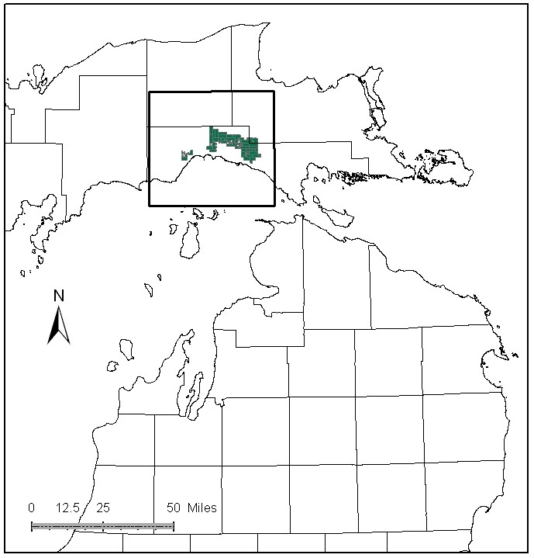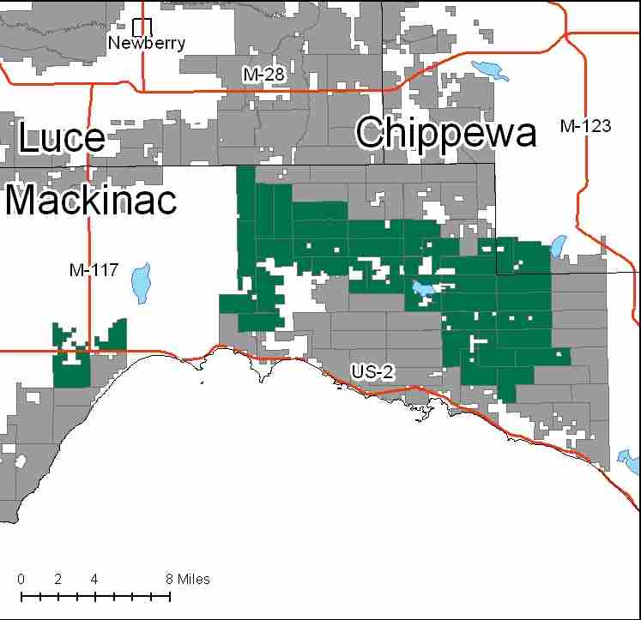

Attributes

The Mackinac Mix Management Area is located in the south and western portion of the Eastern Upper Peninsula in Mackinac and Chippewa Counties. It has approximately 65,658 acres of state-owned land. The attributes which were important in identifying this MA include:

- Ecological Classification - The MA falls within the St. Ignace Lake Plain sub-section of the EUP Ecoregion as classified by Cleland (2006).

- Landforms – Landforms consist of large areas of lacustrine sand deposits that have flat to gently undulating surfaces. On this topography, only a few inches of elevation change can greatly alter drainage conditions. Drainage conditions also depend on depth to underlying bedrock or fine-textured substrate. Glacial erratics are often dolomite and may provide habitat for special plants. Gravel extraction occurs in this landform. Depth to bedrock is often less than 50 feet.

- Cover Types – This MA has a high variability of soil types that produce a diversity of cover types. White pine and hardwoods on the ridges, mixed conifer swamps, and aspen/fir/spruce/pine mixes in between. Timber production and wildlife habitat are primary attributes in this MA.

- Cultural - There are several known historical and prehistoric sites in this MA. It is a traditional cranberry and blueberry gathering area, along with other fruit bearing plants. This MA held the Rexton CCC camp, and several logging camps. The Daughters of the American Revolution Red Pine stand is located near Rexton.

- Social / Economic - Snowmobile trails are well used. There is an antique snowmobile show and museum in Naubinway which attracts modern trail riders. Fishing and Hunting are very popular activities. Other activities include berry picking and mushroom hunting. Black River campground, and Newberry-Rexton motorcycle trail make up the rest of the recreational facilities in the MA. There are several gravel pits located within this MA. Invasive Garlic Mustard and Beech Bark Disease are present in this MA. Recreation is a primary attribute for this MA.

- Special Features - The MA contains Potential Old Growth areas, Special Conservation Area (SCA) Deer Wintering Areas, Cranberry Lake Bog, which is a muskeg candidate Ecological Reference Area (ERA), and northern fen and poor fen ERA’s. Many of the streams in this MA support natural reproduction of Lake Michigan potamodromous fishes (those where fish move from fresh water to fresh water), including the Black River watershed. Trout streams in this MA include: Black River, Peters Creek, Kinny Creek, Silver Creek, Bark Creek, and S. Br. Carp River. Glacial erratic boulders are special habitat structures for rare plants. Special features are primary attributes for this MA.

- Ownership size and connectivity – The state land within this MA is fairly well blocked. Hiawatha Sportsmans Club borders to the west. The Sault Management Unit is responsible for management out of the Naubinway office.

Major Cover Types

- Cedar – Covers 12,919 acres of the MA. Most of this cover type is in 70+ age classes. Various attempts at regeneration have not proved successful.

- Aspen – Is found on 8,424 acres in this MA. The aspen resource in the MA has been subjected to extensive harvest, and there is a spike in the 10-29 year age classes. The acreage in older age classes is difficult to manage due to access issues.

- Upland Hardwoods – Covers 7,580 acres, and are usually of high quality. Most acreage is managed for uneven-age classes.

- Lowland Brush – There is 5,636 acres of lowland brush in the MA.

- Mixed Swamp Conifer – Covers 5,231 acres of the MA. Most of this cover type is in the 70+ year age classes.

- Red Pine – Grows on 3,979 acres of the MA. The age class distribution is fairly even with the exception of the 20-39 year age classes. Some thinning has occurred in the 70-79 year old group. Some sites are converting to hardwoods based on type and soil suitability.

- Treed Bog – There are 3,782 acres of treed bog in this MA.

Total 65,658

Other Types include: Upland Mixed Deciduous, Hemlock, Water, Upland Brush, Upland Mixed Conifer, Non Stocked, Swamp Hardwoods, Upland Mixed, Jack Pine, Scotch Pine, Lowland Mixed, and Sand Dune

Concepts of Management

- Cedar (20% of the MA) - The primary management goal will focus on providing critical winter habitat for white-tailed deer. Harvest will be limited to assure that a closed canopy structure is maintained. Consider developing a comprehensive deer yard management plan.

- Aspen (13% of the MA) – Continue to work towards balancing age classes, targeting stands in older age classes. Inaccessible aspen will succeed to more shade tolerant species. Consider upland game management strategies for species such as hare, ruffed grouse, deer and woodcock.

- Upland Hardwoods (12% of the MA) – Salvage sales will occur where Beech Bark Disease is an issue. Consider uneven age and even age techniques depending on site quality. Under plant oak and disease resistant beech where conditions allow. Retain or recruit some mesic conifers in the canopy within this type. Dead and down wood, snags and cavity trees are important habitat features and should be maintained or supplemented as needed. Retain a component of large trees, including aspen, to meet the habitat requirements of primary cavity nesting wildlife.

- Lowland Brush (9% of the MA) - There is no planned management at this time. Maintain culverts and other water crossings to continue natural drainage in low areas.

- Mixed Swamp Conifer (8% of the MA) – Work on balancing the age classes using regeneration harvests in accessible stands. Consider managing some stands for biodiversity with longer rotations and incorporation of natural disturbance processes for the benefit of wildlife.

- Red Pine (6% of the MA) – Be especially mindful of visual management near the Daughters of American Revolution planted red pine; including maintenance of the sign. Retain some large trees near water courses as habitat structure.

- Other -
- Evaluate managing the Cranberry bog complex through carefully prescribed fires, to allow for the propagation of blueberries and other fruiting shrubs and setting back the encroachment of upland brush and trees.
- The Mackinac Mix Management Area will be managed for an array of cover types. Wildlife values are very high in this MA.
- Public recreation will continue to be a priority in this MA, with conflicts between recreation and timber management resolved by EUP DNR staff.
- Control of exotic species such as garlic mustard and scotch pine will continue. Evaluate new sites for control.
- Glacial erratic boulders need to be protected from timber harvest operations- no felling of trees on boulders, buffer zones should be established around boulders to protect microclimate and keep shade intact.
- ERA’s will be managed to protect and enhance their natural vegetative and wildlife communities, as directed by site-specific management plans for each ERA.

