Maxton Plains Management Area Summary

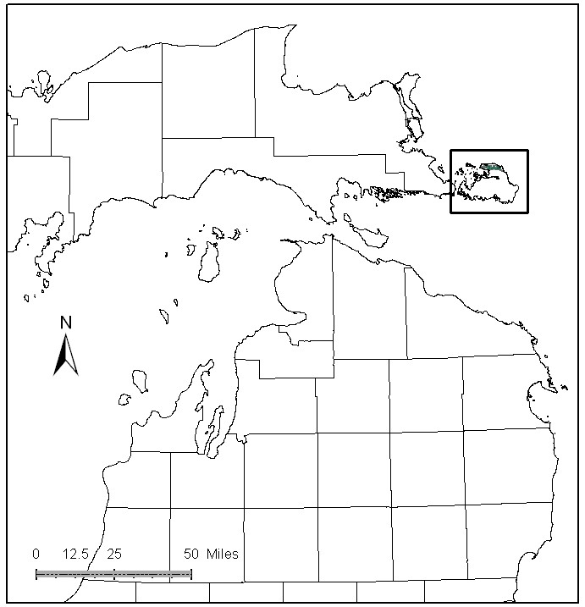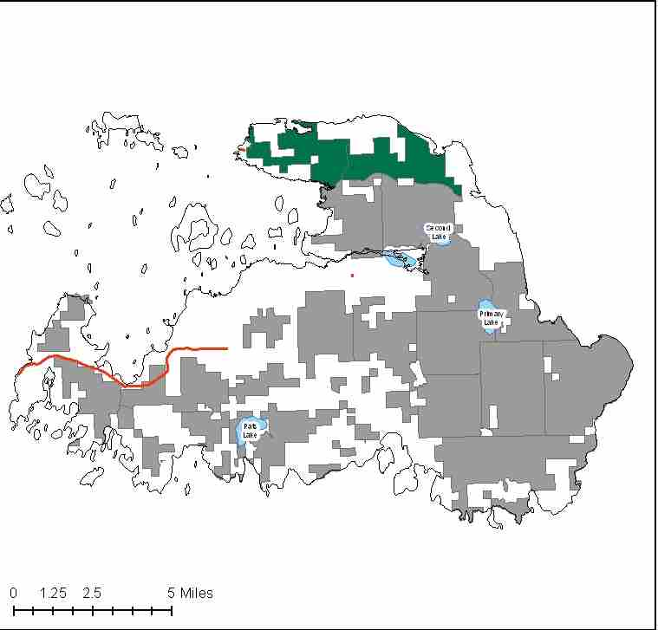

Attributes

The Maxton Plains Management Area is located on Drummond Island in the far eastern part the Eastern Upper Peninsula in Chippewa County. It has approximately 4,358 acres of state-owned land. The attributes which were important in identifying this MA include:

- Ecological Classification - The MA falls within the St.Ignace Lake Plain sub-section of the EUP Ecoregion as classified by Cleland (2006).

- Landforms – The dominant landform is the Drummond Moraine and Drummond Outcrop. These landforms are characterized by thin to discontinuous glacial till over limestone bedrock. Part of the Niagaran Escarpment, underlying limestone bedrock is typically less than 50 feet below the surface. Limestone bedrock is exposed in many places and expressed in the natural communities of Alvar and Limestone bedrock pavement.

- Cover Types – This management area is characterized primarily by open grass and sedge communities, lowland conifers and aspen.

- Social / Economic - Much of this MA is within the Maxton Plains Ecological Reference Area (ERA). The Nature Conservancy’s Maxton Plains Preserve is within the boundaries of this ERA. Alvar is a globally rare vegetative community. An alvar or pavement barren is a biological environment based on a limestone plain with thin or no soil and, as a result, sparse vegetation. Trees and bushes are absent or severely stunted. A large amount of the Alvar natural community in the state is in this MA. This rare plant and animal community draws some tourism to the island for bird watching and viewing rare plants. Intentionally, there are no campgrounds, no jeep trails, and no ORVs and ATVs allowed here.

- Special Features - The Maxton Plains Ecological Reference Area is an “A” ranked globally rare Alvar community. This MA is also known for occurrences of many rare plants and animals associated with the Alvar community and other Great Lakes Endemic species. The Lake Huron Coastline is important because shallow near shore areas can provide important fish spawning and nursery habitat. Other ERA’s include Great Lakes Marsh and Bedrock Pavement. Special features are primary attributes for this MA.

- Ownership size and connectivity – This MA contains a fairly contiguous block of state forest land. The Sault Management Unit is responsible for management.

Major Cover Types

- Upland Mixed – Covers 1,079 acres of the MA; with all of the stands being classified as uneven aged.

- Aspen – Is found on 962 acres of the MA. Due to passive management, and very shallow, droughty, soils in the Alvar areas the aspen resource is in a variety of age classes and rotation age. Most aspen stands are very open - “Serengeti Aspen”. This has led to uneven-aged, multi-structured stands of old aspen in association with multiple ages of conifers.

- Grass – Covers 752 acres and is a reflection of alvar, which is the main community of focus in this MA.

- Upland Mixed Conifers – There are 403 acres of upland mixed conifers within this MA. As with most of the stands in this unique MA, these stands are classes as uneven aged, due to their multi-storied structure.

- Cedar - Most of the 256 acres of cedar are in older age classes.

Total 4,358

Concepts of Management

- The MA is managed to retain the integrity of the natural alvar community occurring here.
- There will be little timber management of this area, except in the NE, due to the fragile and unique nature of this community. Disturbance to the fragile soil layer should be avoided except for carefully controlled events with a specific ecological purpose.
- There are no legal ORV trails in the MA and illegal ORV activity should be monitored and damaged areas restored. Recreational trails are to be discouraged in this MA.
- Exotic invasive plant species are a threat to the ERA’s and should be monitored periodically.
- Management should be coordinated with TNC.
- ERA’s will be managed to enhance their conservation values, as directed by site-specific management plans for each ERA.

