Milakokia Lake Management Area Summary

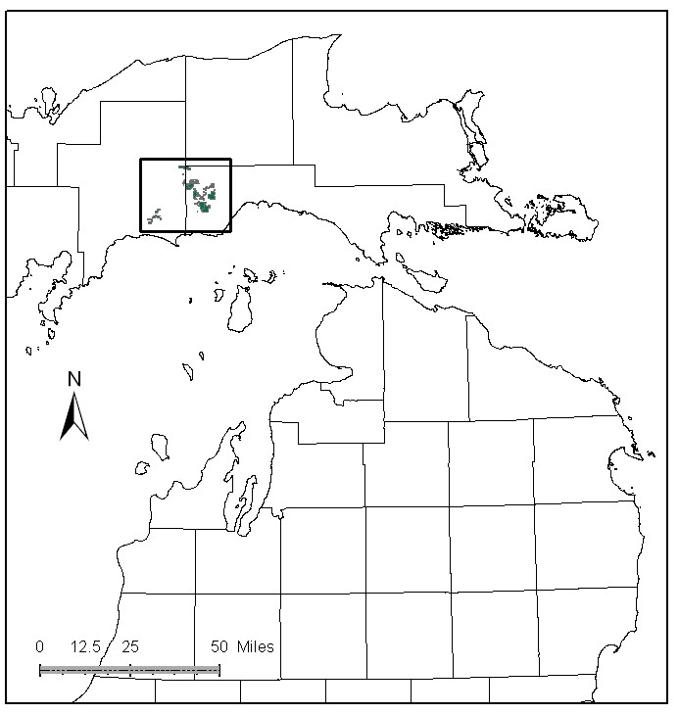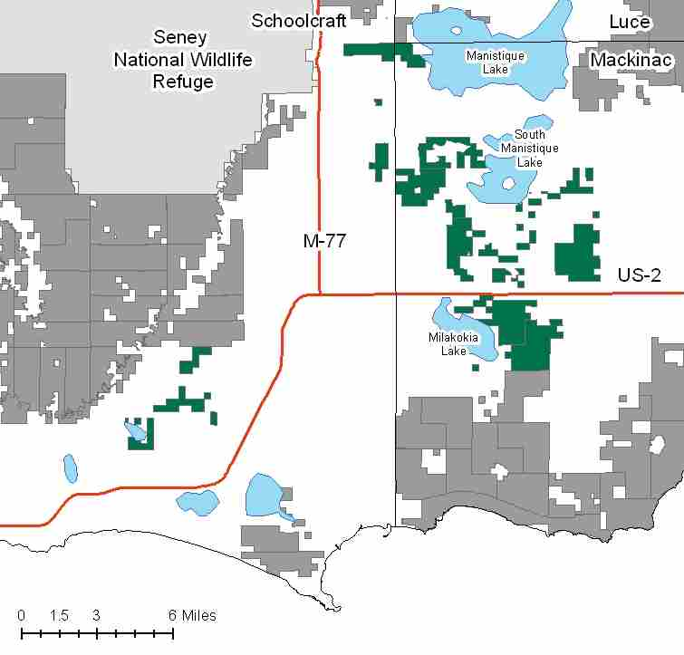

Attributes

The Milakokia Lake Management Area is located in the central part of the Eastern Upper Peninsula in Schoolcraft and Mackinac Counties, and has approximately 14,388 acres of state-owned land. The attributes which were important in identifying this MA include:

- Ecological Classification - The MA falls within St. Ignace Lake Plain sub-section of the EUP Ecoregion as classified by Cleland (2006).

- Landforms – The dominant landforms consist of coarse textured glacial till, peat and muck, and lacustrine sand and gravel.

- Cover Types – These lands have a variety of cover types, but share the same management challenges, those being a fragmented landscape with often difficult access.

- Cultural - Numerous old railroad grades cross through this MA. Many are currently being used as either state forest roads, county roads or 2-track roads – Pike Lake Grade (county road) and Bryan Grade (state forest road) most notably.

- Social / Economic – This MA is near several small communities including: Blaney Park, Gulliver, Gould City, Germfask, Curtis and Helmer. Hunting, snowmobiling, and fishing are popular activities here. Recreation facilities in this MA include: South Manistique Lake and Milakokia Lake State Forest Campgrounds, boat access sites at Big Manistique Lake, South Manistique Lake, Milalokia Lake, and Kennedy Lake. Snowmobile trails have been re-routed several times in this MA due to private property concerns/permissions. Norton-Oglebay Limestone Quarry is active and located on the west side of Milakokia Lake. There is a state gravel pit off N. Gould City Road (N. Gould City pit); and several small sand pits located near Milakokia Lake. Recreation and wildlife habitat are primary attributes in this MA.

- Special Features - Trout streams in this MA include: Taylor Creek, Norton Creek, and East Branch Fox River. The East Branch Fox River is a state-designated Natural River, and the corridor is a High Conservation Value Area (HCVA). There are significant Special Conservation Area (SCA) deer wintering areas in the MA. Garlic mustard, an invasive species, was found at Milakokia Lake State Forest Campground. Blue Heron rookeries are found in the MA.
- Ownership size and connectivity – The state owned land in this MA is fragmented into smaller parcels. The Sault and Shingleton Forest Management Units share management of the area.

Major Cover Types

- Cedar – Covers 3,534 acres, much of it in SCA winter deer yarding complexes. Most of the Cedar stands are over 100 years old. Regeneration harvests are being implemented though a small trial of strip cuts.

- Aspen – There are approximately 3,024 acres of aspen in the MA. Harvesting has been intensive in recent years, and 60% of the aspen in this MA is 10-29 years old. Remaining older stands have access issues.

- Upland Hardwoods – Of the 1,589 acres of upland hardwoods, the majority is in uneven aged management.

- Lowland Poplar – Lowland poplar grows on 1,335 acres in the MA. As with aspen, past intensive harvesting has resulted in 57% of this cover type in the 10-29 year age classes. Remaining older stands have access issues.

- Lowland Brush / Treed Bog – Lowland brush covers 1,219 acres, and treed bog covers 987 acres of the MA.

- Mixed Swamp Conifers – Most of the 1,013 acres of mixed swamp conifers are over 90 years old. Access is an issue for some of these stands.

Total 14388

Other Types include: Water, Marsh, Paper Birch, Tamarack, Non Stocked, Bog or Marsh, Hemlock and Upland Brush

Concepts of Management

- Cedar (25% of the MA) – The primary management objective for this type will focus on providing critical winter habitat for white-tailed deer. Harvest will be limited to assure that a closed canopy structure is maintained but will be considered where winter deer yard habitat is not impacted, cedar regeneration is likely, and wetland soils are not adversely impacted.

- Aspen (21% of the MA) – Continue to work toward balancing the age classes, which will benefit species such as hare, ruffed grouse, deer and woodcock. Where access is a problem, aspen will succeed to more shade tolerant species.

- Upland Hardwoods (11% of the MA) – Continue to manage uneven aged stands using single tree selection on higher quality sites; consider shelterwood or other treatments in lower quality stands. Dead and down wood, snags, and cavity trees are important components within this type. Following the Within Stand Retention Guidelines, retain mesic conifers, mast producing trees, individual large diameter trees, particularly aspen, to benefit wildlife.

- Lowland Poplar (9% of the MA) – Conduct regeneration harvests in areas that will not adversely impact wetland soils, in order to diversify the age classes in this cover type. In inaccessible areas, lowland poplar will succeed to more shade tolerant species.

- Lowland Brush (8% of the MA) / Treed Bog (7% of the MA) – Manage these stands for wildlife and ecological values, generally through passive management.

- Mixed Swamp Conifers (7% of the MA) – In order to diversify the age classes in this cover type, conduct regeneration harvests in areas that will not adversely impact deer yards or wetland soils. Consider managing some stands for biodiversity with longer rotations and incorporation of natural disturbance processes for the benefit of wildlife.

- Other –
  - Much of the management area is classified as deer yard and is managed as such.
  - Access for harvesting is a problem in most of this MA.
  - Continue to focus on the significant recreation opportunities in this MA.
  - Emphasize removal of Garlic Mustard and other invasive plant species.

