Munuscong Bay Management Area Summary

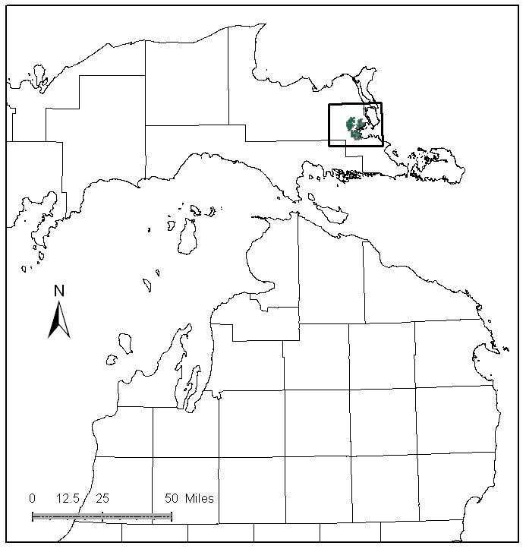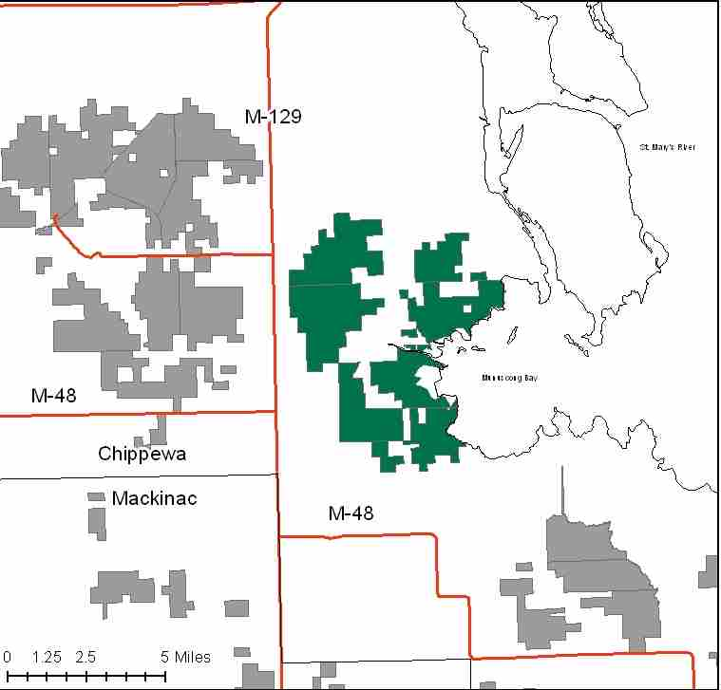

Attributes

The Munuscong Bay Management Area (MA) is located in the far eastern end of the Eastern Upper Peninsula (EUP) in Chippewa County. It has approximately 14,742 acres of state-owned land. The attributes which were important in identifying this MA include:

- Ecological Classification - The MA falls within Rudyard Silty Lake Plain sub-section of the EUP Ecoregion as classified by Cleland (2006).

- Landforms – The dominant landform consists of Clay soils on flat lake plain near Munuscong Bay on the St. Mary’s River. The soils in this area are very erodible.

- Cultural – There are several known archeological sites within the MA, including old homesteads and a fossil bed.

- Social / Economic - Recreational facilities in the MA include: Munuscong River State Forest Campground, and snowmobile trails. Fishing and hunting along with logging are important activities.

- Special Features - This MA is within the Munuscong River Watershed, which is primarily a warm and cool water system. It has historically supported a strong walleye run, but is currently adversely affected by agricultural runoff. Trout streams in this MA include portions of the Little Munuscong River, Desormeaux Creek, Parker Creek, Sanderson Creek, and Rapson Creek. Munuscong Bay supports an outstanding walleye fishery. There are Special Conservation Area (SCA) deer wintering areas, including the Keldon deer yard, and an Ecological Reference Area (ERA), Great Lakes Marsh, within the MA. This MA has numerous man made pot holes in the low grassland portions that provide waterfowl production. DNR and volunteer crews worked together to create these ponds; some of which were created on private property through cooperative agreements. Much of this MA is a wildlife flooding dependent upon natural water level fluctuations. Great Grey Owls and Northern Hawk Owls frequently winter here. Fish and wildlife habitat are primary attributes in this MA.

- Ownership size and connectivity – State land in this MA is concentrated into two primary blocks. The Sault Unit is responsible for management.

Major Cover Types

- Swamp Hardwoods - Swamp Hardwoods cover 2,864 acres of the MA. Most of this is in uneven aged management.

- Cedar – Occurs on 2,670 acres in the MA. Much of this is in the 100 year age class and is managed for the Keldon Deer Yard.

- Lowland Brush and Marsh – Lowland brush occupies 2,053 acres, and marsh covers 1,177 acres of the MA. They are managed similarly for wildlife values, using prescribed fire where appropriate.

- Aspen - Aspen covers 1,214 acres of the MA, with 602 acres are in the 20-29 age class. Twenty eight percent of the aspen is over age 60.

- Lowland Poplar - Lowland poplar covers 1,026 acres of the MA. Over half of this cover type is older than 50 years of age, as access issues prevent active management.

- Grass – Covers 1,017 acres in the MA, and provides habitat for open-land dependent wildlife species.

- Mixed Swamp Conifers – Covers 867 acres in the MA. Over half of the acres are within the 20-49 year age classes, and are not available for harvest at this time.

Total 14,742

Other Types include: Spruce Fir, Red Pine, Oak, Non Stocked, Bog or Marsh, Upland Brush, and Treed Bog

Concepts of Management

- Swamp Hardwoods (19% of the MA) – Continue to manage the uneven aged stands, and attempt regeneration harvests in older stands, where wetland soils will not be adversely impacted. Inaccessible stands will undergo natural successional processes.

- Cedar (18% of the MA) - The primary management goal will focus on providing critical winter habitat for white-tailed deer. Harvest will be limited to assure that a closed canopy structure is maintained but will be considered where winter deer yard habitat is not impacted and cedar regeneration is likely.

- Lowland Brush (14% of the MA) and Marsh (8% of the MA) - Fire will be used for management where appropriate in lowland brush and open areas. This cover type provides habitat for open-land species such as state threatened Le Contes Sparrows, and will be managed accordingly.

- Aspen (8% of the MA) and Lowland Poplar (7% of the MA) – There will be opportunities for harvesting this decade, thus benefiting species such as hare, ruffed grouse, deer and woodcock. Following general aspen management guidelines, work towards balancing the age class distribution, harvesting older stands first.

- Grass (7% of the MA) – Maintain upland grassland communities for wildlife species currently using this cover type and create "emergent-marsh" wetlands to enhance grasslands for species dependent on grassland-wetland complexes. Fire will be used for management where appropriate.

- Mixed Swamp Conifers (6% of the MA) – Harvest selected areas to promote a balanced age class distribution in places that will not adversely impact wetland soils, or wildlife habitat. In some stands maintain biodiversity by leaving large tracts unharvested and allow natural processes to operate generating a range of successional stages.

- Other –
  - The upper portions of the Munuscong River are designated trout waters and will be managed according to Best Management Practices (BMPs) to ensure protection from warming and erosion. BMP’s will also be applied near all streams in this clay-dominated lake plain to prevent erosion and sedimentation from covering historically important spawning habitat in the rivers and the receiving water, Munuscong Bay within the St. Marys River. Coastal marshes provide important spawning and nursery habitat for a variety of species, including northern pike, and protection of these areas is especially important.
  - ERA’s will be managed to enhance and protect their natural vegetative and associated wildlife communities, as directed by site-specific management plans for each ERA.

