North Rudyard Management Area Summary

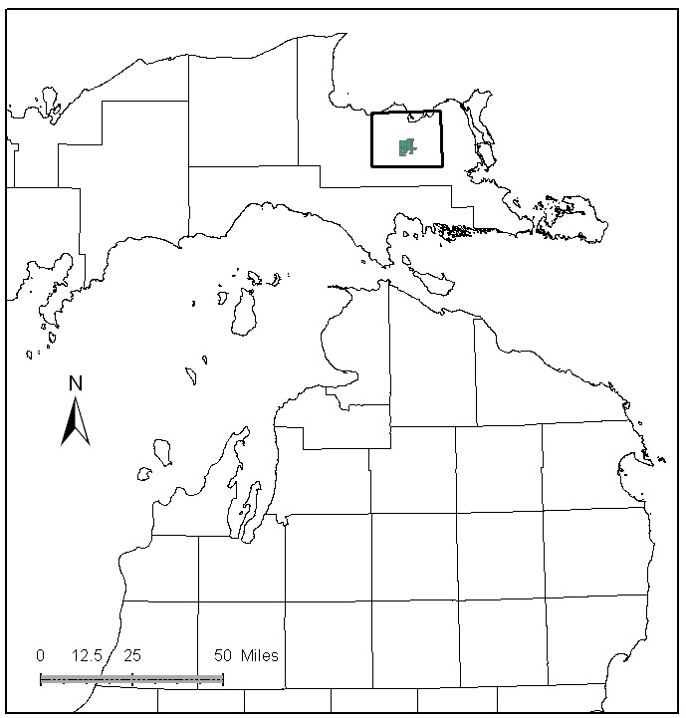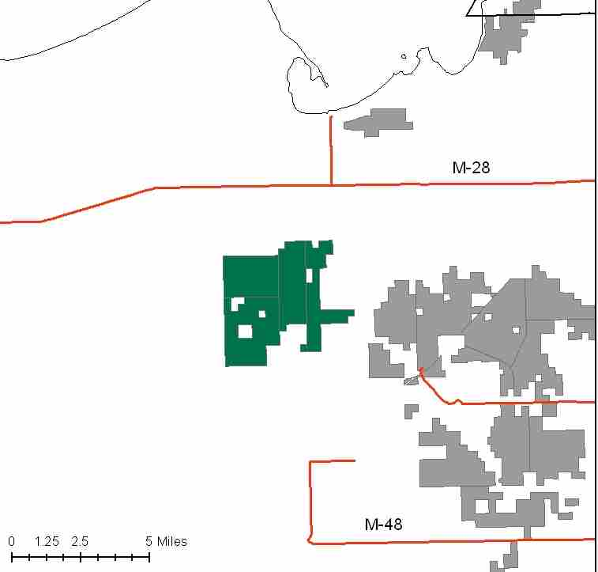

Attributes

The North Rudyard Management Area is located in the east portion of the Eastern Upper Peninsula in central Chippewa County and has approximately 8,337 acres of state-owned land. The attributes which were important in identifying this MA include:

- Ecological Classification - The MA falls within the Rudyard Silty Lake Plain sub-section of the EUP Ecoregion as classified by Cleland (2006).

- Landforms – The dominant landform consists of clay lake plane, with a small area of sandy lake plane. This is a fairly flat, wet portion of the EUP clay lake plain. Willow is more abundant than tag alder in the expansive lowland brush areas. Even winter sales are hard to sell here. Only the south end has upland sites, where northern red oak is found.

- Cover Types – Include wet site adapted species on most of the acreage. Lowland brush and lowland poplar makes up 44% of the MA, with upland hardwoods in the southern portion of this MA on only 8% of the acreage.

- Cultural - Important area to bear and deer hunters due to oak mast in the south end of the compartment.

- Social / Economic - Snowmobile trails pass through this MA on the way to Rudyard and Kinross. Tilson Road gives access through the north and south axis of this MA for forest recreation.

- Special Features - There is a deer wintering area identified in the southeast corner of the MA as a Special Conservation Area (SCA). Wildlife habitat is a primary attribute in this MA.

- Ownership size and connectivity – The State Forest land in this MA is in one block. The Sault Management Unit is responsible for management.

Major Cover Types

- Lowland Brush – Lowland brush is the most common vegetative cover type (2,188 ac). Presently, this cover type is used as habitat for sharp-tailed grouse, snowshoe hares, and songbirds.

- Lowland Poplar – The 1,502 acres of lowland poplar make up the most common tree cover. Sites are wet, so sales must be large and of long duration in order to sell. The spike in the 70 to 79 year old age class has largely been harvested in a large recent sale.

- Aspen – Occurs on 1,233 acres of this management area. The spike in the 60-69 age class was reduced in one large recently completed sale.

- Northern White Cedar – This cover type occurs on 989 acres in this MA. Much of this cedar is in the 100+ year old age class. Cedar has not been a focus for harvests

- Upland Hardwood – Present on 678 acres of the M.A. It is often mixed with northern red oak. Some wintering sharp-tailed grouse use the ridges that have a heavy paper birch component. There are approximately 300 acres of upland hardwoods in the 81 to 110 Basal Area classes, which are ready for harvest.

Total 8,337

Other Types include: Marsh, Mixed Swamp Conifer, Spruce Fir, Grass, N. Red Oak, Bog, and Swamp Hardwoods.

Concepts of Management

- Lowland Brush (26% of the MA) – Maintain the acreage of this cover type for wildlife habitat. If the opportunity arises, survey for golden-winged warbler.

- Lowland Poplar (18% of the MA) –Opportunity for further management in this type is limited in the near future, but the long-term goal is to move toward a balanced age class distribution. Natural successional processes will be allowed on older, inaccessible poplar stands.

- Aspen (15% of the MA) – There are limited opportunities to harvest further aspen in this decade. The long-term goal is to move toward a balanced age class distribution, which will benefit species such as hare, ruffed grouse, deer and woodcock.

- Northern White Cedar (12% of the MA) – Assess condition for deer yarding, timber quality, and regeneration possibilities. The primary management goal will focus on providing critical winter habitat for white-tailed deer. Harvest will be limited to assure that a closed canopy structure is maintained but will be considered where winter deer yard habitat is not impacted and cedar regeneration is likely.

- Upland Hardwood (8% of the MA) – Continue to look for opportunities for un-even age management as well as the reproduction of paper birch. Consider shelterwood and other sale types where hardwood quality is poor. Retain dead and down wood, snags, and cavity trees are important components within this type. Following the Within Stand Retention Guidelines, protect mesic conifers within the canopy and individual large diameter trees, particularly aspen, to benefit wildlife.

- Other - Continue to close roads opened for timber sales to control vehicle damage to wetland soils.

