Pictured Rocks Buffer Management Area Summary

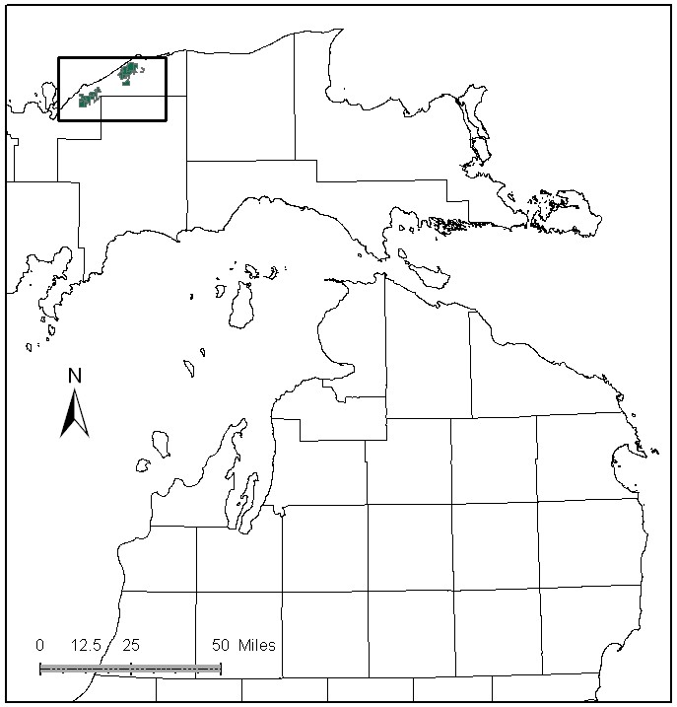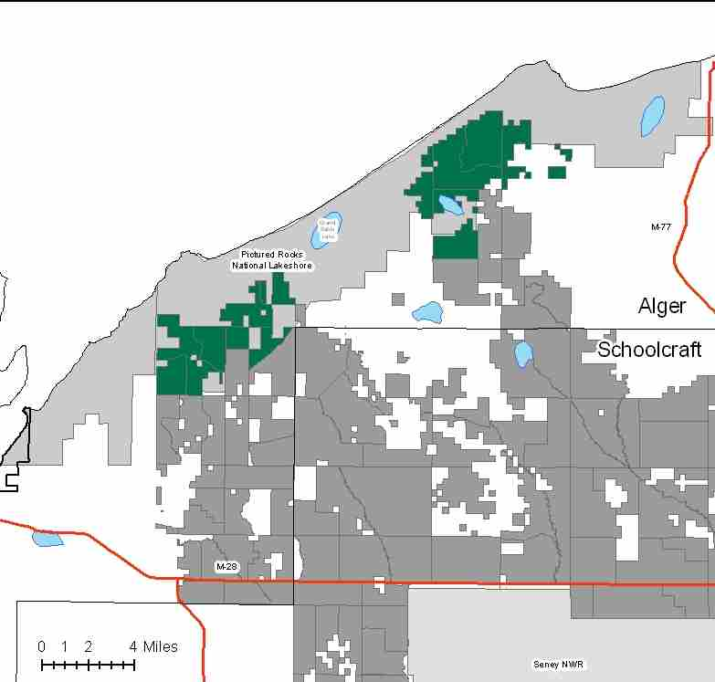

Attributes

The Pictured Rocks Buffer Management Area is located in the northwest part of the Eastern Upper Peninsula in Alger County, and has approximately 19,087 acres of state-owned land. The attributes which were important in identifying this MA include:

- Ecological Classification - The MA falls within the Grand Marais Glaciofluvial-Moraine Complex sub-section of the EUP Ecoregion as classified by Cleland (2006).

- Landforms - The dominant landform consists of sandy ridges of end moraine and pitted outwash, and lacustrine deposits of glacial and postglacial origin.

- Cover Types - The east block of this MA consists of mainly pine types; while the west block consists mainly of hardwoods. Timber production is a primary attribute in this MA.

- Cultural - The portion of this MA adjacent to the Danaher Kingston Outwash MA has logging history from the 1800’s similar to that MA. Remains of old railroad grades and pine camps are present.

- Social / Economic - Recreational facilities found in this MA include: Kingston Lake Campground and public access site, the Fox River Pathway, and snowmobile trails. Access to much of Pictured Rocks National Lakeshore is through this management area. Blueberry picking is popular in the area near Kingston Lake.

- Special Features - The following special protection trout streams are found in this MA: Hurricane River, Spray Creek, and Mosquito Creek. Other trout streams include: Sullivan Creek and Little Beaver Creek.

- Ownership size and connectivity - This MA lies adjacent to the fee boundary of Pictured Rocks National Lakeshore and is largely made up of the Inland Buffer Zone (IBZ) of the park. Management within this MA is conducted with this geographic context in mind. The state land within the MA is fairly concentrated in two separate blocks. The Shingleton Management Unit is responsible for management.

Major Cover Types

- Upland Hardwoods - With approximately 6,467 acres, upland hardwoods are the dominant cover type in this MA and are almost exclusively uneven-aged in structure. Most of the hardwood acres are in the west part of the MA, and consist of high quality sugar maple stands. Management in the west block is relatively intensive, and many treatments have been completed in the last 20 years. The hardwood stands in the east block contain more red maple, beech, white pine and hemlock. This type is very important to interior nesting bird species and black bear.

- Red Pine - Red pine grows on 3,122 acres, mainly in the east part of the MA. There are both natural and planted stands. The majority of the planted stands are 50-59 years old and together with the 40-49 year age class represent one of two spikes in the age class distribution. Natural stands account for a second 100+ spike in the age class distribution.

- White Pine – Natural white pine stands cover 2,216 acres in this MA. These stands are generally found in the east block of the MA. White pine tends to reproduce very well on the better quality sites, and natural regeneration is normally used here. A quarter of the white pine is in older even-aged stands, while the two-thirds of stands are uneven-aged.

- Grass - Grassy openings occupy 1,172 acres of the management area. Most of the acres are on sandy, unproductive soils in the east part of the MA.

- Aspen - There are 1,142 acres of aspen in the MA. The age class distribution is imbalanced, with 70% in the 0-30 year age classes.

- Northern White Cedar - Cedar grows on 1,088 acres, most of which is found in riparian zones in the west block of the MA. The majority of it is over age 70. There is evidence of successful cedar regeneration within the MA.

- Jack Pine - There are 888 acres of jack pine in the MA, mainly in the east block. The age class distribution is fairly well balanced with the exception of no representation in the 30-39 year age class and a slight spike in the 40-49 year age class. Over 40% of the jack pine acres are in stands less than 30 years old.

Total 19,087

Other Types include: Spruce Fir, Hemlock, Non Stocked, Upland Brush, Treed Bog, Black Spruce, Bog or Marsh, and Lowland Poplar

Concepts of Management

- Upland Hardwoods (34% of the MA) - In upland hardwood, use single-tree selection where quality warrants, and consider shelterwood or other treatments in lower quality stands. Encourage size, species and structural diversity. Beech Bark disease is prevalent in the east block, and increasing in the west block. Where site conditions are appropriate, underplant oak and/or disease resistant beech replace hard mast. Dead and down wood, snags and cavity trees, large beech trees and mesic conifers are important habitat features within this type.

- Red Pine (15% of the MA) – Natural pine regeneration is emphasized in the east portion of the MA, using shelterwood/seed tree harvests to maintain this type. Planted red pine should be considered for transition into a more natural system. Work toward balancing the age class distribution, especially within the planted stands. While the intent is to maintain existing red pine acreage, conversion to jack pine, white pine or grass on lower quality sites may decrease red pine acreage over time. Following the Within Stand Retention Guidelines, allow selected individual red pines in other cover types to become super canopy trees, and consider allowing selected areas of managed pine to reach biological maturity.

- White Pine (12% of the MA) – Naturally regenerate mature white pine stands using shelterwood/seed tree harvesting systems. Thin younger stands using single tree selection. Following the Within Stand Retention Guidelines, allow selected individual white pines in other cover types to become super canopy trees. White pine tends to reproduce very well in this MA. The acreage of WP is expected to increase over time.

- Grass (7% of the MA) - Continue to manage large wildlife openings. Some grass stands may be converted to red or jack pine in order to consolidate the acreage of similar types into larger blocks for habitat and ease of management. In other locations, less productive forest stands may be converted to grass to offset conversions to forested cover and to allow for consolidated management. Small grass openings have been naturally reverting back to their original white pine cover type, and will be allowed to do so.

- Northern White Cedar (6% of the MA) - Cedar has not been a focus for recent harvests, however, opportunities should be pursued for harvest and natural regeneration in the areas not supporting wintering deer.

- Aspen (5% of the MA) – The long-term goal of management is balancing the age classes of aspen. Since most of the operable aspen has already been regenerated, it will take time to accomplish this goal. Inaccessible stands will convert to more shade tolerant species.

- Jack Pine (5% of the MA) - Continue work on balancing the age classes of jack pine. Acreage of jack pine may increase if red pine on poor quality sites is converted to jack pine.

- Other - This MA lies within the Pictured Rocks National Lakeshore Buffer Zone, therefore it receives a lot of drive-through use by park visitors. Visual management and recreation are important management objectives.

