Sage Truck Trail Management Area Summary

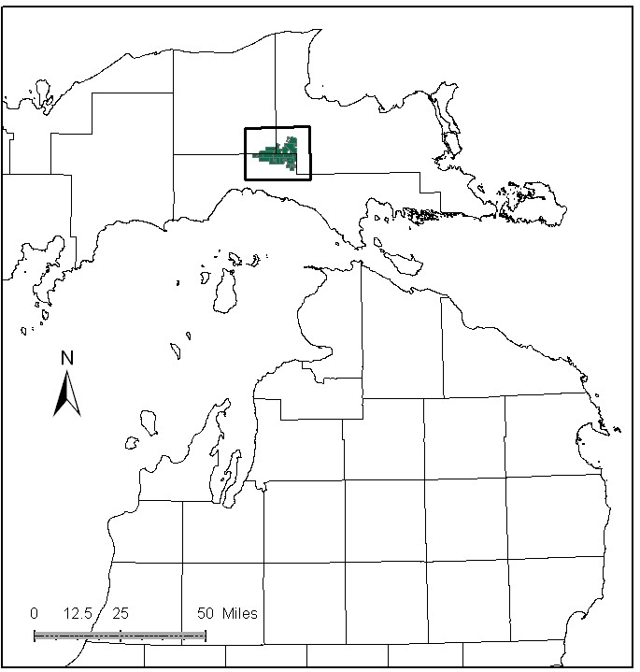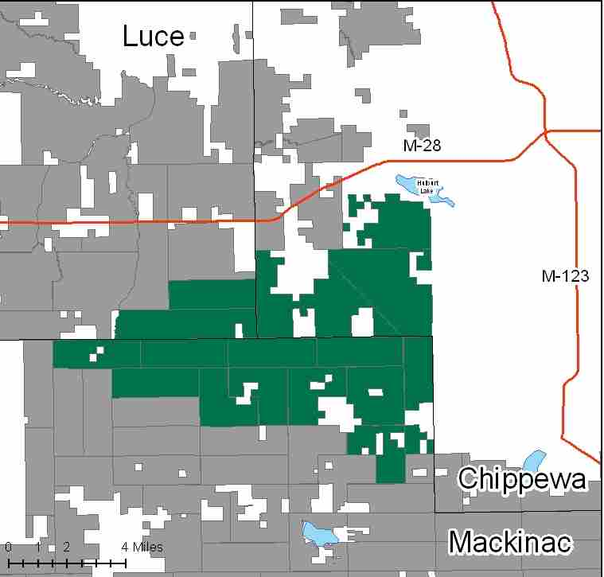

Attributes

The Sage Truck Trail Management Area (MA) is located in the central portion of the Eastern Upper Peninsula (EUP) in Luce, Chippewa and Mackinac Counties. It has approximately 37,149 acres of state-owned land. The attributes which were important in identifying this MA include:

- Ecological Classification - The MA falls within St. Ignace Lake Plain and Seney Lake Plain sub-sections of the EUP Ecoregion as classified by Cleland (2006).

- Landforms – Landforms in this MA consist of glacial moraine fragments, lacustrine lowlands, limestone escarpment, morainal lake bed complex, and glacial outwash features. Much of this area was flooded at one time, see the Tahquamenon River assessment.

- Cover Types – Timber harvesting and wildlife habitat are primary attributes in this MA. Aspen and hardwood stands make up one third of the acres in this MA, and are managed rather intensively. There is also intensive management of red pine in planted stands occuring along the Dinkey Line. This MA has limestone bedrock influenced vegetation, with areas of limestone exposed at the surface and Karst features, including caves. This area contains some hardwood knolls with closely associated wetlands to include large bog expanses, black spruce/tamarack forested wetlands and northern white cedar. Much of the coniferous lowland within the MA is managed for closed canopy winter yarding deer. Timber harvesting in much of the MA is in winter due to access issues.

- Cultural – There are several known archeological sites in the MA, including an old homestead, and many narrow gauge railroad beds.

- Social / Economic – This MA provides excellent moose, wolf and bear habitat. Grouse and deer hunting are popular. The headwaters of the Sage and Hendrie River systems, and the Tahquamenon River are in the MA. The Hendricks Gravel Quarry and the Fiborn quarry are located in this MA. The recreational facilities include a snowmobile trail and the Newberry-Rexton motorcycle trail near the southern edge of the MA.

- Special Features – Trout streams with special protection within the MA include: East Branch Sage River, West Branch Hendrie River, and South Branch Hendrie River; McLeod Ditch is also a trout stream. This MA doesn’t contain any significant lakes. There are Special Conservation Areas (SCA) for wintering deer, and a large candidate biodiversity stewardship area (BSA). There are several Candidate Ecological Reference Areas (ERA) within the MA including: muskeg, caves and sink holes. The caves and sink holes are karst features associated with the Fiborn Quarry. Glacial erratic boulders are important habitat features for rare plants.

- Ownership size and connectivity – This MA has both upland and lowland types in similar amounts and is a large block of contiguous state forest land. The Newberry and Sault Units share management of this area.

Major Cover Types

- Aspen – There are 6,827 acres of aspen in this MA. Aspen harvest has been a focus in this area, and 73% of the stands are in the 0-29 year age classes.

- Upland hardwoods – Covers 6,082 acres in this MA; over half of the stands are currently managed as uneven aged, but a significant acreage is in an even-aged condition.

- Cedar – Most of the 4,821 acres of cedar is designated as deer yards. The majority of the stands are over 80 years old.

- Lowland Brush – Much of the 4,491 acres of lowland brush in this MA is good moose and songbird habitat.

- Mixed Swamp Conifers – Cover 3,737 acres in the MA, most of which is in older age classes.

Total 37,149

Other Types include: Marsh, Tamarack, Lowland Mixed, Water, Upland Mixed Conifers, Non Stocked, Rock, and Sand Dune

Concepts of Management

- Aspen (18% of the MA) – Maintain aspen within MA, focusing on balancing the age class distribution over the long-term, benefiting species such as hare, ruffed grouse, deer and woodcock. Following general aspen management guidelines, plan regeneration harvests for stands over age 50. Aspen in sensitive or inaccessible areas will succeed to more shade tolerant species.

- Upland hardwoods (16% of the MA) – Continue to manage uneven aged stands using single tree selection where site quality warrants; consider shelterwood or other treatments in lower quality even-aged stands. Retain, and if necessary supplement, down and dead wood, cavity nesting trees and snags within this type. Retain a component of large diameter aspen for primary cavity nesting species. Mesic conifers should be recruited and retained in the overstory where applicable.

- Cedar (13% of the MA) – The primary management goal will focus on providing critical winter habitat for white-tailed deer. Harvest will be limited to assure that a closed canopy structure is maintained but will be considered where winter deer yard habitat is not impacted and cedar regeneration is likely. Chipping in cover types adjacent to cedar may be restricted due to wintering deer. Maintain larger openings within and at the edges of the deer yarding complexes.

- Lowland Brush (12% of the MA) – Manage these stands for wildlife values.

- Mixed Swamp Conifers (10% of the MA) – Provide closed canopy cover in areas used by wintering deer. In order to diversify the age class distribution of this cover type, conduct regeneration harvests in areas that will not adversely impact wetland soils. In some stands enhance biodiversity by leaving large tracts unharvested and allow natural processes to operate to generate a range of successional stages.

- Other –
- Although Red Pine is a small percentage of the MA, it will continue to be managed intensively. Consider retaining a mature red pine component at the edge of stands.
- Glacial erratic boulders should be protected as found.
- Protect sensitive sites and species; protect water bodies from erosion, including buffering bogs/vernal pools.
- SCA’s and candidate ERA’s will be managed to enhance and protect their natural vegetative and associated wildlife species, as directed by site-specific management plans for each ERA.
- Exotic invasive plant species have been documented at the Fiborn quarry. Populations of leafy spurge found on state land should be eradicated if possible, and cooperative management pursued with private land owners.

