Seney Manistique Swamp Management Area Summary

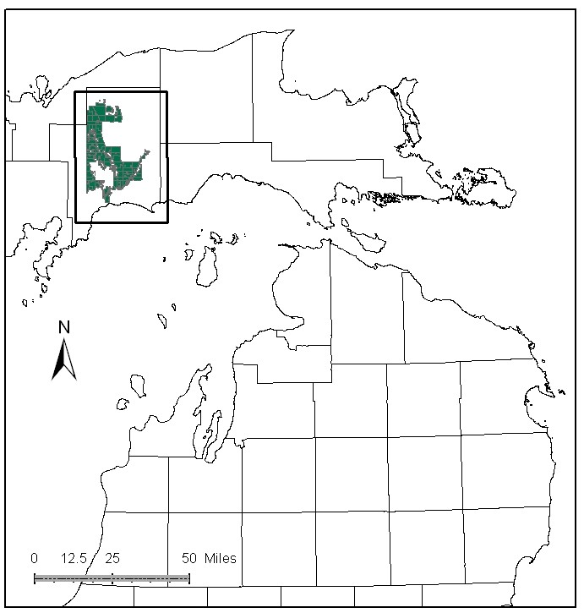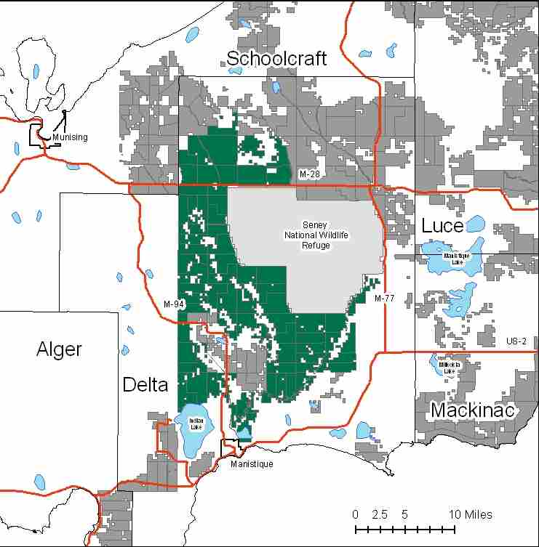

Attributes

The Seney Manistique Swamp Management Area is located in the west part of the Eastern Upper Peninsula in Schoolcraft County, between the communities of Seney, Shingleton, and Manistique. The MA has approximately 146,611 acres of state-owned land. The attributes which were important in identifying this MA include:

- Ecological Classification - The MA falls within the Seney Lake Plain sub-section of the EUP Ecoregion as classified by Cleland (2006).

- Landforms - The dominant landform consists of the Seney Lake Plain, with the Manistique River Corridor flowing through. Numerous tributaries and small streams are also present.

- Cover Types - The MA is dominated by conifers and non-forested areas. Cover type and landform are primary attributes for this MA.

- Cultural - The Manistique River was extensively traveled by Native Americans, and many artifacts have been found along the river, particularly near Manistique. The river was also used during the logging era, to move wood downstream to markets. The MA contains an area near M-94 known locally as the Mint Farm, named for an unsuccessful agricultural effort, that dramatically changed the watershed in the area. The 1976 Seney Fire, which is the largest fire in modern Michigan history, occurred in a large portion of this MA.

- Social / Economic – Despite highways M-94 and M-28 going through the MA, a fair amount of it remains inaccessible due to wetlands. Recreational facilities in the MA include: Mead Creek Campground, Merwin Creek Campground (managed by Schoolcraft County), the Rainey Wildlife viewing area, canoe outfitters on the Manistique River, and several snowmobile trails. Hunting is popular in this area.

- Special Features - The area is very botanically rich. There are several Ecological Reference Areas (ERAs) including: rich conifer swamp, patterned fen, and dry mesic northern forest. Low lying Jack pine stands on wet sands topped by a thin organic soil have a unique plant assemblage. Several rare boreal plant species occur on these sites, including the only known site in the state for one State endangered species. Special Conservation Area (SCA) deer wintering areas, including the Sturgeon Hole Deeryard, are also found here. In addition, a significant amount of acreage is designated as potential biodiversity stewardship areas (BSA). Trout streams that occur within this MA include: Creighton Creek, Stoner Creek, Shotgun Creek, Hickey Creek, West Branch Hickey Creek, Bear Creek, and Mead Creek. The main branch of the Manistique River supports a variety of warm and coolwater fish species, as well as a remnant lake sturgeon population. The MA borders the north shore of Indian Lake. Kirtland’s Warblers have been occasionally found within this MA. Special features are primary attributes in this MA.

- Ownership size and connectivity - This management area is a large contiguous block of state forest land and borders the Seney National Wildlife Refuge. Much of it is remotely located and the swamps make access difficult. The Shingleton Management Unit is responsible for management of this MA.

Major Cover Types

- Marsh and Lowland Brush - This MA is dominated by 29,462 acres of marsh, and 21,573 acres of lowland brush. Many of these stands fall within SCA and ERA designations, such as patterned fen.

- Jack Pine - There are 23,482 acres of jack pine in the MA. A large portion of these acres, especially in the older age classes, are either inaccessible or unavailable for intensive management.

- Aspen - Of the 9,934 acres of Aspen in the MA, 78% are in the 0-30 year age classes, reflecting intensive management in recent years.

- Black Spruce - Of the 8,730 acres of black spruce in the MA, only 21% of the acres are less than 50 years old. The majority of the acres of this cover type are inaccessible due to their location within large marsh complexes or unavailable for intensive management.

- Red Pine - Occurs on 8,492 acres; 75% of this is over 60 years old. The majority of these stands are of natural origin, often on inaccessible islands within large marsh complexes.

- Upland Hardwoods - The 7,803 acres of upland hardwoods are dominated by low quality red maple. The majority of the stands have been classified as uneven aged.

- Mixed Swamp Conifers - The MA has 7,477 acres of mixed swamp conifers, often in inaccessible areas. A large number of acres in this cover type are over 80 years old, and will be considered for harvest where accessible.

- Cedar - There are 7,467 acres of Cedar in the MA. Over 80% of stands are greater than 80 years old. Some stands are used by wintering deer.

Total 146,611

Other Types include: Grass, Spruce Fir, Lowland Poplar, Bog or Marsh, Non stocked, Oak, Upland Brush, Scotch Pine, and Sand Dune

Concepts of Management

- Marsh (20% of the MA) and Lowland Brush (15% of the MA) - Continue to manage these large roadless areas for wildlife. Protect the ERA values found in these cover types.

- Jack Pine (16% of the MA) - Where access permits, focus on balancing the age class distribution. Natural regeneration of jack pine has been successful in this MA, though there are concerns about the successful regeneration of this species without a seed source. To address this, whole tree harvesting should not be allowed. Harvest jack pine in large blocks when possible, to benefit jack pine dependent wildlife species including Kirtland’s Warbler.

- Aspen (7% of the MA) - Where accessible, harvest the older aspen to focus on balancing the age class distribution, which additionally benefits many wildlife species. In the inaccessible areas, aspen will succeed to more shade tolerant species.

- Black Spruce (6% of the MA) - Attempt to balance the age classes where accessible. Natural regeneration has been successful where management has occurred, though there are concerns about the successful regeneration of this species without a seed source. To address this, whole tree harvesting should not be allowed.

- Red Pine (6% of the MA) - Harvest natural red pine stands using shelterwood / seed tree systems. Natural regeneration is preferred, but may need to be supplemented by planting where accessible. Inaccessible islands of red pine that may never have access for harvesting will be allowed to reach biological maturity.

- Upland Hardwoods (5% of the MA) - Harvest using single-tree selection where quality warrants, and consider shelterwood or other treatments in lower quality stands. Dead and down wood, snags and cavity trees, mast producing trees and mesic conifers are important features to retain or enhance where deficient. Any harvests taking place in deer wintering yard areas should be done during the winter months to provide this food source at an important time.

- Mixed Swamp Conifers (5% of the MA) - Because a large number of acres in this cover type are over 80 years old, regeneration harvests should be considered where stands are accessible. However, closed canopy cover should be retained in deer wintering yard areas to maintain suitable wintering habitat.

- Cedar (5% of the MA) - Cedar has not been a focus of recent management activities in this MA. To maintain this cover type, explore possibilities for cedar regeneration harvests. Maintain a complex of closed canopy stands to provide suitable wintering habitat for deer.

- Other –
  - Many of the timber sales in this MA are harvested in the winter due to the large marshes, and the need to improve the existing road infrastructure.
  - The Seney National Wildlife Refuge borders this MA, and discussions with them regarding compatible habitat management should be continued.
  - ERA’s will be managed to protect and enhance their natural vegetative and wildlife communities, as directed by site-specific management plans for each ERA.
  - The area from Commencement Creek to the Creighton River is fairly rich in boreal species that are of conservation concern in Michigan. It is likely that further surveys in the area would identify additional populations of rare boreal species.

