Strickler Aspen Management Area Summary

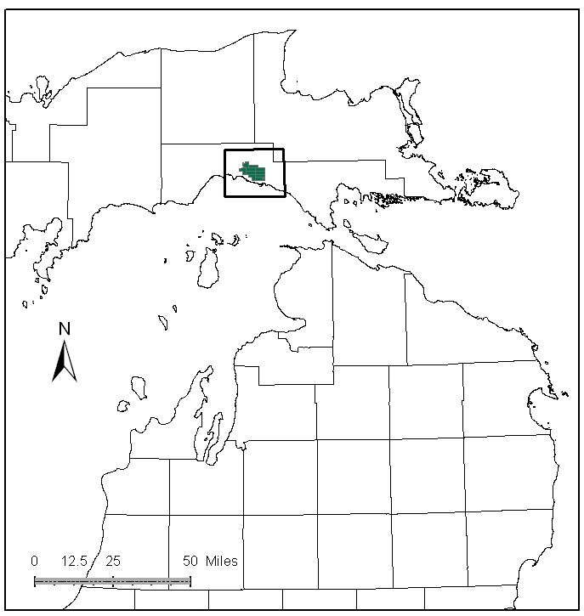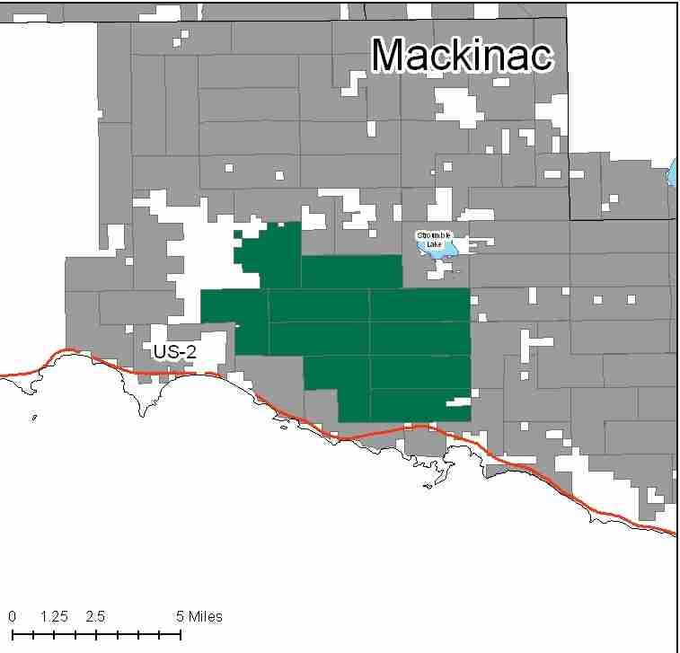

Attributes

The Strickler Aspen Management Area is located in the central portion of the Eastern Upper Peninsula in west Mackinac County. It has approximately 19,181 acres of state-owned land. The attributes which were important in identifying this MA include:

- Ecological Classification - The MA falls within the Saint Ignace Lake Plain sub-section of the EUP Ecoregion as classified by Cleland (2006).

- Landforms – The dominant landform is the Newberry Moraine which consists of lacustrine sand and gravel with small streams.

- Cover Types – The cover types within this MA have been highly altered from circa 1800 vegetation types to current dominance of aspen. Timber production and wildlife habitat are primary attributes of this MA.

- Social / Economic - The MA experiences significant timber management as it has good proximity to fiber markets. There are many recreational opportunities within this MA including a snowmobile trail, and the Garnet Lake State Forest campground, managed by Hudson Township. Deer and grouse hunting are a well established activity. Walk-in hunting opportunities are found within the Strickler Grouse Management Area.

- Special Features - A large portion of the MA is influenced by winter deer use. The Strickler Grouse management unit is a major focus of emphasis within this MA; an intensive aspen management plan was developed in 1994 for this area. Trout streams in the MA include: East Branch Black River, Borgstrom Creek, Hog Island Creek, Davenport Creek, and Paquin Creek. Coldwater streams in this MA also support natural reproduction of Lake Michigan potamodromous fishes

- Ownership size and connectivity – This is a large block of contiguous state land. The Sault Management Unit is responsible for management.

Major Cover Types

- Aspen – At 6,768 acres, aspen is the most common cover type in the MA. Due to past harvesting, the age class distribution is relatively balanced, with the exception being the 40-49 year age class. Acres in the older age classes may not be available for harvesting, due to access.

- Cedar – With 2,480 acres, cedar covers a significant portion of the MA. Its closed canopy management provides deer yarding areas. All of the cedar in this MA is over 70 years old, and most of it is over 100 years old. There has been successful cedar regeneration documented in this area.

- Red Pine – Occurs on 1,679 acres in the MA. The age class distribution is unbalanced, and there are currently no red pine stands in the 30-59 year age classes. The majority of the red pine is in the 70-79 year age class, and much is of planted origin.

- Upland Hardwoods – Of the 1,475 acres of upland hardwood in this MA, almost 70% is classified as uneven aged.

- Mixed Swamp Conifer – Covers 1,425 acres in this MA. While some younger stands occur, approximately 68% of the stands are over 80 years old.

- Lowland Poplar – The age class distribution is skewed toward younger and older age classes. The 1,392 acres of lowland poplar is managed aggressively where possible, with 60% in the 30-39 year age classes. Most of the remaining acreage is older than 80 years and inaccessible.

- Lowland Brush – This cover type is found on 1,172 acres.

Total 19,181

Other Types include: Upland Mixed Conifer, Lowland Mixed, Marsh, Bog or Marsh, Non Stocked, and White Pine

Concepts of Management

- Aspen (35% of the MA) - Intensive timber management in this cover type will continue. Continue to maintain age-class diversity in the aspen cover types by harvesting stands as needed, benefiting species such as hare, ruffed grouse, deer and woodcock. Continue to maintain biological diversity within these stands and retain conifer component where applicable. Older stands that are unavailable for harvest will succeed to more shade tolerant species.

- Cedar (13% of the MA) - The primary management goal will focus on providing critical winter habitat for white-tailed deer. Harvest will be limited to assure that a closed canopy structure is maintained but will be considered where winter deer yard habitat is not impacted and cedar regeneration is likely.

- Red Pine (9% of the MA) - Within red pine stands, maintain some larger trees within stream corridors to more closely mimic biological rotation and to provide shade and snags within the corridor. Following general red pine management guidelines, thin stands where BA allows. Continue work to balance the age class distribution in this type through regeneration harvests and replant after harvest as site conditions dictate.

- Upland Hardwoods (8% of the MA) – Look for opportunities to do single-tree thinning or selection sales where the hardwood quality is good. Consider shelterwood and other sale types where quality is poor. Maintain mesic conifers within the canopy and retain dead and down wood, snags and cavity trees. Where deficient, a component of large trees, including aspen, should be retained for primary cavity nesters.

- Mixed Swamp Conifer (7% of the MA) – Where accessible, consider regeneration harvests to continue balancing the age class distribution. Natural successional processes will allowed in inaccessible stands. Dead and down wood and small conifers should be retained in this habitat for species such as snow shoe hare.

- Lowland Poplar (7% of the MA) – Where accessible, this type should continue to be harvested, while retaining some components of the stand for biodiversity. Natural successional processes will allowed in inaccessible stands. Dead and down wood and small conifers should be retained in this habitat for species such as snow shoe hare.

- Lowland Brush (6% of the MA) – Continue to manage for wildlife species that use this cover type.

- Other - Maintain walk-in hunting opportunities in the Strickler Grouse Management Area by maintaining gate closures and working with law enforcement to curb illegal ORV activities.

