Tahquamenon River Basin Wetlands Management Area Summary

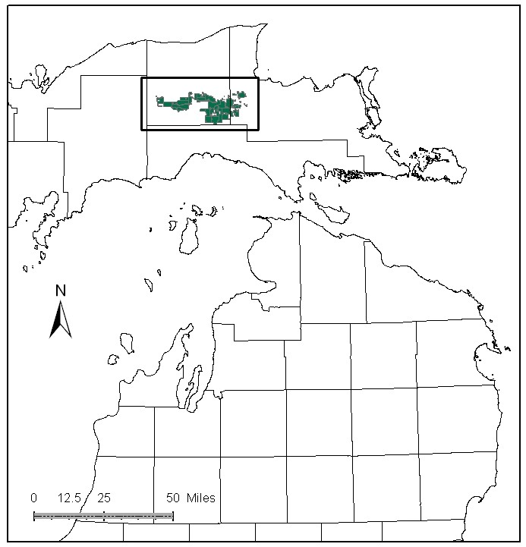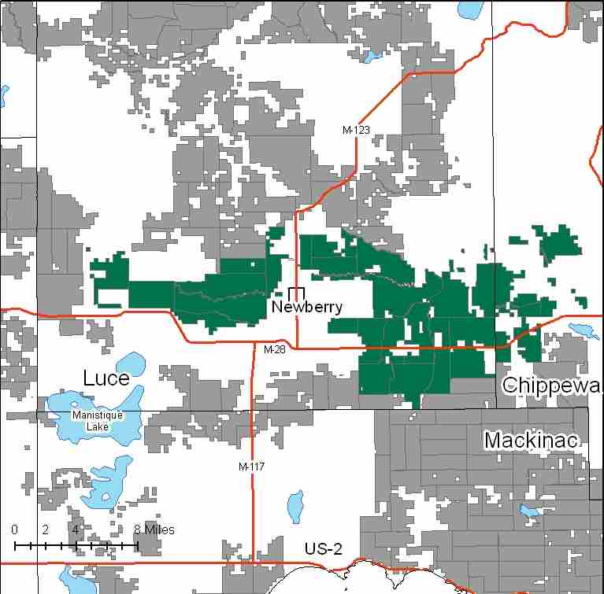

Attributes

The Tahquamenon River Basin Wetlands Management Area (MA) is located in the north central portion of the Eastern Upper Peninsula (EUP) in Luce County. It has approximately 82,818 acres of state-owned land. The attributes which were important in identifying this MA include:

- Ecological Classification - The MA falls primarily within the Seney Lake Plain sub-section of the EUP Ecoregion as classified by Cleland (2006).

- Landforms – The dominant landform consists of the Tahquamenon River Drainage. This land form is characterized by glacial moraine fragments, lacustrine lowlands and glacial outwash features. Much of this area was flooded by ancient Lake Superior at various times in history. This area contains the largest expanse of wetlands in the state.

- Cover Types – This area is associated with the Sage and Hendrie River systems and the Tahquamenon River corridor in Luce, Chippewa, and Mackinac Counties. This area contains some hardwood knolls with closely associated wetlands to include large bog expanses, Black spruce/tamarack forested wetlands and northern white cedar.

- Cultural - In an attempt to alter the hydrology of the area and promote farming, a few of the larger streams such as the Sage River, Hendrie River, and McLeod Ditch were ditched and channelized. This did not drain the swamps as intended, though the channels remain. The Soo Line/Soo Junction railroad was established in 1910 to access a mill on the mainstream of the Tahquamenon River. The Betty B landing, where the railroad ended at the river, was the location of a tugboat named “Betty B” that towed barges up the river full of tourists to enjoy the scenery in the 1930’s. The Southern end of the Charcoal railroad grade, which transported hardwood timber to the Vulcan Furnace Company charcoal kiln, as well as the historical Kneeland-Bigelow Logging camp and associated Railroad grade are within the MA.

- Social / Economic - There are many recreational opportunities within the MA including: fishing access sites, snowmobile trails, Natalie State Forest Campground, and the privately owned Toonerville Trolly which follows the Soo line grade. Bird watching, hunting, and trapping are also popular. The Dollarville flooding, a state wildlife management area, is used heavily by waterfowl hunters, boaters, and fishermen.

- Special Features - Associated with the river systems are lowland swamp conifers and cedar complexes that make up some very important deer wintering complexes within the MA, including those around the McMillan area, and the Sage and Hendrie Rivers. The Dollarville flooding is used extensively by nesting and migrating shorebirds, waterfowl, eagles, osprey and aquatic furbearers. Wild rice grows in the flooding and within the channel of the Tahquamenon River and is harvested by Native American residents. Fishing opportunities are many - trout streams include: First Creek, East Creek, Teaspoon Creek, East Lake Creek, Carlson Creek, Otto Brandt Creek, 39 Creek, Sixteen Creek, Big Ditch, and the Sage River. Special protection streams include: East Branch Sage River, Silver Creek, West Branch Sage River, East Branch Tahquamenon River, Tahquamenon River, and Red Creek. Special features are the primary attributes in this MA.

- Ownership size and connectivity – This large block of state forest owned land is managed by the Newberry Forest Management Unit.

Major Cover Types

- Mixed Swamp Conifer – Covers 13,772 acres in this MA. Almost 80% of the stands are over age 70. Many of these stands are inaccessible.

- Cedar – There are 12,887 acres of cedar in this MA. Almost 90% of stands are older than age 60. Much of this area provides important habitat for deer and other wildlife.

- Lowland Brush / Treed Bog / Marsh – Lowland brush covers 12,080 acres, treed bog covers 10,969 acres and marsh covers 6,207 acres in this MA. These wet areas provide important habitat for a large number of wildlife species.

- Black Spruce – Of the 4,802 acres of black spruce in this MA, 63% are over 80 years old. While most of the stands are inaccessible, there has been some harvesting in this cover type.

- Aspen – Covers 4,663 acres in this MA. Most age classes are represented, with a modest spike in the 10-29 year age classes. Many older aged stands are inaccessible.

- Swamp Hardwoods – Is found on 4,256 acres in this MA, over half of which is classified as uneven aged.

Total 82,818

Other Types include: Paper Birch, Spruce Fir, Non Stocked, Hemlock, Red Pine, Grass, Upland Brush, Bog or Marsh, and Scotch Pine

Concepts of Management

- Mixed Swamp Conifer (17% of the MA) – Where connectivity between cedar stands is lacking and snow intercept value high, retain stands as part of critical deer winter habitat.

- Cedar (16% of the MA) – The primary management goal will focus on providing critical winter habitat for white-tailed deer in wintering complex SCA’s. Harvest will be limited to assure that a closed canopy structure is maintained but will be considered where winter deer yard habitat is not impacted and cedar regeneration is likely.

- Lowland Brush (15% of the MA) / Treed Bog (13% of the MA) / Marsh (7% of the MA) – Continue to protect wildlife and other ecological values of these types. Where possible, protect these areas from harvest operations in adjacent stands.

- Black Spruce (6% of the MA) – Where accessible, consider regeneration harvests to work toward age balancing the age class distribution. Natural succesional processes will be allowed on inaccessible acreage.

- Aspen (6% of the MA) – Where accessible, continue work toward balancing the age class distribution, which will benefit species such as hare, ruffed grouse, deer and woodcock. Where applicable, retain a conifer component within these stands. Aspen will succeed to more shade tolerant species in inaccessible areas.

- Swamp Hardwoods (5% of the MA) – Where accessible, consider regeneration harvests in the even aged stands, to improve age class structure.

- Other –
  - Protect sensitive sites and species; also protect water bodies from erosion.
  - Most stands will be winter harvest due to low, wet ground.
  - Motorized access should be restricted north of the Dollarville flooding.
  - No new ORV or snowmobile trail development will be considered in this MA.

