Tahquamenon River Patterned Fens Management Area Summary

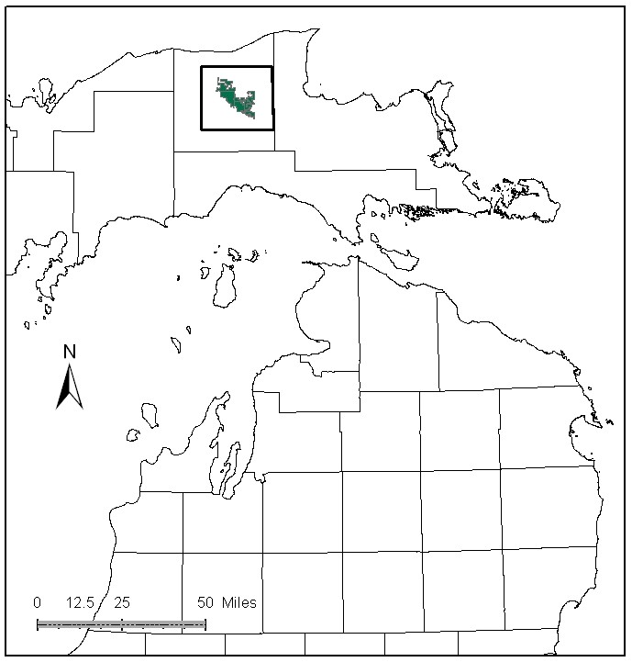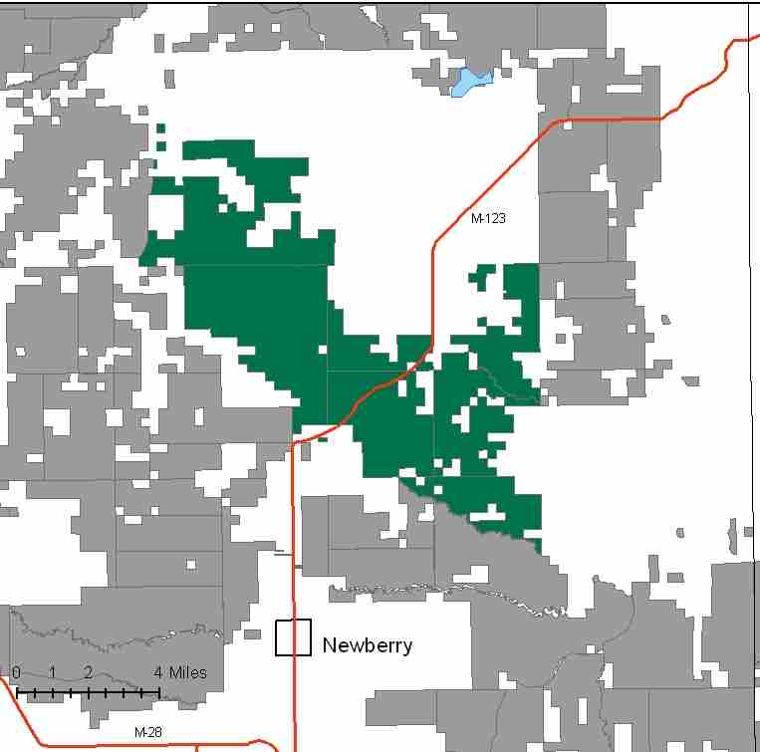

Attributes

The Tahquamenon River Patterned Fens Management Area is located in the north central portion of the Eastern Upper Peninsula, in Luce County, and has approximately 29,530 acres of state-owned land. The attributes which were important in identifying this MA include:

- Ecological Classification - The MA falls within the Seney Lake Plain sub-section of the EUP Ecoregion as classified by Cleland (2006).

- Landforms – The dominant landform in this MA is the Two Hearted Lowlands, a sand lake plain that contains the largest expanses of wetland in the State.

- Cover Types – Many of the forested cover types are not actively managed due to lack of access and high ecological values. These include red and jack pine ridges within the expansive wetland areas. Vegetation is primarily non-forested peatland complexes, with pine ridges, surrounded by forested landscapes. Northern hardwood stands have been highly altered by historic harvesting and the current outbreak of beech bark disease.

- Cultural - Gathering opportunities exist for blueberry and mushrooms.

- Social / Economic - Hunting, fishing and birding are important forms of recreation within this MA.

- Special Features – Special features are primary attributes in this MA. Many rivers originate from wetlands here, including: Dawson Creek, the East Branch Two Hearted River (a state designated Natural River), the Auger River, Gimlet Creek, and the North and West branches of Murphy Creek. Dawson Creek and the East Branch Two Hearted River are trout streams, and Dawson Creek is a special protection stream. East Branch Two Hearted River supports natural reproduction of potamodromous species. A unique assemblage of native plants and animals use these peatlands. Subsequent to the wildfire of August 2007, there has been an increase in use by the unusual black-backed woodpecker. Large high quality patterned peatlands classed as Ecological Reference Areas (ERA’s) occur within this MA, including those burned by the Sleeper Lakes fire in 2007. These ERA’s are adjacent to and part of The McMahon Lake Preserve owned and managed by The Nature Conservancy (TNC). TNC’s McMahon Lake Preserve and Two-Hearted River preserve are intermixed and adjacent to this MA. There is a candidate muskeg ERA, and many stands classed as potential biodiversity stewardship areas (BSA).

- Ownership size and connectivity – This is a large block of contiguous state forest land, and it is managed by the Newberry Forest Management Unit.

Major Cover Types

- Treed Bog and Marsh – Treed bog is found on 8,982 acres, and marsh is found on 8,513 acres in this MA. These two cover types comprise the largest portion of the area included in the muskeg and patterned peatland.

- Jack Pine – Grows on 2,358 acres within the MA. It has all age groups represented, with a spike in the 70 to 79 year old age class. Some JP is located on inaccessible ridges within wetland matrices.

- Mixed Swamp Conifer – Covers 1,892 acres is this MA. This cover type has not been actively managed in recent years, and over half of the stands are over age 70. A portion of this cover type has been classified as uneven aged, reflecting the multi-storied stands found in inaccessible, unmanaged areas.

- Lowland Brush – Lowland brush is found on 1,723 acres in this Management Area. Most of these acres are found near river corridors.

- Black Spruce - Covers 1,425 acres in this MA. More than 73% of the black spruce stands are over 70 years old. Many of these older stands are inaccessible, limiting harvesting.

Total 29,530

Other Types include: Aspen, Bog or Marsh, Hemlock, Paper Birch, Lowland Poplar, Non Stocked, and Scotch Pine

Concepts of Management

- Treed Bog (30% of the MA) and Marsh (29% of the MA) - These cover types represent the vast majority of the peatland dominated wetland complex. The primary management of these types will be for their ecological and wildlife values.

- Jack Pine (8% of the MA) – This mixed pine type is primarily on ridges within the peatland complex. In general, these ridges will remain unharvested to retain the integrity of the peatlands and to represent an older age class of pine in the MA. Within accessible areas, continue regeneration harvests with the goal of balanced age classes.

- Mixed Swamp Conifer (6% of the MA) – In order to start balancing the age classes in this cover type conduct regeneration harvests in older age classes where accessible.

- Lowland Brush (6% of the MA) – Manage for ecological and wildlife values.

- Black Spruce (5% of the MA) - Where accessible, follow general black spruce management guidelines, considering regeneration harvests after age 80. As most of the younger age classes are under-represented, work toward age class distribution.

- Other –
  - Restoration of the Sleeper Lake Fire control lines will be continued wherever possible to restore the sensitive hydrology of the peatlands. Road access to the peatlands is limited.
  - New access roads used by firefighters during the Sleeper Lake Fire should be removed or blocked to eliminate access to this sensitive area by conventional vehicles and ORV’s. Other road closures will be considered, if they are providing unwanted access to sensitive ERA’s.
  - ERA’s will be managed to enhance and protect their natural vegetative and associated wildlife communities, as directed by site-specific management plans for each ERA.
  - Illegal ORV activity will be monitored by Law Enforcement Division.
  - No new ORV or snowmobile trail development will be considered in this MA.
  - Monitor for exotic invasive plants and eliminate Scotch pine and other invasives on state forest land as the opportunities arise.
  - Coordinate management with The Nature Conservancy (TNC) and Forest Land Group, particularly where lands are interspersed with their properties.

