Two Hearted Headwaters Management Area Summary

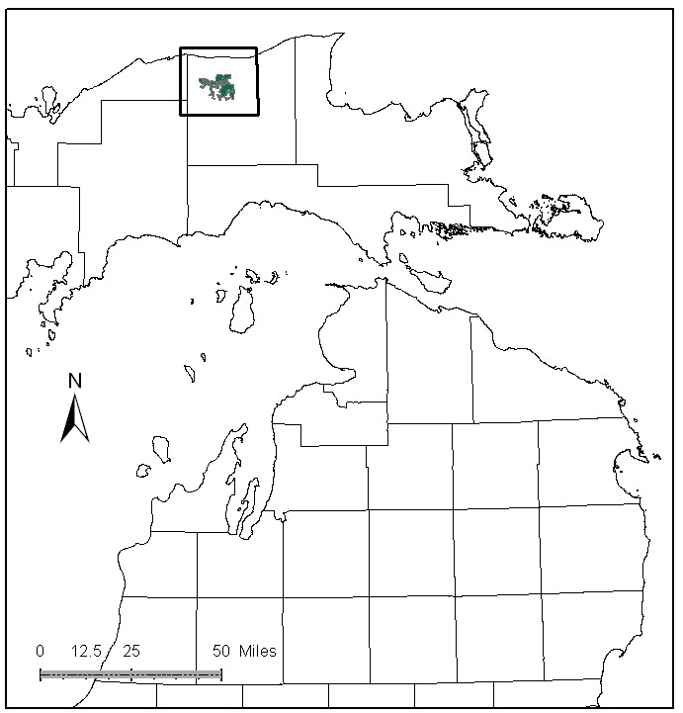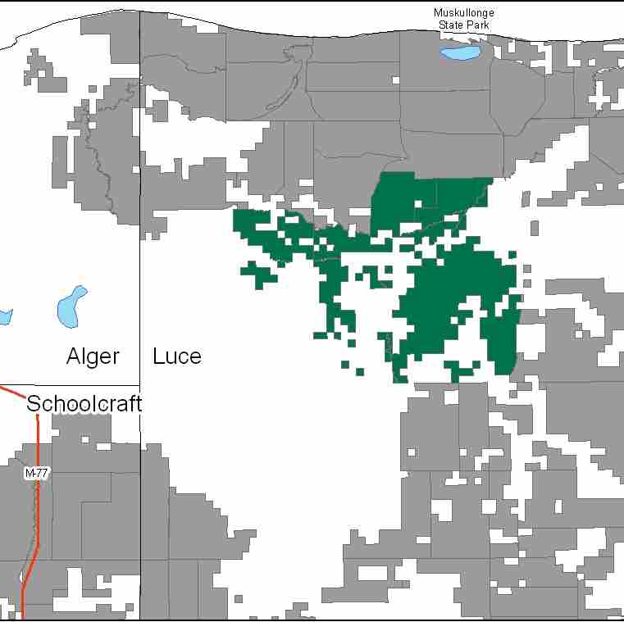

Attributes

The Two Hearted Headwaters Management Area (MA) is located in the central portion of the Eastern Upper Peninsula (EUP), in Luce County, and it has approximately 17,868 acres of state-owned land. The attributes which were important in identifying this MA include:

- Ecological Classification - The MA falls within Grand Marais Glaciofluvial-Moraine complex sub-section of the EUP Ecoregion as classified by Cleland (2006).

- Landforms – Landforms in this MA are moraine ridges and pitted outwash plains. Kettles within the pitted outwash and moraines contain bogs with thick deposits of peat.

- Cover Types – This block of ownership is dominated by the Two Hearted River. The river valley creates its own distinctive vegetation when compared to surrounding landscapes.

- Social / Economic - Recreational opportunities include: trout fishing, hunting, and wildlife viewing. Recreational facilities within the MA include: The Two-Heart and Pine Ridge ORV Trails, snowmobile trails and Pretty Lakes State Forest Campground. This campground has a quiet area that is removed from active management, hence boat motors are not allowed on Pretty Lake or the other Lakes in the Pretty Lake Complex. Many of the small lakes within this watershed are used recreationally for fishing, kayaking/canoeing and birdwatching. Recreation is a primary attribute for this MA.

- Special Features - This MA was specifically selected for all of the special features found within it. The headwaters of the Two-Hearted River, a State designated Natural River originate within this MA. Other special features include the Two-Hearted Lakes, Beavertown Lakes and the Pretty Lakes Quiet Area Complex. A Hardwood Swamp Conifer Ecological Reference Area (ERA) is found along the stream course. Candidate Ecological Reference Areas include: Dry Mesic northern forest, Muskeg and Rich Conifer Swamp. There are potential biodiversity stewardship areas (BSA) within this MA as well. Two Hearted Headwaters has significant fisheries for Michigan citizens. Trout streams with special protections include: West Branch Two Hearted River, South Branch Two Hearted River, Dawson Creek, and North Branch Two Hearted River. Other trout streams include Jack Creek, Camp One Creek, and Johns Creek. Special features are primary attributes for this MA.

- Ownership size and connectivity – This is a large contiguous block of state forest ownership within the Two Hearted River watershed. The Newberry Forest Management Unit is responsible for management. A large portion of the private land owned in proximity to this MA is part of The Nature Conservancy (TNC) Two-Hearted River Forest Preserve.

Major Cover Types

- Treed bog and Marsh – Treed bog covers 4,733 acres, and Marsh covers 1,451 acres within the MA. Many of these stands are within ERA and candidate ERA designation.

- White Pine – Is the predominant forested cover type with 2,325 acres in the MA. Much of this is of natural origin. Over half of the white pine stands are over 90 years old; most of the remaining stands contain multiple age groups.

- Mixed Swamp Conifer and Black Spruce – Mixed swamp conifer covers 2,062 acres, and black spruce covers 1,448 acres of the MA. All of these stands are over 50 years old and most are over 100 years old.

- Upland Hardwood – Is found on 1,664 acres in the MA, most of it in uneven aged in structure. The majority of the stands have less than 110 square feet of basal area. Much of the upland hardwood is found on sandy soils where timber productivity is poor. Many stands have been heavily thinned due to beech bark disease, which has altered the stand composition.

- Red Pine – Of the 1,034 acres of red pine within the MA, the majority are in natural stands.
Total 17,868

Other Types include: Aspen, Tamarack, Spruce Fir, Swamp Hardwoods, Paper Birch, Non Stocked, and Grass

Concepts of Management

- Treed bog (26% of the MA) and Marsh (8% of the MA) – Manage these stands for their ecological and wildlife values.

- White Pine (13% of the MA) – Use shelterwood/seed tree harvests to foster natural pine regeneration. Retain large diameter trees within stands as supercanopy trees, and allow some stands in this cover type to reach biological maturity.

- Mixed Swamp Conifer (12% of the MA) and Black Spruce (8% of the MA) – Look for opportunities to conduct regeneration harvests within these types.

- Upland Hardwood (9% of the MA) – Consider underplanting of oak, disease resistant beech, and hemlock to increase the hard mast production and to restore forest diversity. Where applicable, mesic conifers within the canopy should be retained or encouraged. Dead and down wood and snags are important features of this cover type and should be retained or restored where deficient.

- Red Pine (6% of the MA) – Natural pine regeneration and management is desirable in this MA. Use shelterwood/seed tree harvests to promote natural regeneration.

- Other –
  - Water bodies should be buffered through consultation with Fisheries Division, and application of Natural River guidelines.
  - The Pretty Lake Quiet Area will continue to be managed for ‘big trees’. Timber management should be carefully considered in this area so as not to compromise other stated values.
  - ERA’s will be managed to protect and enhance their natural vegetative and wildlife communities, as directed by site-specific management plans for each ERA.
  - Coordinate management with The Nature Conservancy (TNC), where lands are interspersed with their preserve.

