Waishkey Bay Management Area Summary

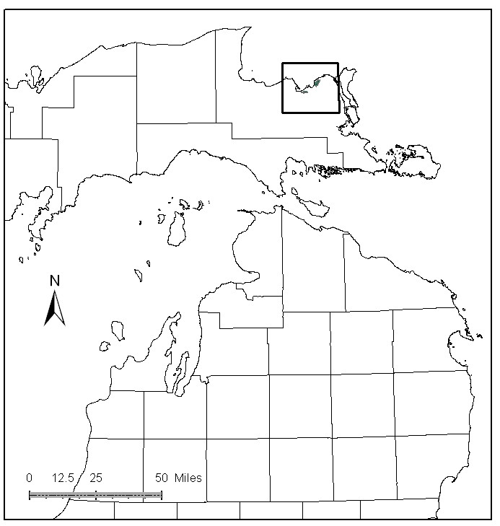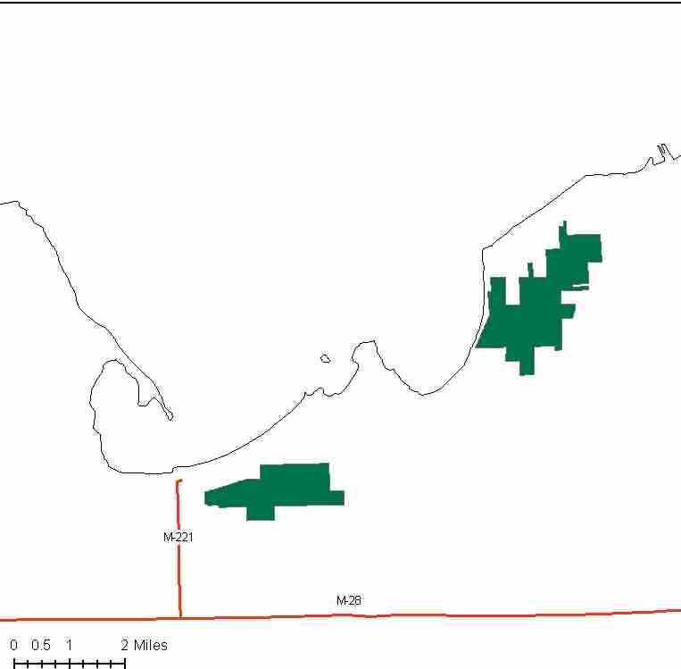

Attributes

The Waishkey Bay Management Area is located near the northern shoreline of Lake Superior, in the eastern portion of the Eastern Upper Peninsula, and in Chippewa County. It has approximately 2,698 acres of state-owned land. The attributes which were important in identifying this MA include:

- Ecological Classification - The MA falls within the Rudyard Silty Lake Plain sub-section of the EUP Ecoregion as classified by Cleland.

- Landforms – The dominant landform consists of lacustrine silts and clays, with lake formed sand ridges. Soils are very prone to erosion, and tend to be acid.

- Cover Types – The cover types are typical of the area along this portion of Lake Superior. It was cut over heavily when the Mill in Waishkey Bay was operating. The present forest has a great deal of lowland brush and other lowland types with white pine and paper birch on the ridges.

- Cultural – When the Bay Mill and town burned in 1904, only the Native American residents remained. Fishing, blueberry picking and logging were important then, and still are. There are known prehistoric and historic sites in this MA.

- Social / Economic - Snowmobile trail on state and private lands; intensive use by bow hunters and firearm deer hunters; bird watching is gaining in popularity; and the northeast portion of this area is in the Sault Ste. Marie city limits and includes the Algonquin Cross Country Ski Trail. The mouth of the Waishkey River at Waishkey Bay is a popular fishing area for perch and walleye. There was an outbreak of Emerald Ash Borer at Brimley State Park, involving a quarantine, ash tree removal, and subsequent monitoring. Wildlife habitat and recreation are primary attributes in this MA.

- Special Features – At this time, there are no known Special Conservation Areas (SCAs). Lake Superior is just north of this MA, and there are some Great Lakes Islands just off-shore. Although there are no trout streams, the East Branch of Waiska River is within the MA.

- Ownership size and connectivity – This MA is managed by the Sault Management Unit. It exists in two blocks along the old railroad bed.

Major Cover Types

- Lowland Brush – Is found on 738 acres, with much of this occurring in low areas between small ridge dune features. This habitat type is important for several wildlife species including songbirds and moose.

- Black Spruce – Covers 443 acres in this MA. Some harvest and regeneration work has been done 20-30 years ago where access exits, but there has been no recent activity.

- Swamp Hardwoods – Swamp hardwoods is found on 372 acres, with stands predominantly in the 60 to 89 year age classes.

- Aspen – Of the 370 acres found in this cover type, stands are predominately trembling aspen and are exclusively in the 50-79 year age classes.

- Paper Birch – There are 230 acres of types that are mostly birch, with almost all acres in the 50-79 year age classes and a peak in the 50-59 age class. This may be an important cultural resource to the local Native American population.

- Marsh – Marsh is found on 225 acres in areas that are wet most of the growing season in most years.

Total 2,698

Other Types include: White Pine, Northern white Cedar, Treed Bog, Tamarack, and Mixed Conifer.

Concepts of Management

- Lowland Brush (27% of the MA) – There will be little management activity in this cover type.

- Black Spruce (16% of the MA) – Look for opportunities to conduct regeneration harvests within these types. In some stands to maintain biodiversity by leaving large tracts unharvested and allow natural processes to operate generating a range of successional stages.

- Swamp Hardwoods (14% of the MA) – Where accessible, consider regeneration harvests in the even aged stands, to obtain some younger age classes.

- Aspen (14% of the MA) – If possible, expand the aspen resource in this area to benefit species such as hare, ruffed grouse, deer and woodcock. Where possible manage for a balanced age class distribution.

- Paper Birch (9% of the MA) – Encourage the regeneration of paper birch through harvest of older stands.

- Marsh (8% of the MA) – There will be little management activity in this cover type.

- Other –
  - Attempt to gain access in hard to reach areas for harvest and regeneration work.
  - Control road density and associated trash dumping.
  - Continue to allow monitoring of EAB with cooperation of Michigan Department of Agriculture.
  - Continue to manage for snowmobile trail use in winter.

