Whitefish/Vermillion Point Management Area Summary

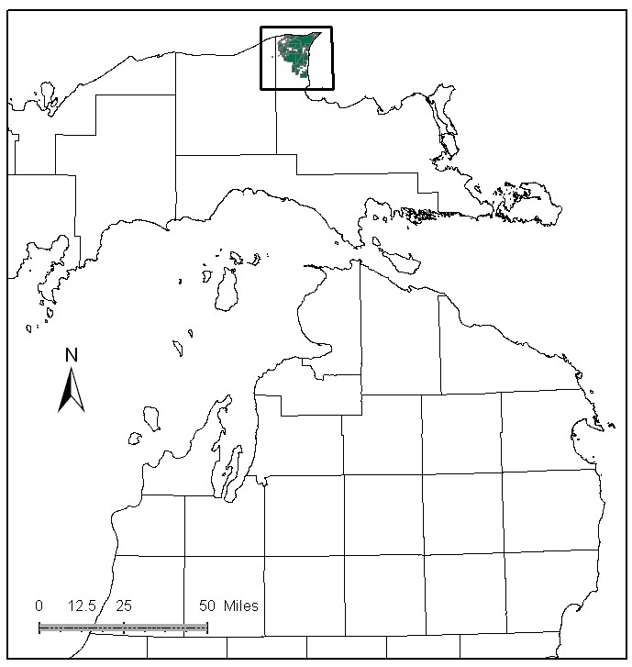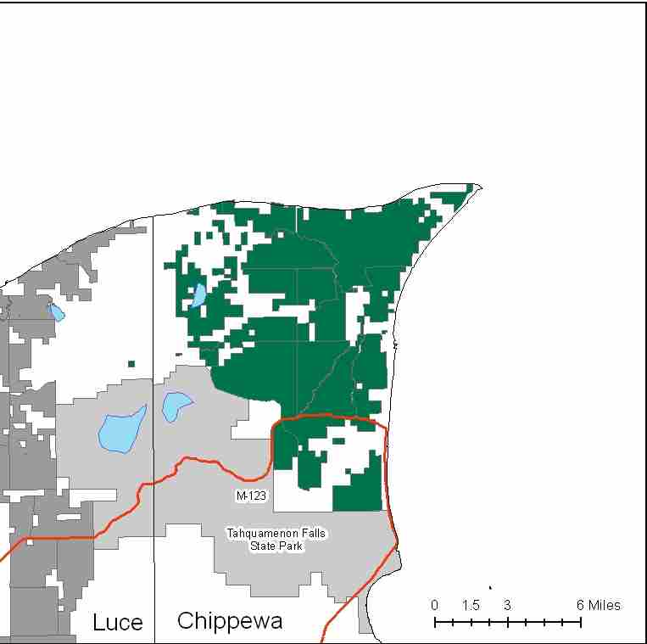

Attributes

The Whitefish/Vermillion Point Management Area is located in the north-central part of the Eastern Upper Peninsula, in Chippewa County, and has approximately 43,790 acres of state-owned land. The attributes which were important in identifying this MA include:

- Ecological Classification - The MA falls within Grand Marais Glaciofluvial Moraine Complex sub-section of the EUP Ecoregion as classified by Cleland (2006).

- Landforms – The dominant landform consists of an extensive complex of alternating swales and sand-spits, sand dunes and beach ridges which support natural communities such as wooded dune and swale.

- Cover Types – The pine resource of this management area is primarily of natural origin as opposed to the planted stands of other locations. This natural growth takes place on Dune and Swale Complexes which are unique assemblages of physiographic, soil and vegetative components. Non-forested communities are dominated by peatlands. Some of the forested cover types near the lakeshore have access issues.

- Cultural - Gathering of blueberries and cranberries is an important cultural use within the MA. There are several known archaeological sites.

- Social / Economic - This MA contains several locally significant destinations including the Great Lakes Shipwreck Historical Museum, a 33 acre parcel of land at the point managed and owned by the U.S. Fish and Wildlife Service as part of the Seney National Wildlife Refuge and The Michigan Audubon’s Whitefish Point Bird Observatory and as such receives a large amount of recreational use. Hunting, trapping, wildlife observations and fishing are significant forms of recreation within this MA. Two campgrounds Andrus Lake and Shelldrake Dam are located within the MA. Whitefish Point Harbor has a boating access site that is maintained by the DNR. There are snowmobile trails in this MA associated with the community of Paradise. Recreation is a primary attribute in this MA.

- Special Features - Whitefish Point is recognized as being important habitat for migratory birds. The surrounding land and water features create a natural corridor, funneling thousands of birds directly to the point each spring and fall as they travel through the Great Lakes region. The point has been designated by the American Bird Conservancy as being a globally Important Bird Area (IBA). The majority of the shoreline within the MA is considered critical habitat for the federally endangered piping plover and other rare Great Lakes endemic species. A Director’s Order is in place to help protect nesting plovers and other shorebirds within this High Conservation Value Area (HCVA). Special Conservation Areas (SCAs) include: Tahquamenon State Park Visual Management Area, Andrus Lake and Shelldrake Dam campgrounds, Marsh Lakes Natural Area, Vermillion Point Natural Area, and Betsy Lake Natural Area. Trout streams include: Betsy River, South Branch Betsy River, and Cheney Creek. Betsy River and South Branch Betsy River are special protection trout streams. A large amount of this MA is classed as candidate Biodiversity Stewardship Areas (BSA). Candidate Ecological Reference Areas include muskeg and patterned fen. Special features are primary attributes in this MA.

- Ownership size and connectivity – This is a large contiguous block of ownership that is geographically separated from other blocks of state forest lands. The Newberry Unit is responsible for management.

Major Cover Types

- Jack Pine – At 19,986 acres, jack pine is the most common cover type and makes up almost half of the M.A. Most of the JP is in large, pure stands. It is being managed for age class diversity and some retention patches are left in large harvest treatments. There are age class spikes in the 0-19 and 70-79 year old age classes.

- Treed Bog and Marsh – Treed Bog covers 5,554 acres and Marsh covers 2,449 acres. Cranberry bogs, marsh, and treed bogs often occur within patterned peatlands. Most of the bog areas are south and west of M-123. While there is little timber value or opportunity for harvest, the area provides good habitat for a myriad of flora and fauna. The primary benefit of these cover types is for wildlife.

- Red Pine – Is found on 2,512 acres in the MA. Near the Lake Superior shore these stands are on steep, narrow, sandy ridges within the peatlands, and are often inaccessible. The stands are of a natural origin, mainly in the 70-79 year old age class. Throughout most of the MA, the red pine is managed intensively.

- Mixed Swamp Conifers – Of the 2,368 acres in this cover type, 85% is over 70 years old. Young age classes are non-existent. A small portion of the cover type is listed as uneven aged, reflecting multi-storied stands.

- Aspen – Covers 1,424 acres in this MA. All age classes through age 80 are represented, reflecting past management, with a slight spike in the most recent 0-9 year age class.

- Oak and Paper Birch – Paper birch covers 1,136 acres and oak covers 600 acres in this MA. These stands primarily exist on beach ridges in Dune and Swale Complexes. Although management is allowed in these areas, they are not often actively managed as they are difficult to access and are somewhat fragile ecosystems.
Total 43,790

Other Types include: Spruce Fir, Cedar, Sand Dune, Hemlock, Swamp Hardwoods, Lowland Poplar, Grass, Non Stocked, Upland Brush, Tamarack, and Scotch Pine

Concepts of Management

- Jack Pine (46% of the MA) - Continue to work on balancing the age class distribution of jack pine stands. Where possible, manage stands in large contiguous blocks of 100 acres or more. Retain oak and birch components within the stands. Consider needs for various wildlife species to include spruce grouse, common nighthawk, and whip-poor-will.

- Treed Bog (13% of the MA) / Marsh (6% of the MA) – Manage these areas for their rich ecological and wildlife values.

- Red Pine (6% of the MA) – Continue to work toward age class diversity, using shelterwood/seed tree harvests to naturally regenerate these stands. Some of the red pine ridges within the peatlands fall into the potential BSA category. Due to the fragility of the peatlands and low timber volumes, some of these ridges will remain unharvested.

- Mixed Swamp Conifers (5% of the MA) – Where special conservation areas won’t be affected, consider regeneration harvests to develop younger age classes in this cover type.

- Aspen (3% of the MA) – Continue work to balance the age class distribution. Inaccessible stands will succeed to more shade tolerant species.

- Paper Birch (3% of the MA) and Oak (1% of the MA) - Although management is allowed in these areas, they are not often actively managed as they are difficult to access and are somewhat fragile ecosystems. Where possible, plan harvests to diversify the age classes within these types.

- Other –
  - The MA has a significant component of Special Conservation Areas. Continue to manage for recreational opportunities, while protecting and/or enhancing the ecological integrity of the MA.
- In timber sales, make special consideration of migrating and nesting bird species, using leave patches, standing snags, down woody structure, and appropriate timing of sales.
- Additional roads and trails should be carefully evaluated so as not to impact the more fragile sites within this MA.

