NATURAL RESOURCES COMMISSION
Keith J. Charters-Chair ● Mary Brown ● Darnell Earley ● Bob Garner ● Gerald Hall ● John Madigan ● Frank Wheatlake
STEVENS T. MASON BUILDING ● P.O. BOX 30028 ● LANSING, MICHIGAN 48909-7528
www.michigan.gov/dnr ● (517) 373-2329
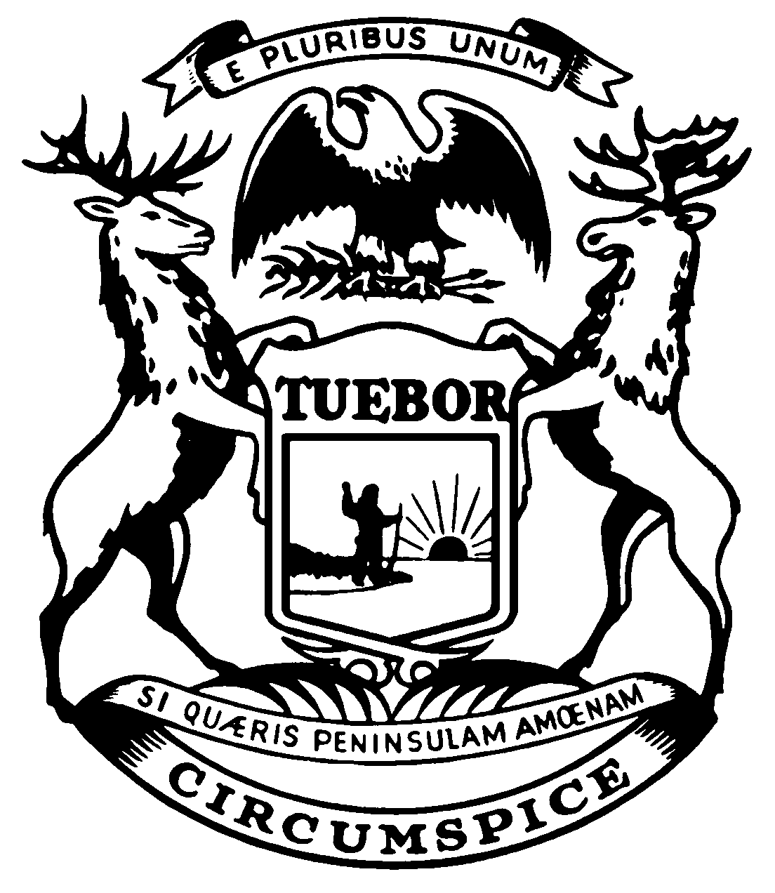
State of Michigan
JENNIFER M. GRANHOLM  governor | DEPARTMENT OF NATURAL RESOURCES  Lansing | REBECCA A. HUMPHRIES  director

June 13, 2006

The Honorable Patricia L. Birkholz, Chair The Honorable David W. Palsrok, Chair
Senate Committee on Natural Resources House Committee on Natural Resources,
and Environmental Affairs Great Lakes, Land Use, and Environment
805 Farnum Building S1385 House Office Building
P.O. Box 30036 P.O. Box 30014
Lansing, Michigan 48909-7536 Lansing, Michigan 48909-7514

The Honorable Michelle McManus, Chair The Honorable Howard Walker, Chair
Senate Appropriations Subcommittee on House Appropriations Subcommittee on
Natural Resources Natural Resources
905 Farnum Building S-1388 House Office Building
P.O. Box 30036 P.O. Box 30014
Lansing, Michigan 48909-7536 Lansing, Michigan 48909-7514

Dear Senators Birkholz and McManus and Representatives Palsrok and Walker:

Pursuant to Section 807, PA 154 of 2005, the Department of Natural Resources (Department) is required to submit a comprehensive plan to expand current off-road vehicle trail mileage by at least 25% over the next four years. The plan is attached. If you have any questions, please feel free to contact me.

Sincerely,

Sharon M. Schafer, Chief
Budget and Support Services
517-335-3276

Attachment

cc: Senate Committee on Natural Resources/Environmental Affairs
House Committee on Natural Resources,
Great Lakes, Land Use, and Environment
Senate Appropriations Subcommittee Members
House Appropriations Subcommittee Members
Ms. Jessica Runnels, Senate Fiscal Agency
Dr. Kirk Lindquist, House Fiscal Agency
Ms. Mary Lannoye, State Budget Director, Department of
Management and Budget (DMB)
Mr. Jacques McNeely, DMB
Ms. Jennifer Harrison, DMB
Director Rebecca Humphries, DNR
Mr. Dennis Fedewa, Chief Deputy, DNR
Ms. Arminda Koch, Resource Management Deputy, DNR
Mr. Dennis Fox, Chief of Staff, DNR
Mr. Rodney Stokes, Legislative Liaison, DNR
Ms. Lynne Boyd, DNR
DEPARTMENT OF NATURAL RESOURCES
ORV Trail Expansion Plan

Currently, the Department of Natural Resources’ (Department) ORV Trail and Route Program encompasses 3,185 miles of designated trails. Public Act 154 of 2005, Section 807, requires the Department to expand ORV trail mileage by at least 25% over the next four years. That equates to an additional 796 miles, or 199 miles per year for 4 years.

Trail Expansion Plan:

- Acquisition: the department has identified an available abandoned rail corridor in the West Upper Peninsula that directly connects Michigan’s Iron River to Marinesco Trail to the designated Wisconsin ORV trail system. This will provide access to 60 miles of Wisconsin designated ATV trails and 300 miles of ATV trails in NE Wisconsin Counties for residents of Michigan. Negotiations for the purchase of the corridor are underway.

- ORV Plan Implementation: A department initiated public planning process during 2004-2005 to update the ORV plan and assess program needs resulted in diverse opinion. Department will complete review of the Plan submitted by MSU and make final recommendations to the Director and the Natural Resources Commission in September 2006.

- Designated Scramble Areas: examine existing illegal use areas and evaluate the potential to designate them for riding opportunities during FY 2008. This will fulfill trail riding miles and scramble area opportunities.

- Connections: connect the existing state designated trail system with trail or routes, depending on the local available opportunities. This would fulfill the public requests identified during the ORV Plan process for longer riding/touring opportunities. This will be accomplished by Sponsor advocates working with the local DNR land manager to propose trails or routes, utilizing the trail proposal process, to designate the connections or with the county road commission for specific designated routes on the county road shoulders.

- Private land additions: nonprofit trail grant sponsors and manufacturers and dealers of ORV/ATV’s are being encouraged to work with local units of government and private land owners to secure lands or trail easements nearer the population centers in Southern Lower Michigan (snowmobile trail model).

Fiscal Implications:

Designated trail system expansion will result in the need for increased funding support for law enforcement, trail maintenance, damage restoration and program oversight. This will require an increase in Trail Permit Fees and a legislative change in the allocation of ORV funds.

ORV Trail Program Status:

PA 451 of 1994, Part 811, Section 8119 provides for the department distribution of grants to plan, improve, construct, sign, and maintain ORV trails, areas, routes and access to those; the leasing of land, the acquisition of easements, permits, or other agreements for the use of land for ORV trails, areas, and routes, to public agencies and nonprofit clubs and organizations. The Department works with trail advocates in designating trails and routes through a Trail Proposal Process.

ORV Trail Program designated trails reside entirely on public lands or public road rights of way. In contrast the Snowmobile Trail Program has 50% of its 6,200 mile designated trail miles on private lands, 25% on State Forest Lands and 25% on National Forest Lands Expansion of the ORV trail system on private lands must be considered. Trail grant sponsors and manufacturers will be encouraged to assist in the effort to expand the designated ORV trail system by 25% in 4 years. Their advocacy and willingness to maintain expanded riding opportunities is crucial in meeting this ambitious plan objective.

Environmental damage from illegal ORV use is an on going land management challenge for both state and federal land managers. These illegal ORV users jeopardize other legal mandates or program missions. Illegal ORV use is cited as a significant finding during the December 2005 forest certification audits by Sustainable Forestry Initiative (SFI) and Forest Stewardship Council (FSC). Corrective measures by the Department must occur by October 2006 to address the illegal use and resulting environmental damage.

