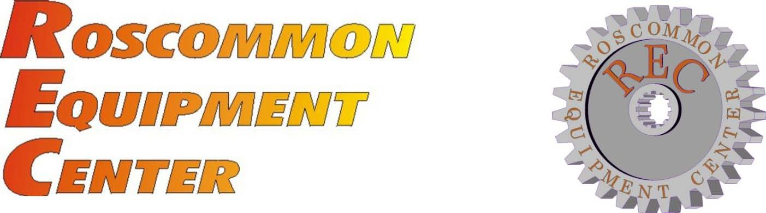

NewsNote # 19
October, 2015

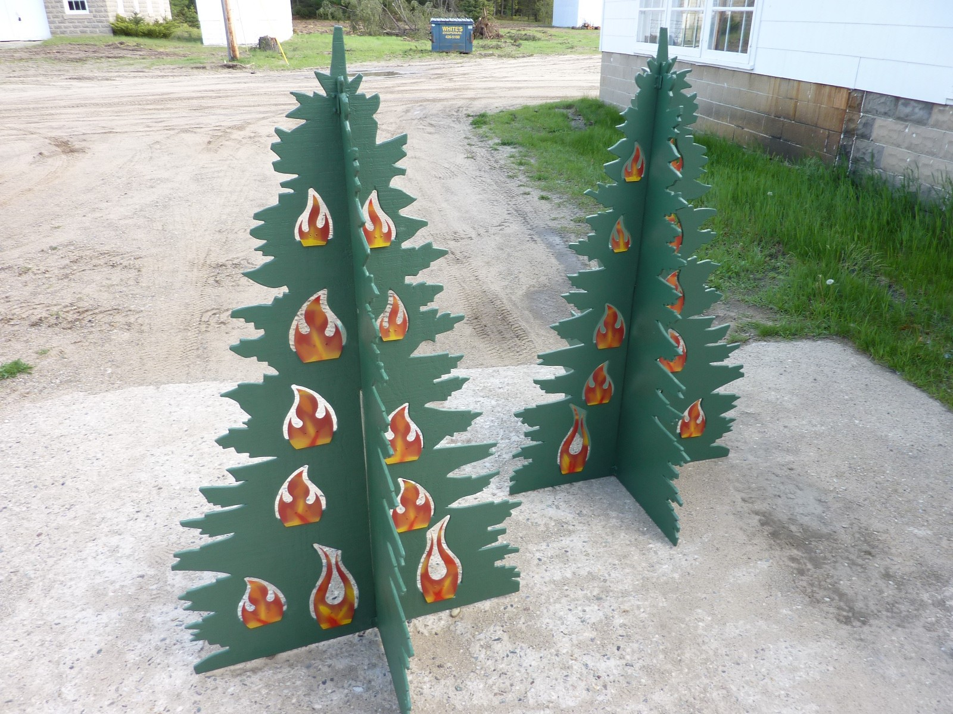

Fire Prevention “Tree Game”

National Association of State Foresters
in Cooperation with
Michigan’s Forest Fire Experiment Station

REC NewsNote No. 19

Fire Prevention "Tree Game"

Table of Contents
Disclaimer 2
Introduction 3
Design 4
Appendix A 5
Appendix B 6-14

Roscommon Equipment Center c/o Forest Fire Experiment Station 1337 East Robinson Lake Road
P.O. Box 68 Roscommon, Michigan 48653 Telephone: (989) 275-5211 Fax: (989) 275-8249 Email: info@RoscommonEquipmentCenter.org Web Site: www.RoscommonEquipmentCenter.org

Disclaimer
This report has been developed for the guidance of member States, Provinces, Federal Agencies and their cooperators. The National Association of State Foresters and the State of Michigan assume no responsibility for the interpretation or use of this information.

The use of trade, firm or corporation names is for the information and convenience of the user. Such use does not constitute an official evaluation, conclusion, recommendation, endorsement or approval of any product or service to the exclusion of others, which may be suitable.

Introduction

REC staff in conjunction with the Michigan Department of Natural Resources (MIDNR) have worked together to create an interactive carnival type game to help communicate the message of fire prevention.

The "Tree Game" explained below gives agencies a tool to be able to better explain causes of forest fire to children and give them a chance to learn how forest fires are extinguished by having them actively participate in putting out a mock fire on the Tree Game.

States across the country have invested much time and resources in developing various programs to help educate the public regarding preventable forest fires. The Smokey Bear program is a good example of this type of educational initiative.

Design

MIDNR approached REC with the intent of developing an apparatus that was easily transportable, setup and operated at indoor or outdoor functions. The apparatus would need to be able to help MIDNR staff interactivley engage children and their parents to communicate the message of fire prevention and to teach them in general terms how forest fire is classically fought.

REC created the Tree Game to fulfill this need.

The Tree Game is shaped like a conifer tree and consists of 2 seperate panels that when assembled is self standing and presents more of a 3D representation. One of the panels has cutouts of various sizes to house the artificial "flames". The flames are installed such that they will stand upright and are hinged to be able to be knocked over or "extinguished" by a child with either a low pressure water spraying device or a small sandbag (for indoor functions).

** Several drawings used for re-creating the game need to be printed full-scale and will be used as a pattern for fabrication.

Appendix A ...............Photograph of the Tree Game being used

Appendix B ..............Construction Drawings

Appendix A

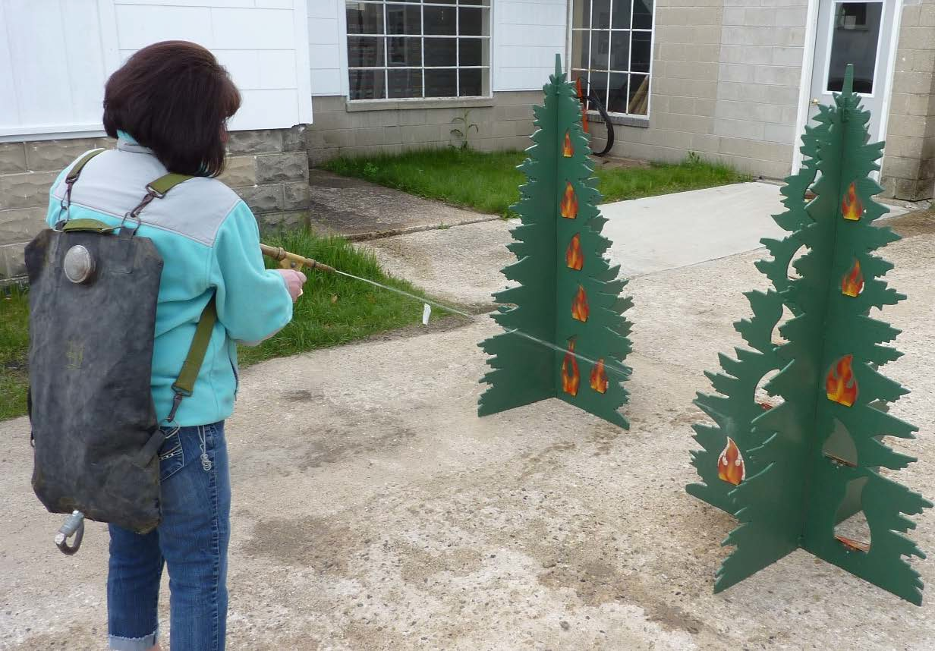

APPENDIX B
STD. TOL. FRACTIONAL:
0 TO 6 IN + - 1/32
6 IN AND UP + - 1/16
ANGULAR:
+ - 1 DEG. N0. BY DATE REVISION

DECIMAL: FOREST FIRE EXPERIMENT STATION
1 PLACE + - 0.05
2 PLACE + - 0.01
3 PLACE + - 0.005
P.O. BOX 68 ROSCOMMON, MICHIGAN 48653

DRAWN:
DGP DESIGNED: DGP APPROVED:

DATE:
02-Jan-2014
SCALE:

FOREST, MINERAL AND
FULL
DW NO.
D
FIRE MANAGEMENT

PROJECT NO.:
13-0
I
TITLE: TREE, FRONT
G. 42-0001
SIZE:

/

POSITION INDICATORS FOR PANEL GUIDE MOUNTING HOLES

0

*** MAKE FROM PLYWOOD, 1/2" THICK MINIMUM
*** APPROXIMATE SIZE OF FINISHED PART IS 36" X 60"
*** FINISH: EXTERIOR GRADE GREEN PAINT
0 0

EXTERIOR GRADE CLEAR TOPCOAT RECOMMENDED POST PAINT

/

\

I
I

1 -+7/8 -
t
5/16

I

2-7/8

/

I

\

I

I
I I
I

I t
5/16
I
-

- 4-3/4
1
1-7/8

I

I I
I
I
<

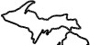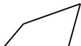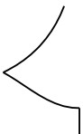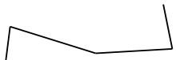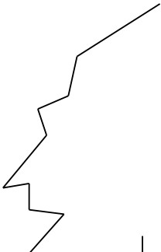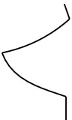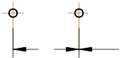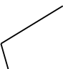

-0 ' - -0'-

1

5

t
5/16
( +
I
-
2

STD. TOL. FRACTIONAL:
0 TO 6 IN + - 1/32
6 IN AND UP + - 1/16
ANGULAR:
+ - 1 DEG. N0. BY DATE REVISION

DECIMAL: FOREST FIRE EXPERIMENT STATION
1 PLACE + - 0.05

DRAWN:
DGP DESIGNED: DGP APPROVED:

DATE:
03-Dec-2013 FOREST, MINERAL AND
SCALE:

2 PLACE + - 0.01
3 PLACE + - 0.005
I PROJECT NO.:
13-0
P.O. BOX 68 ROSCOMMON, MICHIGAN 48653
TITLE:
TREE, SIDE

FULL
FIRE MANAGEMENT
SIZE:
DWG.
NO. 42-0002
D

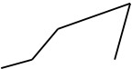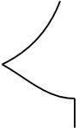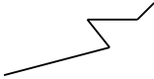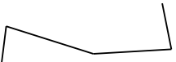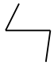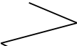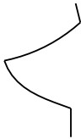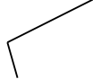

*** MAKE FROM PLYWOOD, 1/2" THICK MINIMUM
*** APPROXIMATE SIZE OF FINISHED PART IS 36" X 60"
*** FINISH: EXTERIOR GRADE GREEN PAINT
EXTERIOR GRADE CLEAR TOPCOAT RECOMMENDED POST PAINT

/

\

I
I

/

I

7
\

I

V

I
I I
I

\ I
\

I
I

\ I I
I
<
L

I

5 REQ'D. |  | 1-5/8 | 1/8 | 2 REQ'D.  1 3  1  2  1-3/4  1  3 REQ'D.  ** FINISH WITH EXTERIOR GRADE PAINT  3/8  MAKE FROM 1/16 AL.  1
 |  |  | STD. TOL. |  |  |  |  |  | DRAWN:
 |  |  |  |  |  |  |  |  | DGP
FRACTIONAL:
0 TO 6 IN + - 1/32
6 IN AND UP + - 1/16
DESIGNED:
DGP
 |  |  | ANGULAR: |  |  |  |  |  | APPROVED:
 |  |  |  |  | N0. | BY | DATE | REVISION
1  3 | 1 |  | + - 1 DEG. |  |  |  |  |  |  | FOREST, MINERAL AND FIRE MANAGEMENT
 |  |  | DECIMAL:  1 PLACE + - 0.05  2 PLACE + - 0.01  3 PLACE + - 0.005 |  | FOREST FIRE EXPERIMENT STATION  P.O. BOX 68 ROSCOMMON, MICHIGAN 48653 |  |  |  | DATE:  22-Oct-2013
SCALE:
FULL
 |  |  | PROJECT NO.:  13-0 |  | TITLE: FLAME (S-M-L) |  |  |  |  | DWG.  NO. 42-0004 | SIZE:  B

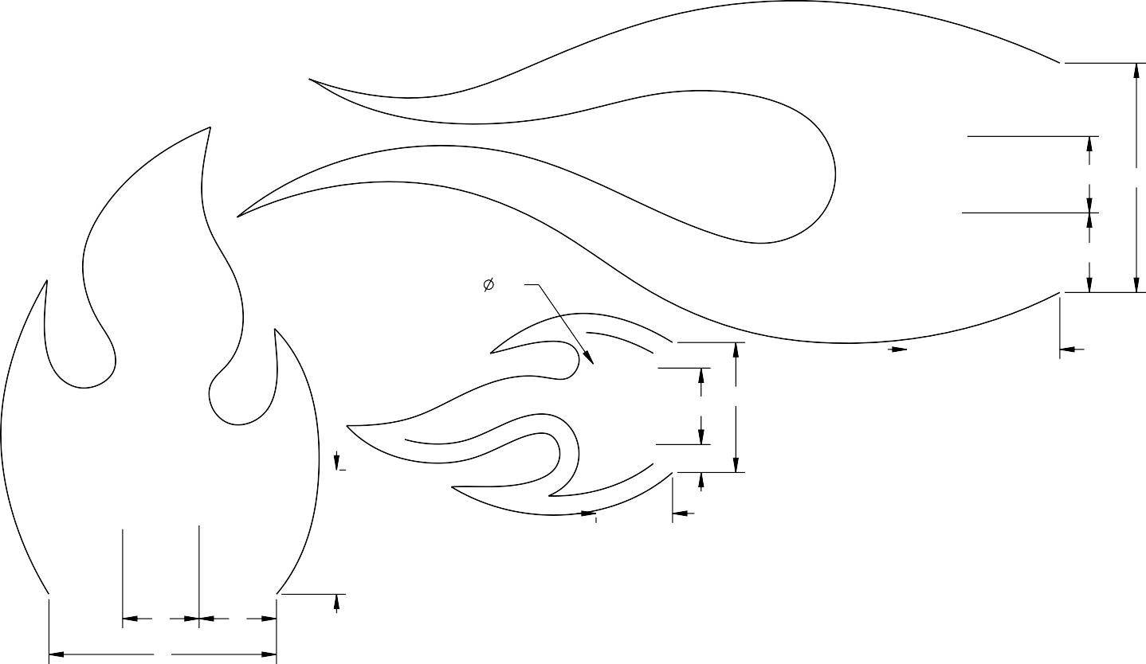8

1-1/2

1/4 1
5/16
2 PLCS
1/8

1-1/2

PART NO: 42-0005
MAT'L: McMaster Carr Item#: 1581A281 EST WT: 0.65 LBS
STD. TOL. |  |  |  |  | DRAWN:  dgp | FOREST, MINERAL AND FIRE MANAGEMENT
FRACTIONAL
0 TO 6 IN + - 1/32
6 IN AND UP + - 1/16
DESIGNED:
DGP
ANGULAR:  + - 1 DEG. |  |  |  |  | APPROVED:
 | N0. | BY | DATE | REVISION
DECIMAL:  1 PLACE + - 0.05  2 PLACE + - 0.01  3 PLACE + - 0.005 | FOREST FIRE EXPERIMENT STATION  P.O. BOX 68 ROSCOMMON, MICHIGAN 48653 |  |  |  | DATE:  13-Nov-2014
 |  |  |  |  | SCALE:
PROJECT NO.: | TITLE: AL. HINGE, 1 1/2 X 1 1/2 |  |  |  |  | DWG.  NO. 42-0005 | SIZE:  A

1-1/2
7/32 1/8
2 PLCS
3/8

1

1

PART NO: 42-0006
MAT'L: AL. ANGLE, 1 X 1 X 1/8 K02600
FFES SPEC NO: AK-20606AG EST WT: 0.13 LBS
STD. TOL. |  |  |  |  | DRAWN:  DGP | FOREST, MINERAL AND FIRE MANAGEMENT
FRACTIONAL
0 TO 6 IN + - 1/32
6 IN AND UP + - 1/16
DESIGNED:
DGP
ANGULAR:  + - 1 DEG. |  |  |  |  | APPROVED:
 | N0. | BY | DATE | REVISION
DECIMAL:  1 PLACE + - 0.05  2 PLACE + - 0.01  3 PLACE + - 0.005 | FOREST FIRE EXPERIMENT STATION  P.O. BOX 68 ROSCOMMON, MICHIGAN 48653 |  |  |  | DATE:  22-Oct-2015
SCALE:
FULL
PROJECT NO.: | TITLE: ANGLE, GUIDE |  |  |  |  | DWG.  NO. 42-0006 | SIZE:  A

ITEM | PART NO. | DWG |  | DESCRIPTION | QTY
1 | 42-0001 |  | TREE, FRONT |  | 1
2 | 42-0002 |  | TREE, SIDE |  | 1
3 | 42-0004 | B | FLAME (S-M-L) |  | 3
4 | 42-0005 | A | AL. HINGE, 1 1/2 X 1 1/2 |  | 3
5 | 42-0006 | A | ANGLE, GUIDE |  | 4

**(1) OF EACH SIZE OF FLAME SHOWN FOR CLARITY

STD. TOL. FRACTIONAL:
0 TO 6 IN + - 1/32
6 IN AND UP + - 1/16
ANGULAR:

For Assembly:
*Use #4 x 7/16" Panhead screws to attach hinges to the tree panel (Mcmaster Carr P/N: 90190A109)
* Use #10 x 1/2" Panhead screws to attach angle guides to the tree panel (Mcmaster Carr P/N: 90190A242
*Use Aluminum 1/8" blind rivets .126"-.187" grip range to attach flames to the hinges
(Mcmaster Carr P/N: 97447A020)
DRAWN:
DCM
DESIGNED:

APPROVED:

+ - 1 DEG. N0. BY DATE REVISION

DECIMAL: FOREST FIRE EXPERIMENT STATION
1 PLACE + - 0.05
DCM
DATE:
22-Oct-2015
SCALE:

FOREST, MINERAL AND

SCALE 7/32
2 PLACE + - 0.01
3 PLACE + - 0.005

P.O. BOX 68 ROSCOMMON, MICHIGAN 48653
FIRE MANAGEMENT

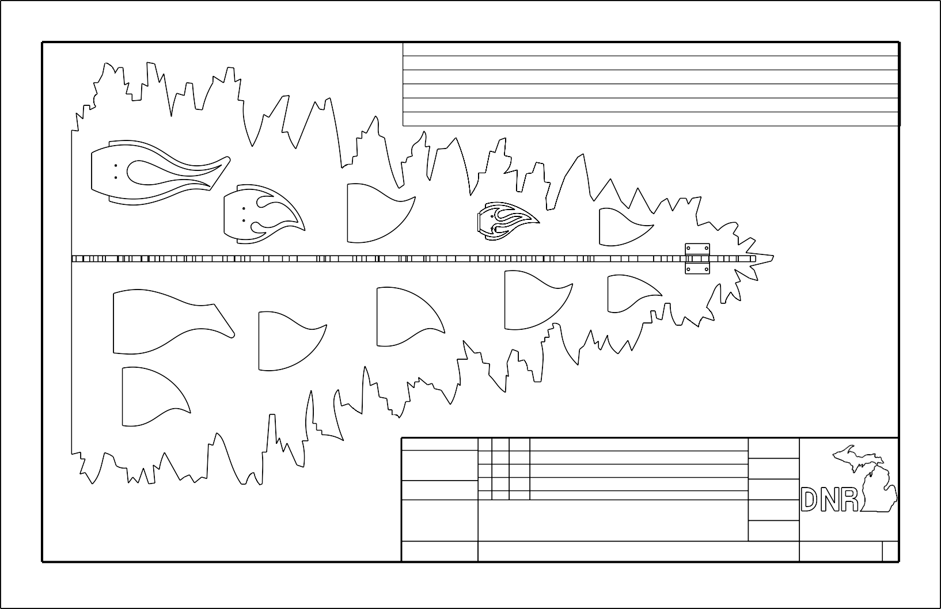
PROJECT NO.:
TITLE:
FIRE TREE ISOMETRIC
DWG. NO.
SIZE:
B

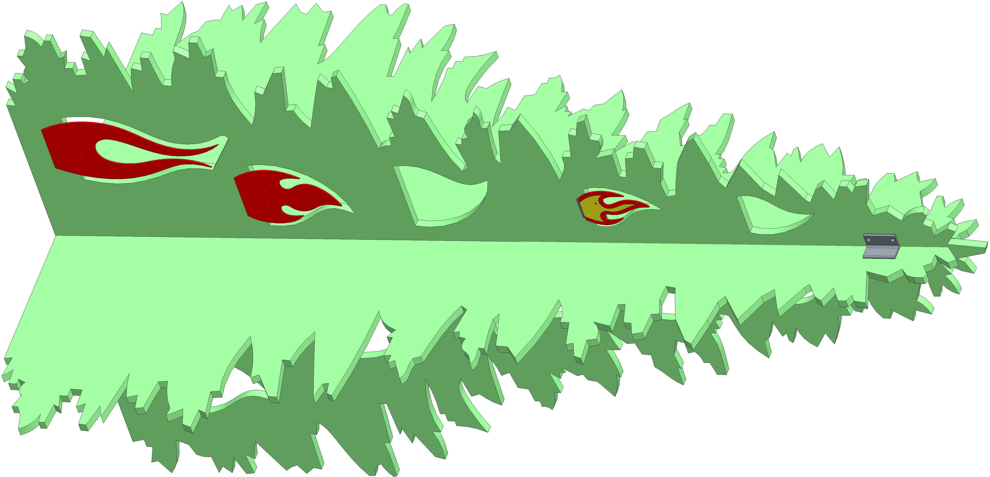
SCALE 1/4 | STD. TOL. |  |  |  |  | DRAWN: | FOREST, MINERAL AND FIRE MANAGEMENT
FRACTIONAL:
0 TO 6 IN + - 1/32
6 IN AND UP + - 1/16
 |  |  |  |  |  | DESIGNED:
 | ANGULAR:  + - 1 DEG. |  |  |  |  | APPROVED:
 |  | N0. | BY | DATE | REVISION
 | DECIMAL:  1 PLACE + - 0.05  2 PLACE + - 0.01  3 PLACE + - 0.005 | FOREST FIRE EXPERIMENT STATION  P.O. BOX 68 ROSCOMMON, MICHIGAN 48653 |  |  |  | DATE:  22-Oct-2015
 |  |  |  |  |  | SCALE:
 | PROJECT NO.: | TITLE: FIRE TREE ISOMETRIC |  |  |  |  | DWG. NO. | SIZE:  B

SCALE 1/4 | STD. TOL. |  |  |  |  | DRAWN: | FOREST, MINERAL AND FIRE MANAGEMENT
FRACTIONAL:
0 TO 6 IN + - 1/32
6 IN AND UP + - 1/16
 |  |  |  |  |  | DESIGNED:
 | ANGULAR:  + - 1 DEG. |  |  |  |  | APPROVED:
 |  | N0. | BY | DATE | REVISION
 | DECIMAL:  1 PLACE + - 0.05  2 PLACE + - 0.01  3 PLACE + - 0.005 | FOREST FIRE EXPERIMENT STATION  P.O. BOX 68 ROSCOMMON, MICHIGAN 48653 |  |  |  | DATE:  22-Oct-2015
 |  |  |  |  |  | SCALE:
 | PROJECT NO.: | TITLE: FIRE TREE ISOMETRIC |  |  |  |  | DWG. NO. | SIZE:  B
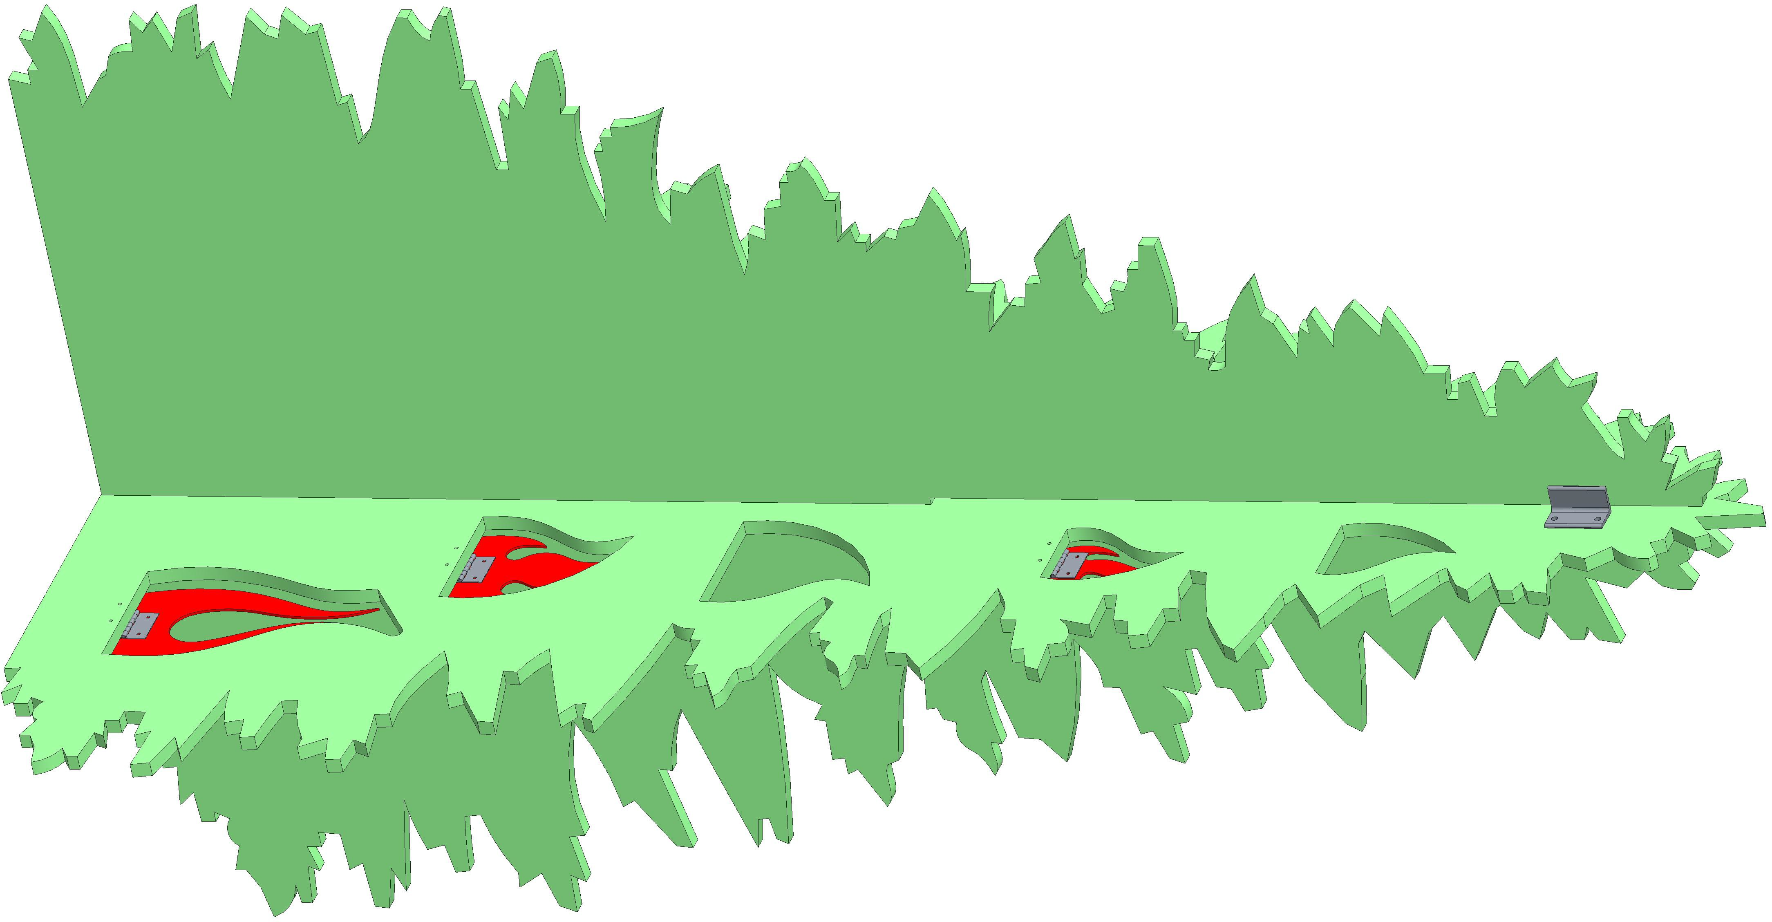

Further Information

For further information regarding this or any other REC product , please contact the REC Program Administrator at:

Roscommon Equipment Center c/o Forest Fire Experiment Station 1337 East Robinson Lake Road
P.O. Box 68 Roscommon, Michigan 48653 Telephone: (989) 275-5211 Fax: (989) 275-8249
Email: info@RoscommonEquipmentCenter.org Web Site: www.RoscommonEquipmentCenter.org

14

